University of Seville  
 School of Computer Engineering

**Performance Report**



Software engineering  
Design and testing 2

2018 – 2019

06/04/2019

Group 26

**Index**

1. Observations 6

2. Package 6

Create 6

Edit LUIS 7

Delete 9

Conclusion 11

3. Evaluation 12

Create 12

Delete 14

Conclusion 15

4. Message 16

Send 16

Move 17

Copy 19

Delete 21

Conclusion 23

5. Message box 24

Create 24

Edit 25

Delete 27

Conclusion 29

6. Social profile 30

Create 30

Edit 32

Delete 33

Conclusion 35

7. Dashboard 36

Show dashboard and launch all process 36

Conclusion 38

8. Category 38

Create 38

Edit 40

Delete 42

Conclusion 44

9. Request 44

Create 44

Edit 46

Delete 48

Conclusion 50

10. TraverseTown 50

Create 50

Edit 52

Delete 54

Conclusion 56

11. Issue 57

Create 57

Delete 58

Conclusion 60

12. Town 61

Create 61

Edit 63

Delete 64

Conclusion 66

13. Comment 67

Create 67

Conclusion 69

14. Configuration 69

Display and edit 69

Conclusion 71

15. Finder 72

Search 72

Conclusion 74

16. Offer 74

Create/Edit 74

Delete 76

Conclusion 78

17. Curricula 78

Create a curriculum 78

Edit a curriculum 80

Delete a curriculum 82

18. Records (Professional and Miscellaneous record) 84

Create Miscellaneous Record 84

Create Professional Record 86

Edit a Miscellaneous Record 88

Edit a Professional Record 89

Delete a professional record 91

Delete a miscellaneous data 92

Conclusion 94

19. Actor 94

Create 94

Edit 96

Delete 98

Conclusion 100

20. Vehicle 100

Create 100

Edit 102

Delete 104

Conclusion 106

21. Solicitation 107

Create 107

Edit 108

Delete 110

Conclusion 112

22. Sponsorship 113

Create 113

Edit 115

Delete 116

Conclusion 118

23. Fare 118

Create 118

Edit 121

Delete 123

Conclusion 124

24. TODO DE AQUI PABAJO SE BORRA 125

25. Position 125

Create 125

Edit 127

Delete 130

Conclusion 132

26. Mess 132

Search by tags, list by that tag and display a mess 132

Send a message 134

Delete a message 136

Send a broadcast mess 138

Conclusion 139

27. Dashboard 140

Display the dashboard and set the spammers 140

Conclusion 141

28. Configuration 142

Display the configuration and edit it 142

Conclusion 144

29. Problem 144

Create 144

Edit 146

Delete 148

Conclusion 150

30. Finder 150

Search and clear 150

Conclusion 152

31. Curricula 152

Create a curriculum 152

Edit a curriculum 154

Delete a curriculum 156

32. Records (Professional and Miscellaneous record) 158

Create Miscellaneous Record 158

Create Professional Record 160

Edit a Miscellaneous Record 162

Edit a Professional Record 163

Delete a professional record 165

Delete a miscellaneous data 166

Conclusion 168

33. Social profile 168

Create 168

Edit 170

Delete 172

Conclusion 174

34. Actor 175

Create 175

Edit 177

Delete 178

Conclusion 180

35. Vehicle 181

Create 181

Edit 183

Delete 184

Conclusion 186

36. Solicitation 187

Create 187

Edit 189

Delete 191

Conclusion 192

37. Sponsorship 194

Create 194

Edit 195

Delete 197

Conclusion 199

38. Fare 199

Create 199

Edit 202

Delete 204

Conclusion 205

39. Conclusion of the performance 206

# Observations

We have considered that our performance tests were valid as long as they were lasting between 2’5 and 3 seconds and no error was showed.

# Package

## Create

Sequence:

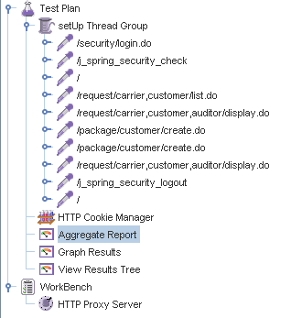

Aggregate Report:

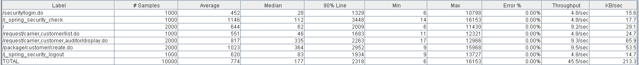



Thread properties:

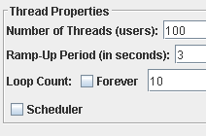

Graph Results:

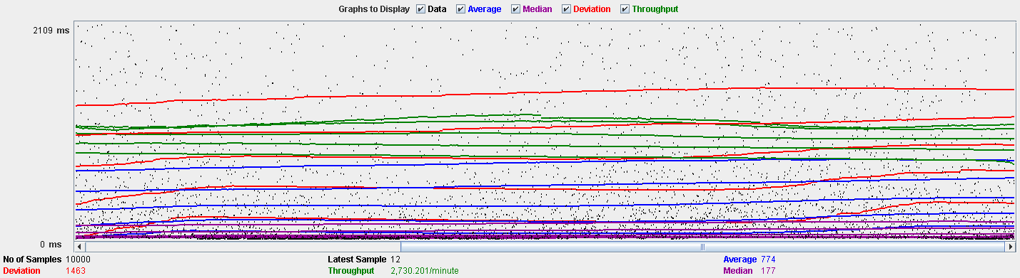

Performance Results:

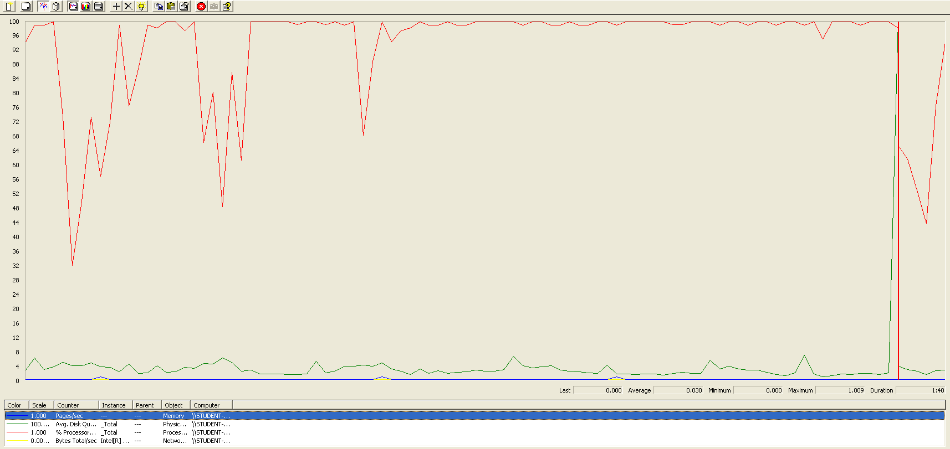

The CPU is always being used while the disk usage is barely noticeable..

## Edit LUIS

Sequence:

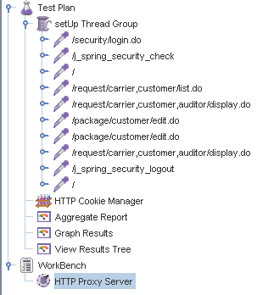

Aggregate Report:

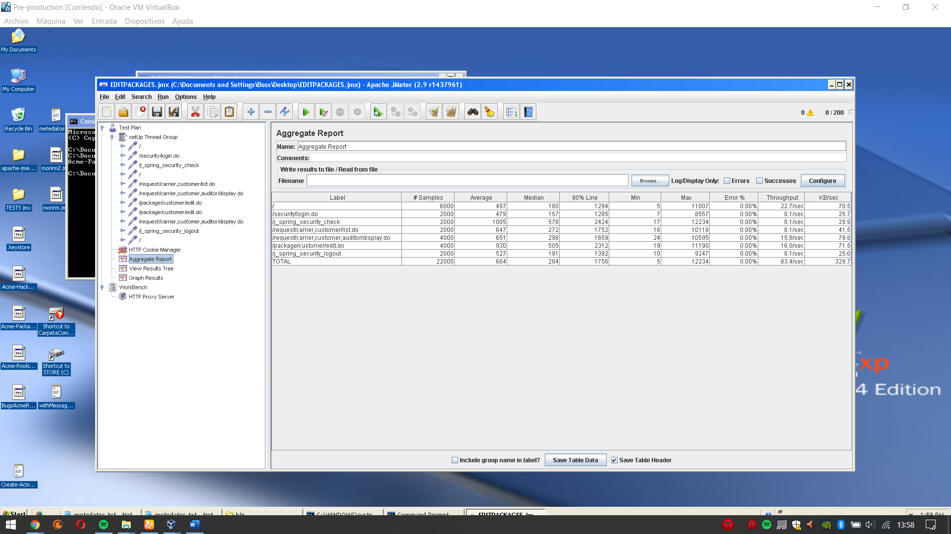

Thread properties:

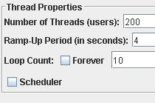

Graph Results:

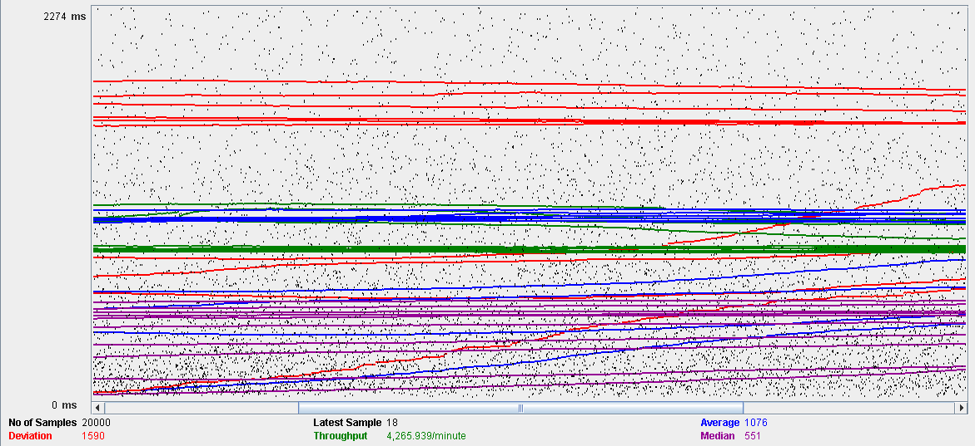

Performance Results:

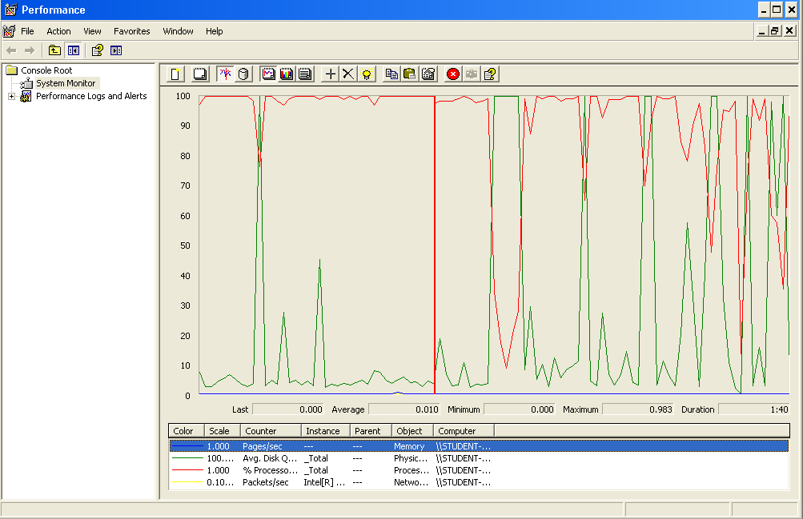

Again we can see that the CPU is always being used while the disk usage shows some periodic peaks.

## Delete

Sequence:

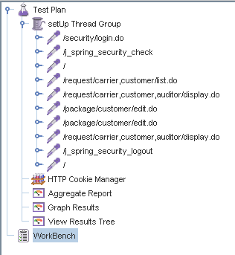

Aggregate Report:

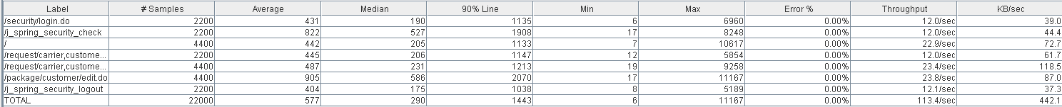



Thread properties:

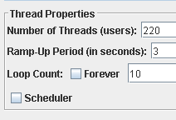.

Graph Results:

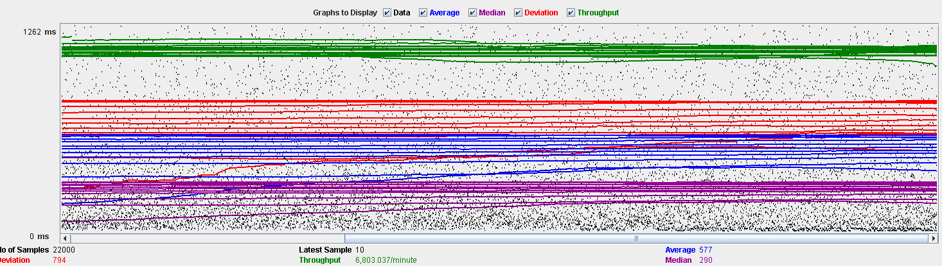

Performance Results:

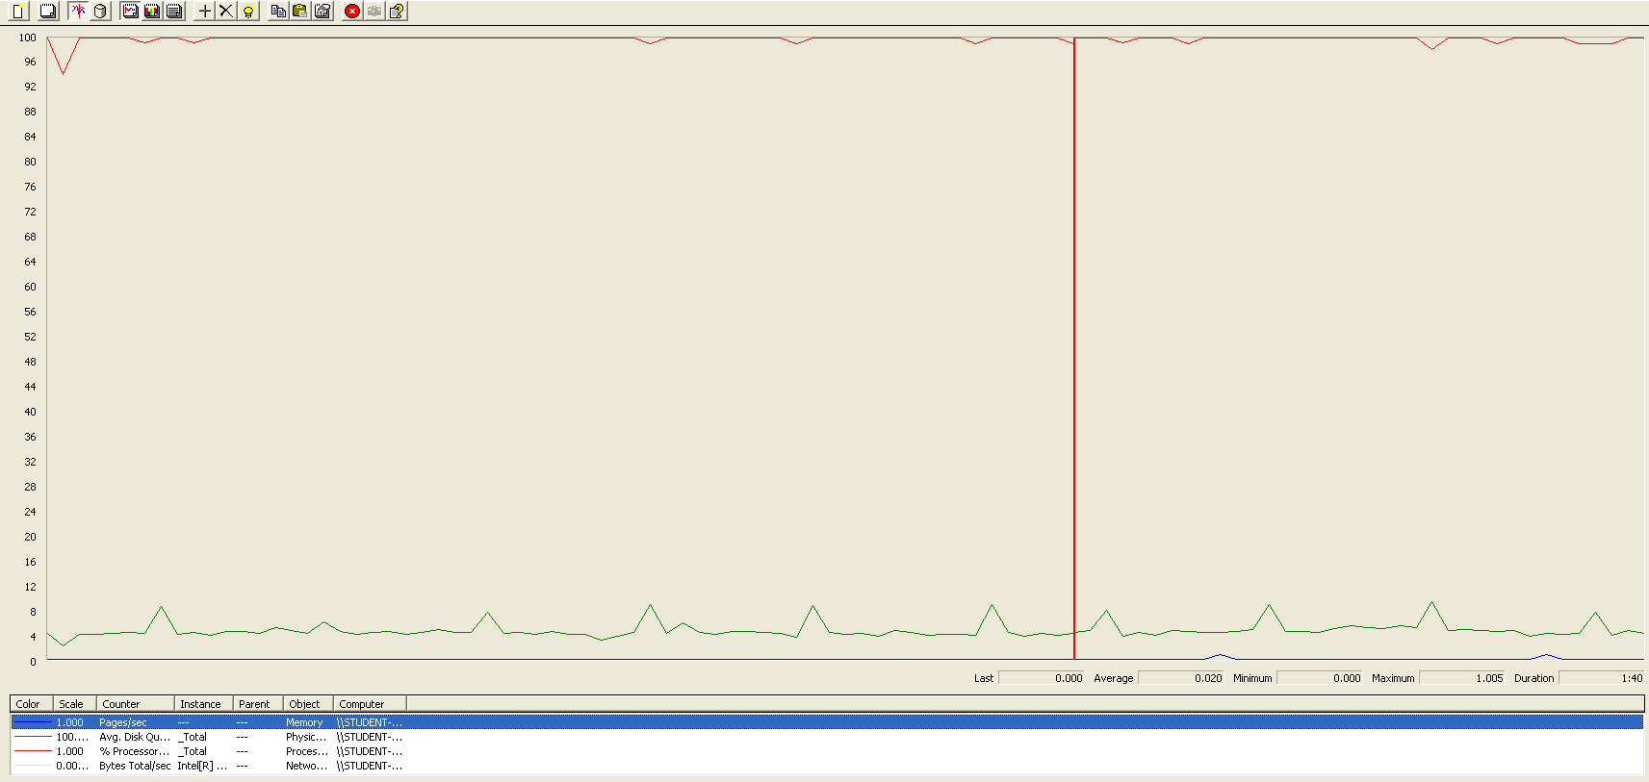

Again we can see that the CPU is always being used while the disk usage shows some peaks. The times are a little bit lower in order to avoid errors.

## Conclusion

The test was performed using:

CPU: i7 6700hq (2 cores in the virtual machine)

RAM: 4 GB (virtual machine)

For this use case we can say that the limitation occurs during the creation process, being the maximum of concurrent users 100. The times during the delete process did not reach the 3 seconds mark in order to avoid errors.

# Evaluation

## Create

Sequence:

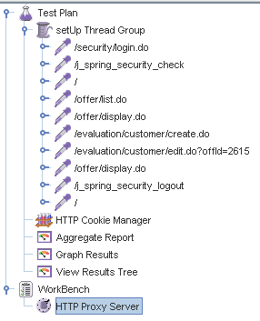

Aggregate Report:

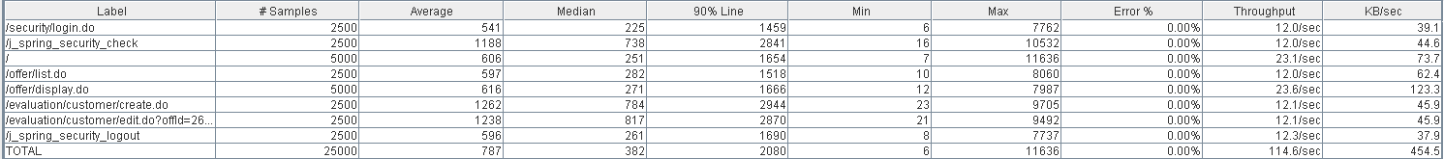



Thread properties:

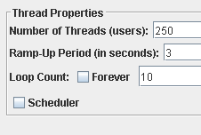

Graph Results:

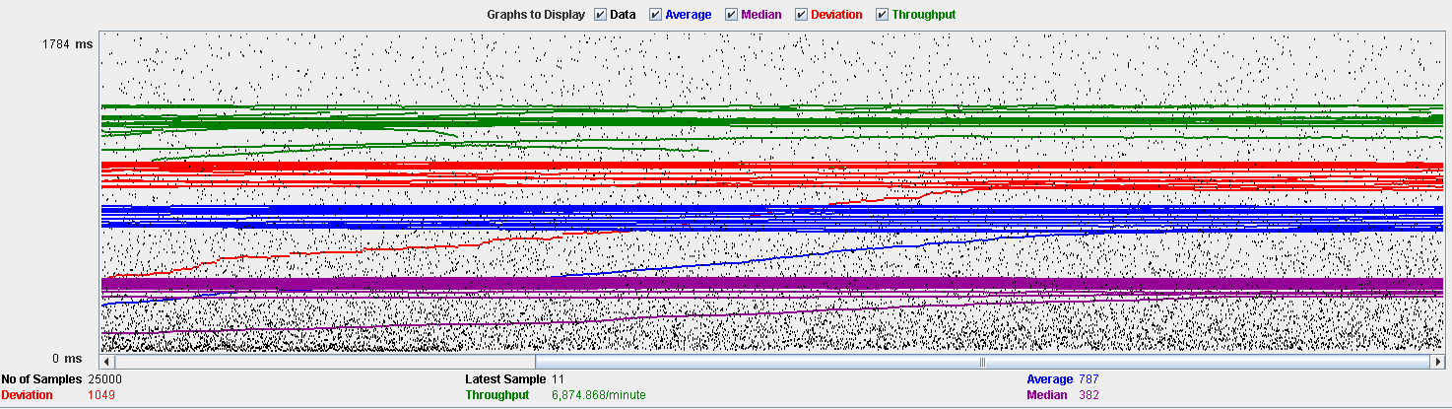

Performance Results:

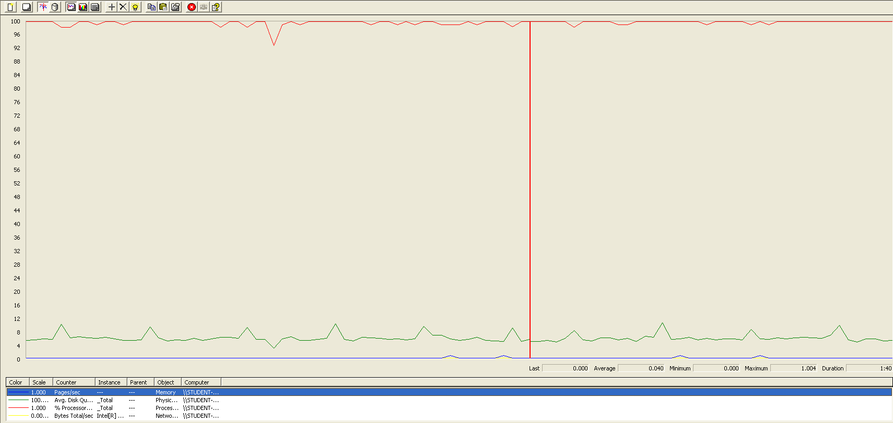

The CPU is always being used while the disk usage is barely noticeable.

## Delete

Sequence:

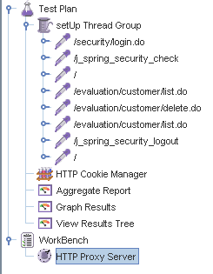

Aggregate Report:





Thread properties:

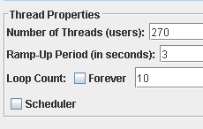

Graph Results:

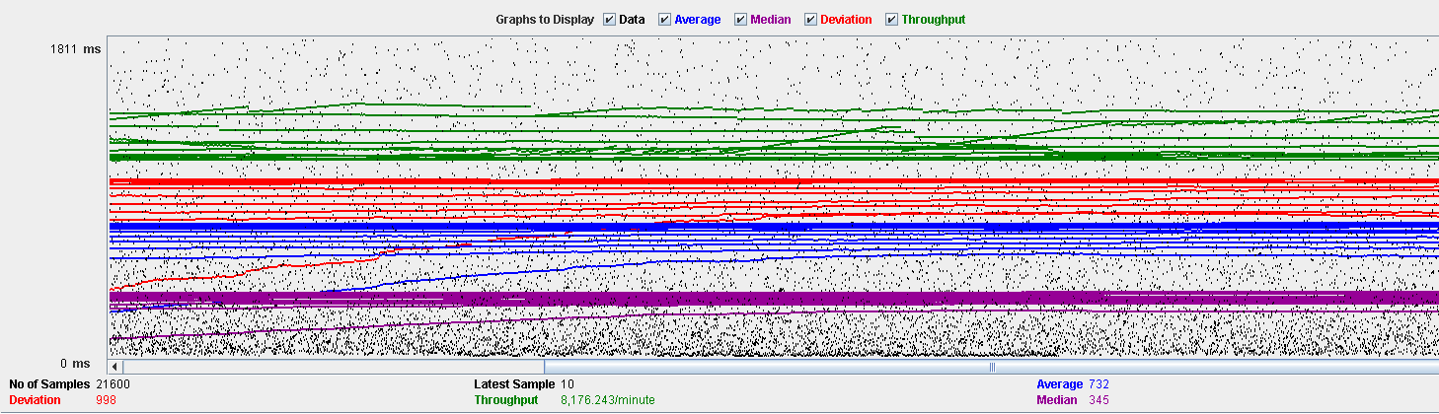

Performance Results:

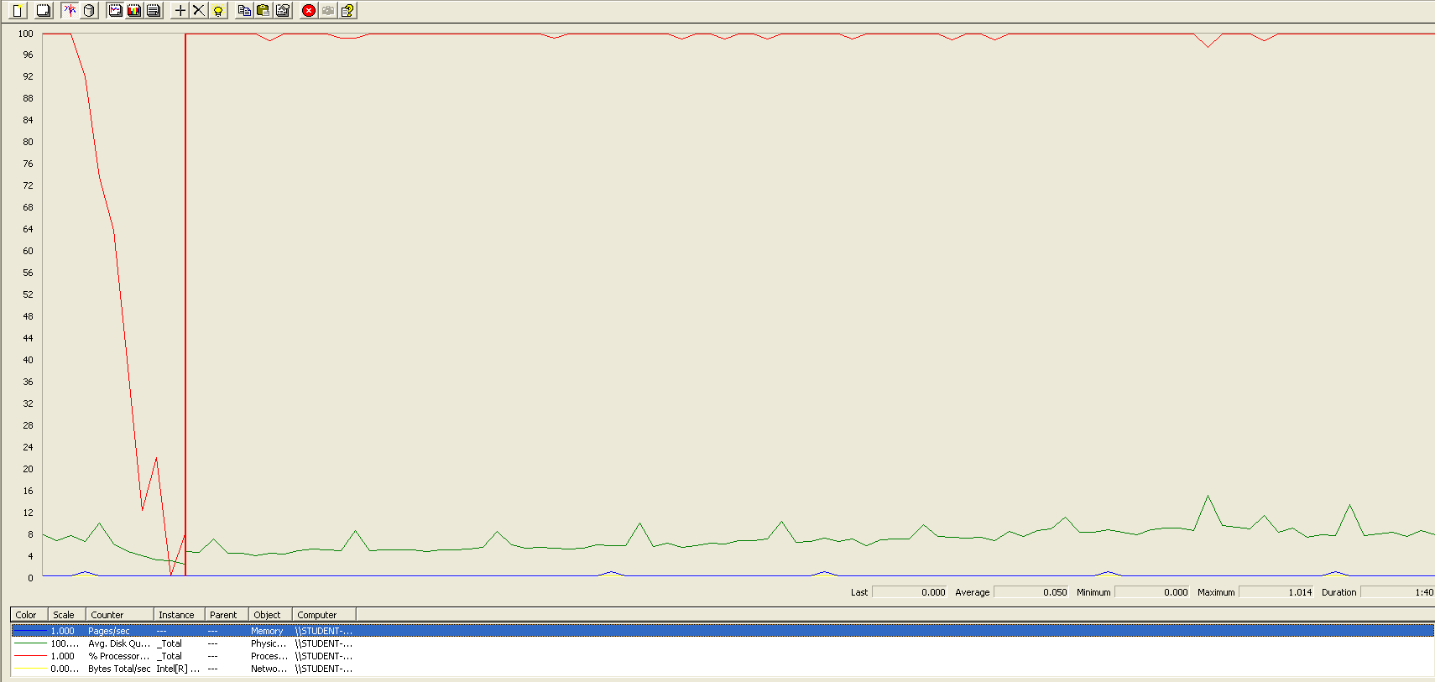

The CPU is always being used while the disk usage is barely noticeable.

## Conclusion

The test was performed using:

CPU: i7 7700hq (2 cores in the virtual machine)

RAM: 4 GB (virtual machine)

For this use case we can say that the limitation occurs during the creation process, being the maximum of concurrent users 250.

# Message

## Send

Sequence:

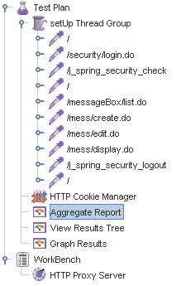

Aggregate Report:

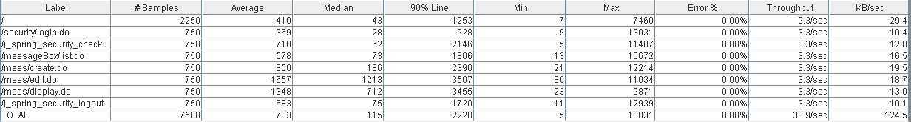

Thread properties:

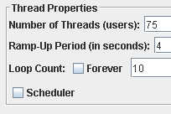

Graph Results:

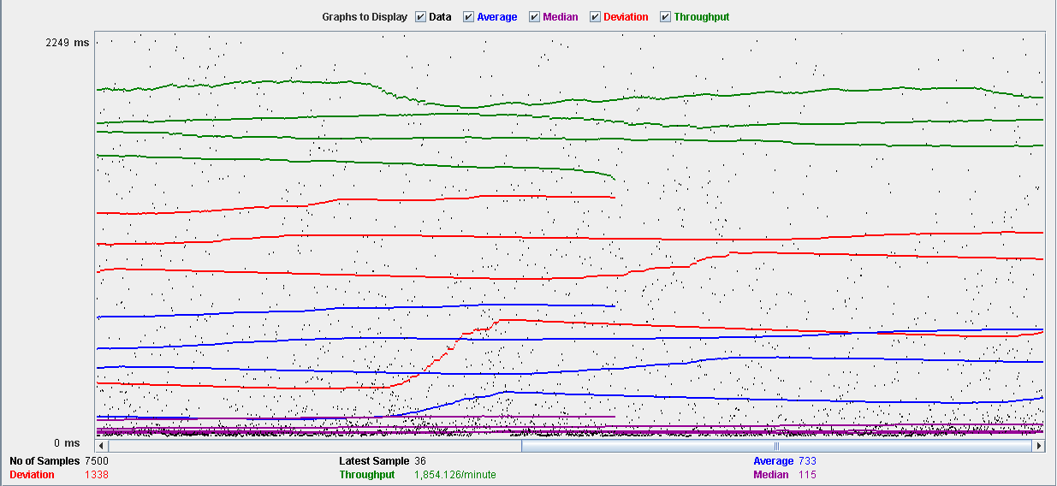

Performance Results:

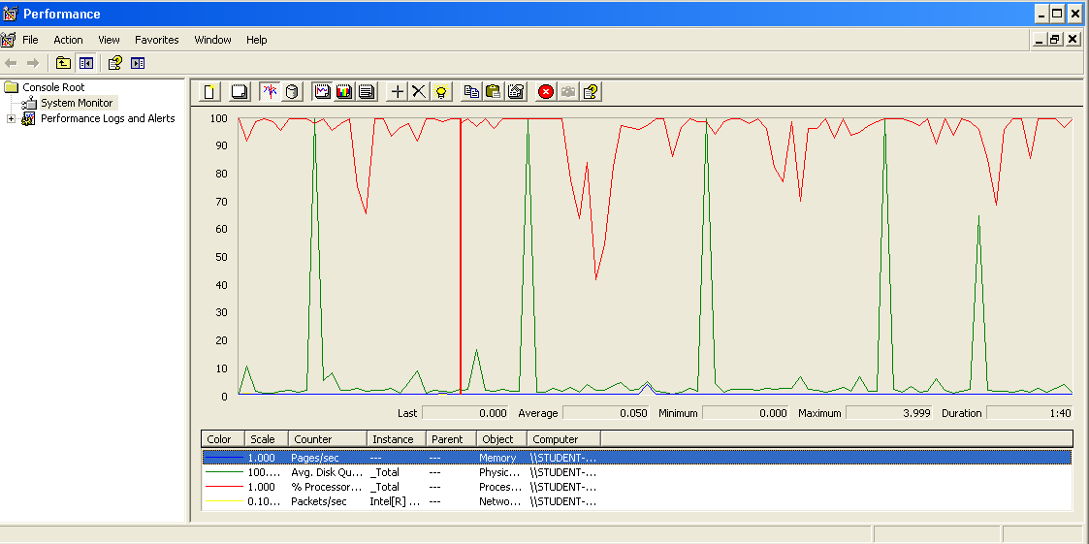

The CPU is always being used and some picks of physical disk.

## Move

Sequence:

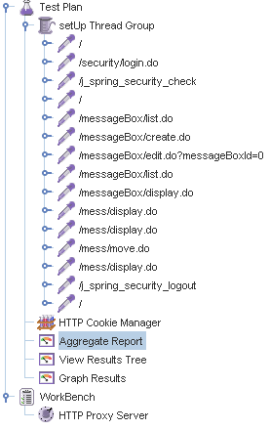

Aggregate Report:

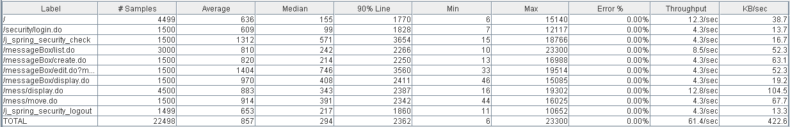

Thread properties:

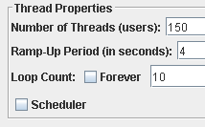

Graph Results:

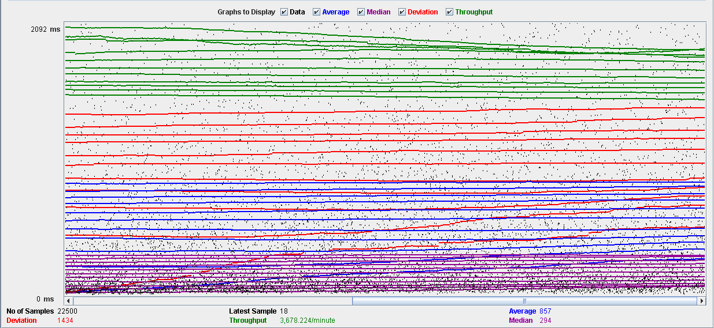

Performance Results:

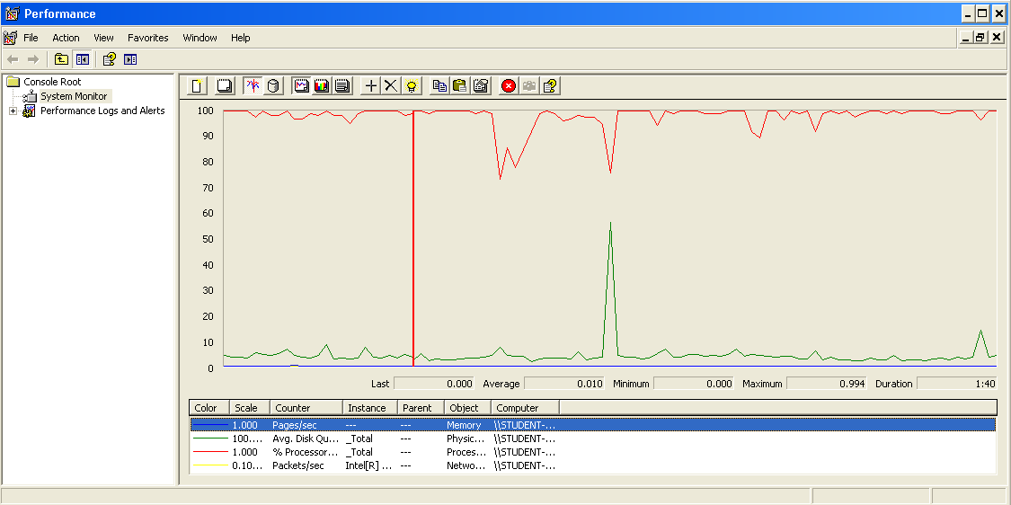

The CPU is always being used and some picks of physical disk.

## Copy

Sequence:

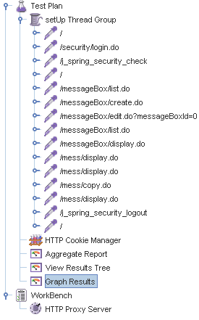

Aggregate Report:

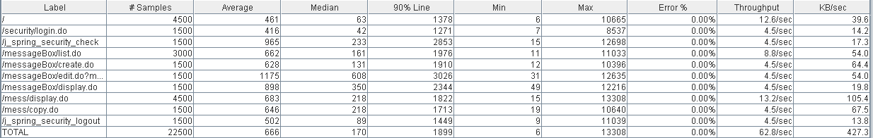

Thread properties:



Graph Results:

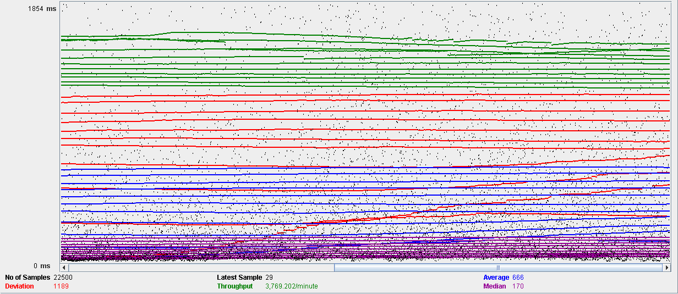

Performance Results:

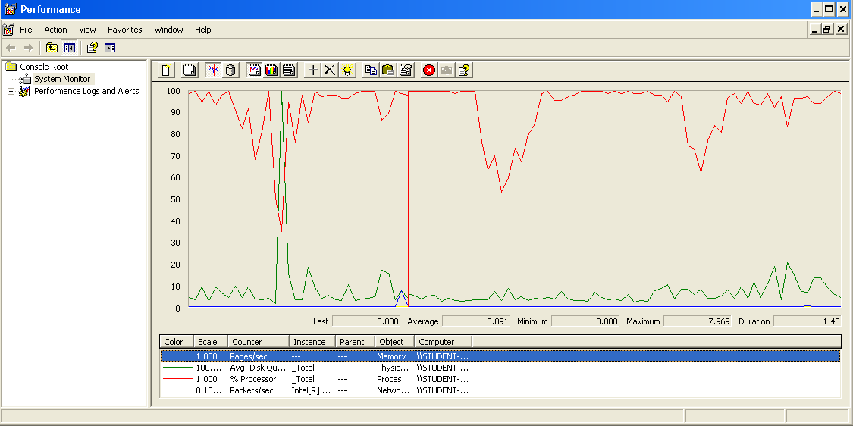

The CPU is always being used and a pick of physical disk.

## Delete

Sequence:

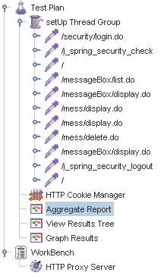

Aggregate Report:

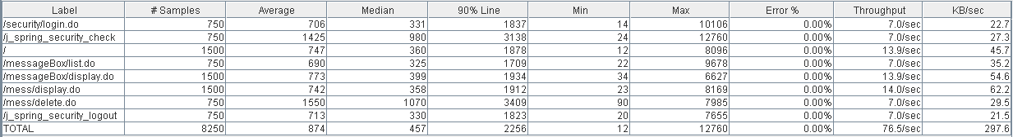

Thread properties:



Graph Results:

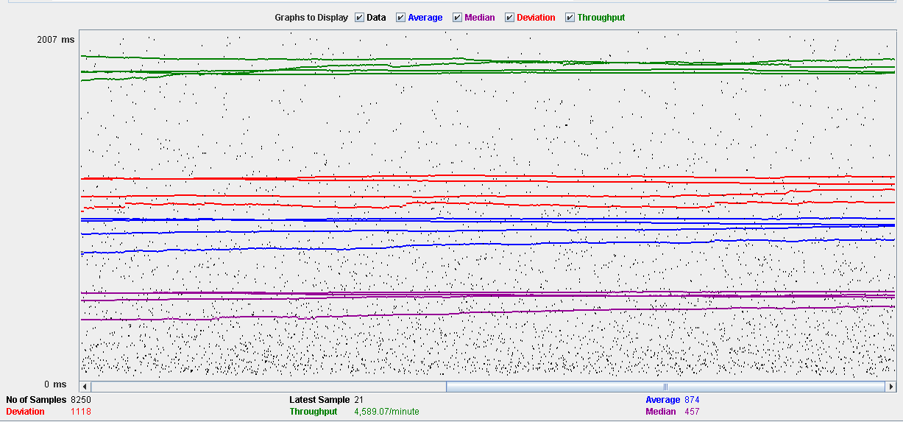

Performance Results:

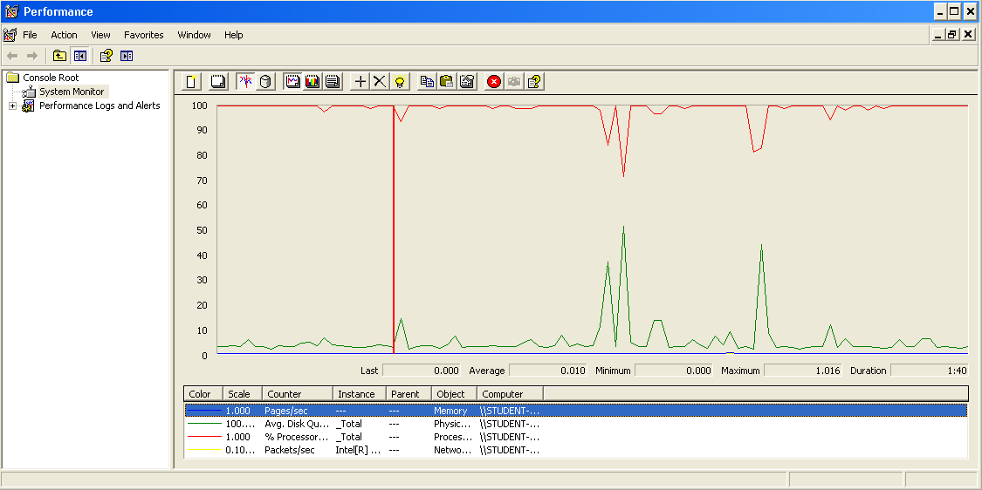

The CPU is always being used while the physical disk has some picks.

## Conclusion

The test was performed using:

CPU: i7 7700hq (2 cores in the virtual machine)

RAM: 2 GB (virtual machine)

For this use case we can say that the limitation occurs during the send and delete process, being the maximum of concurrent users 75.

# Message box

## Create

Sequence:

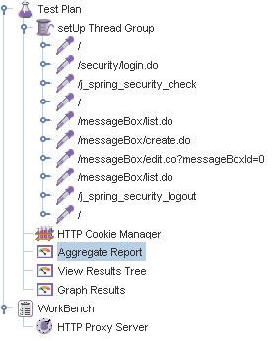

Aggregate Report:

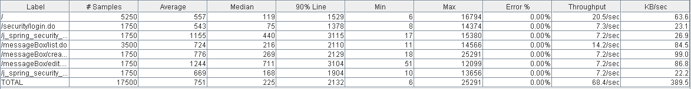

Thread properties:

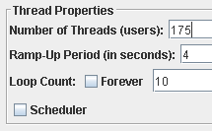

Graph Results:

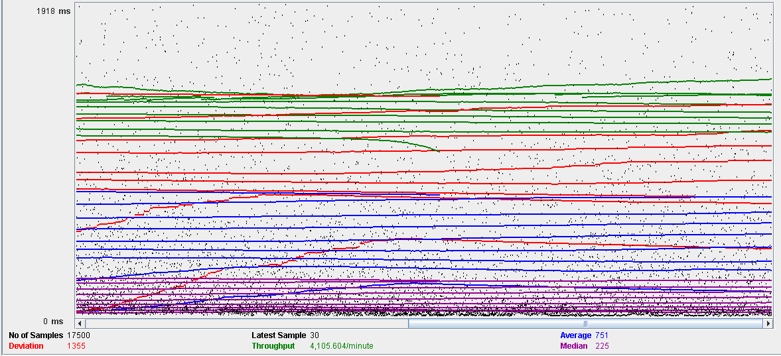

Performance Results:

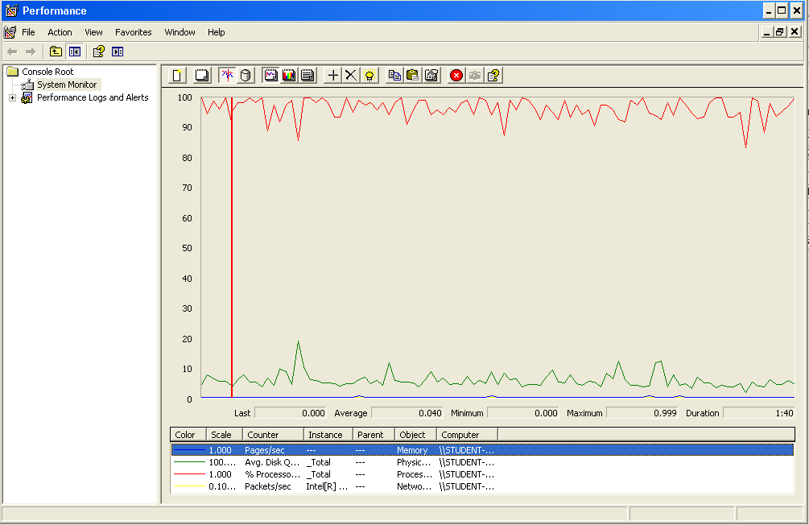

The CPU is always being used and physical disk usage is barely noticeable.

## Edit

Sequence:

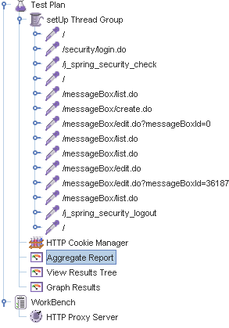

Aggregate Report:

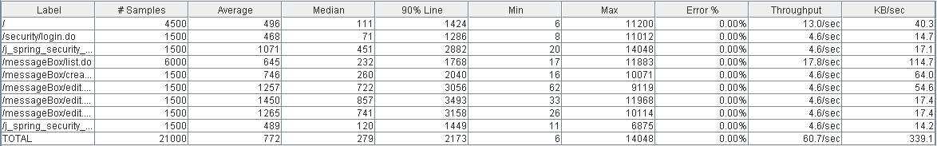

Thread properties:



Graph Results:

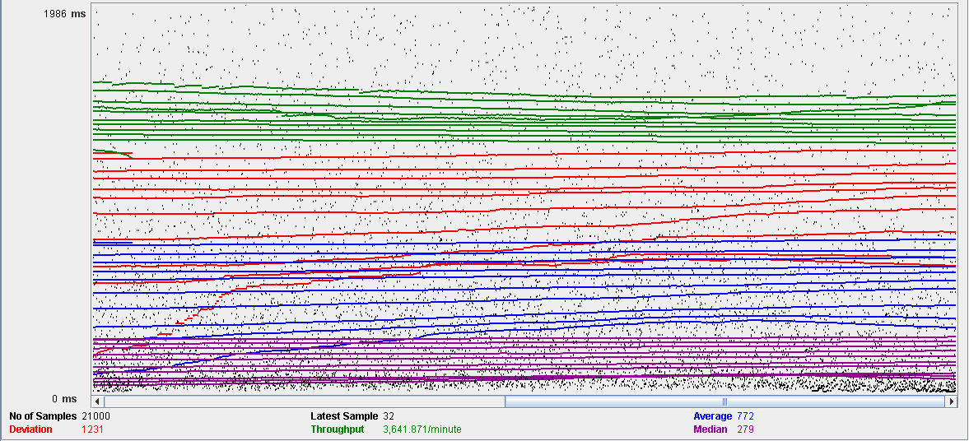

Performance Results:

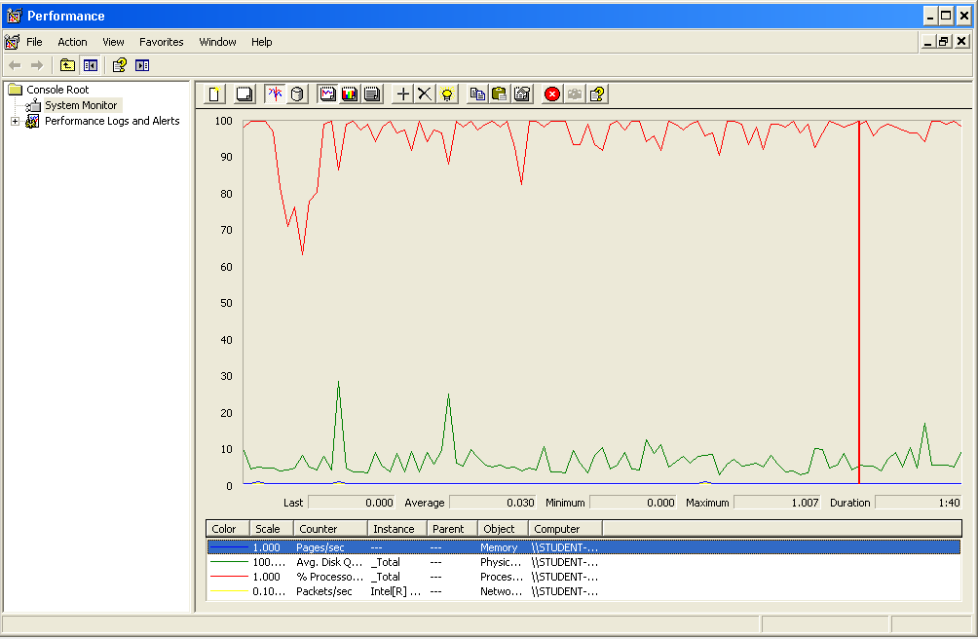

The CPU is always being used and small picks of physical disk

## Delete

Sequence:

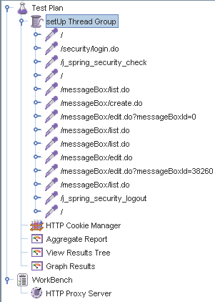

Aggregate Report:

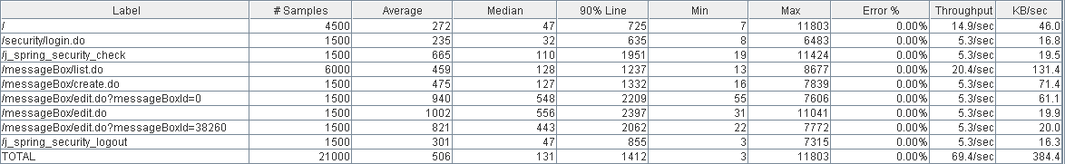

Thread properties:



Graph Results:

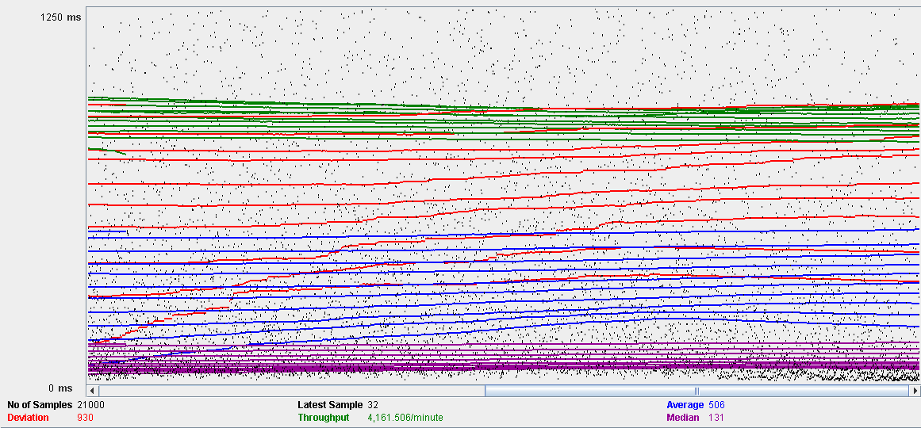

Performance Results:

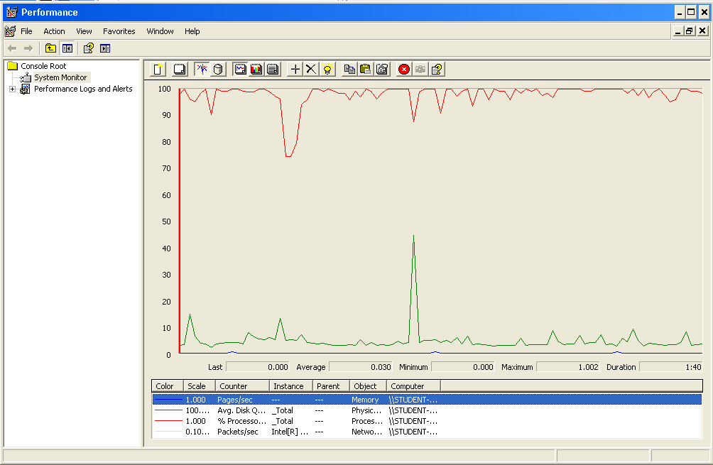

The CPU is always being used while the memory has some picks.

## Conclusion

The test was performed using:

CPU: i7 7700hq (2 cores in the virtual machine)

RAM: 2 GB (virtual machine)

For this use case we can say that the limitation occurs during the edition process, being the maximum of concurrent users 150.

# Social profile

## Create

Sequence:

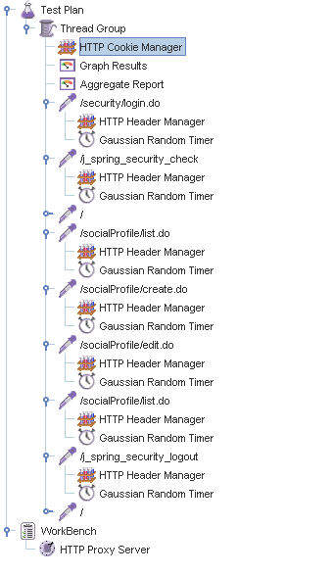

Aggregate Report:

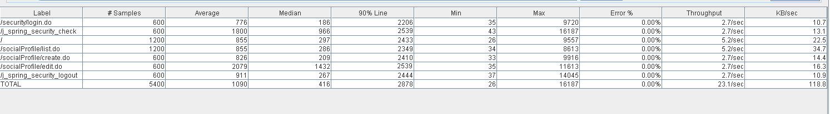

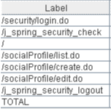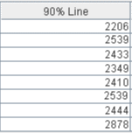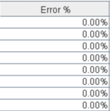

Thread properties:

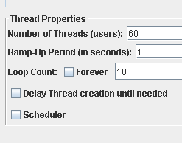

Graph Results:

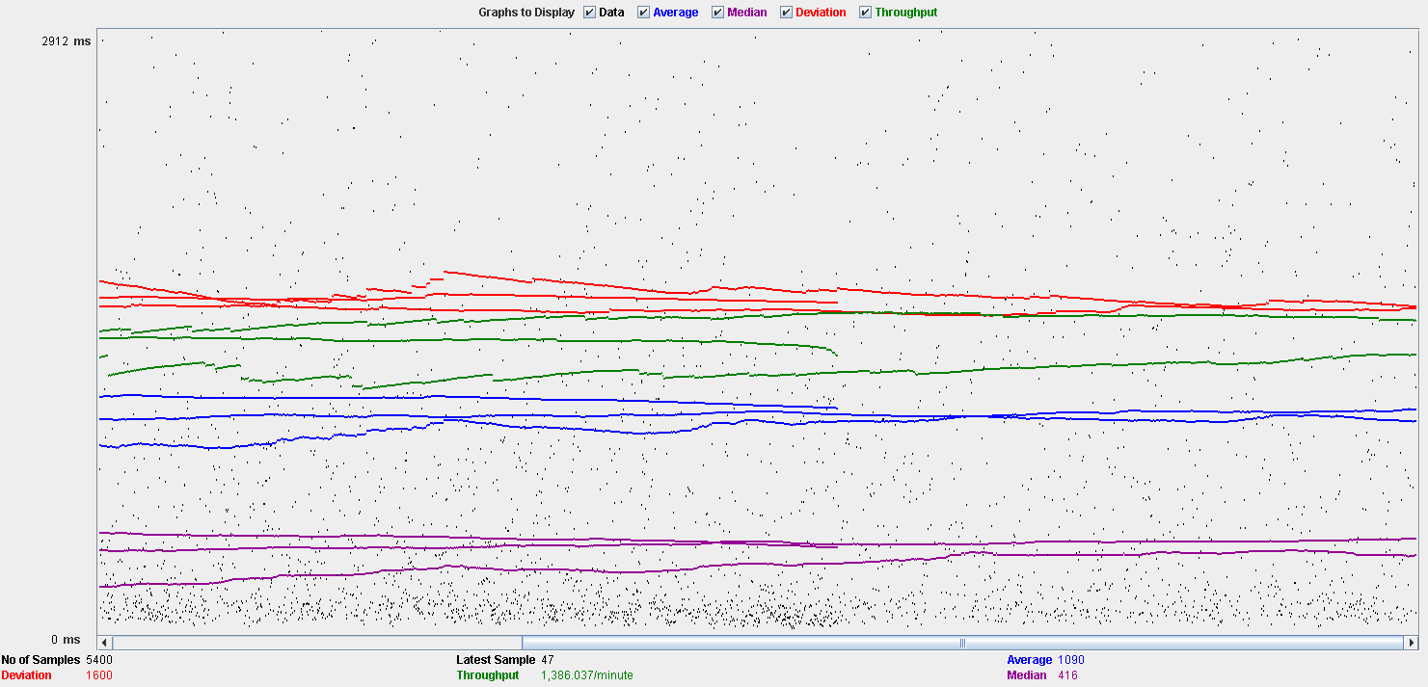

Performance Results:

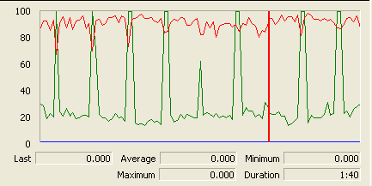

The CPU is always being used while the disk show many peaks.

## Edit

Sequence:

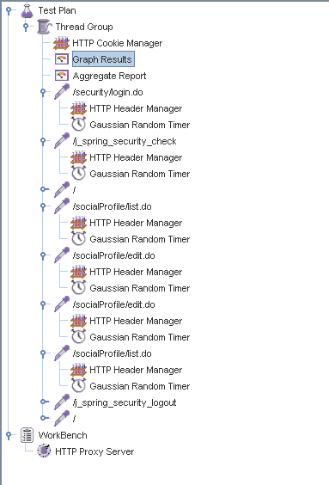

Aggregate Report:

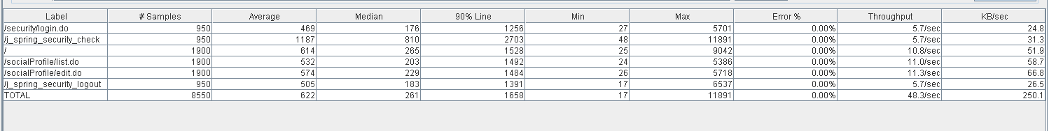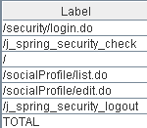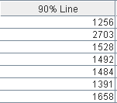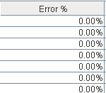

Thread properties:

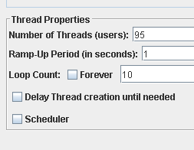

Graph Results:

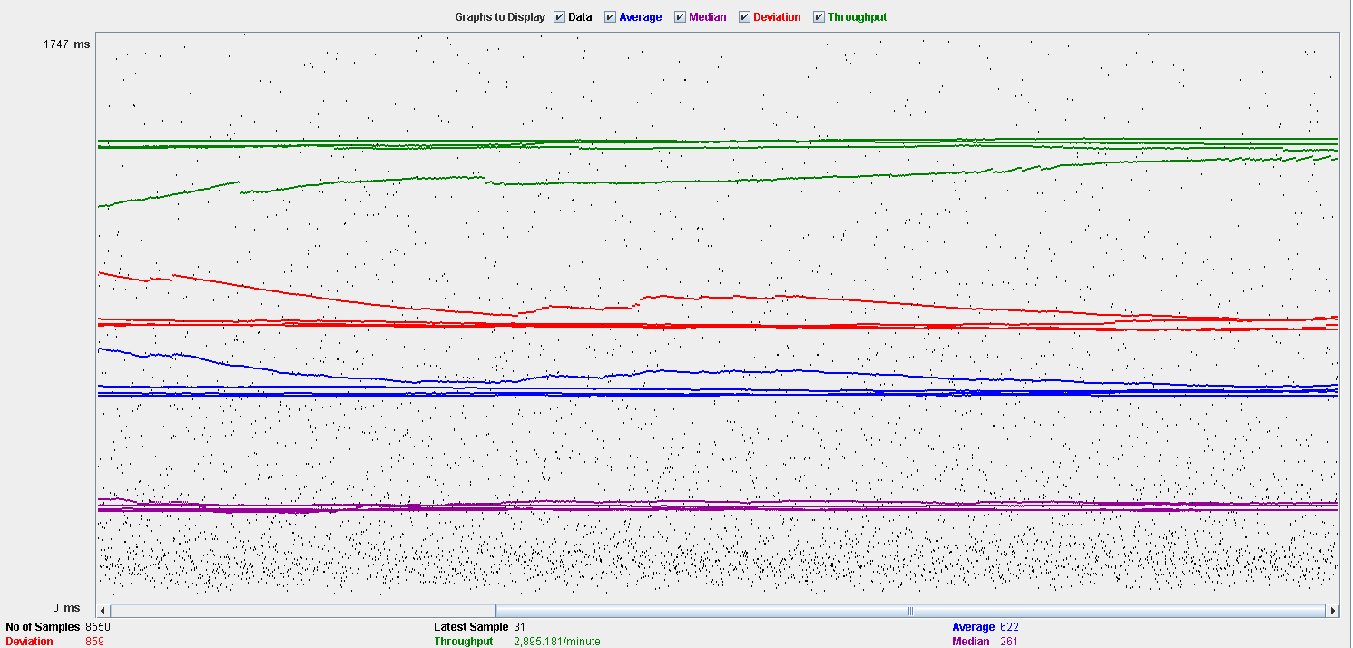

Performance Results:

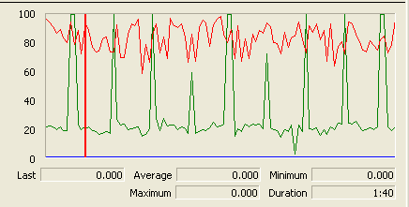

Again we can see that the CPU is always being used while the disk usage shows some periodic peaks.

## Delete

Sequence:

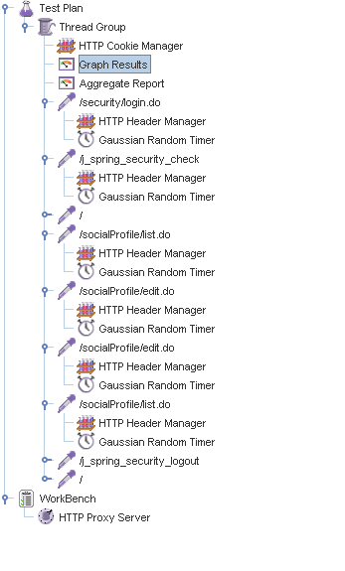

Aggregate Report:

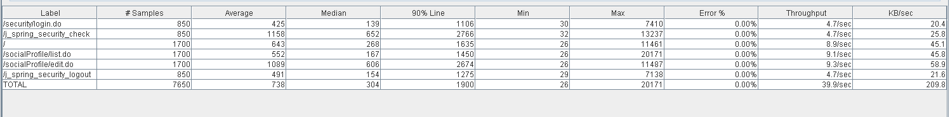

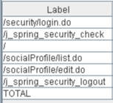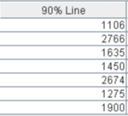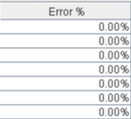

Thread properties:

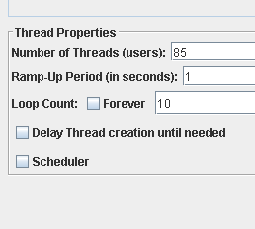.

Graph Results:

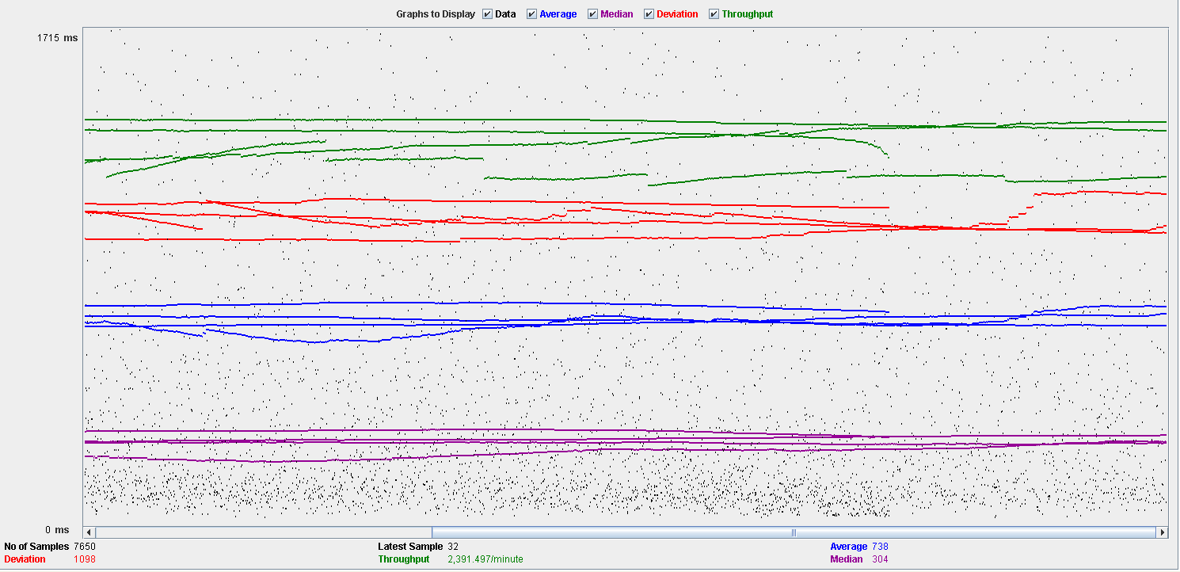

Performance Results:

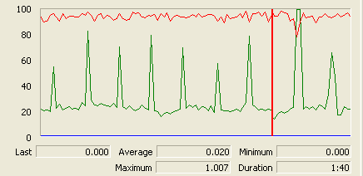

Again we can see that the CPU is always being used while the disk usage shows some peaks.

## Conclusion

The test was performed using:

CPU: i5 2500k (2 cores in the virtual machine)

RAM: 2 GB (virtual machine)

For this use case we can say that the limitation occurs during the creation process, being the maximum of concurrent users 60.

# Dashboard

## Show dashboard and launch all process

Sequence:

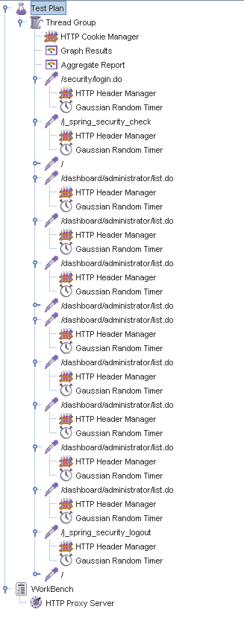

Aggregate Report:

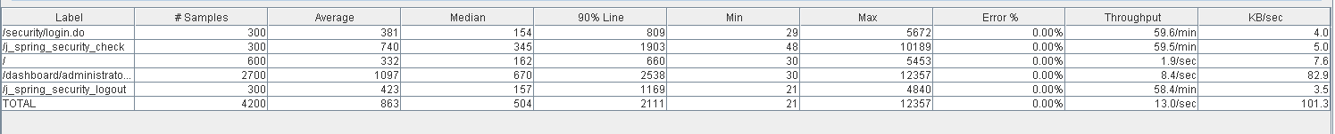

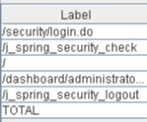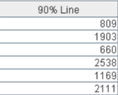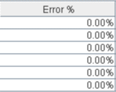

Thread properties:

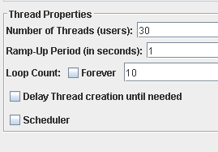

Graph Results:

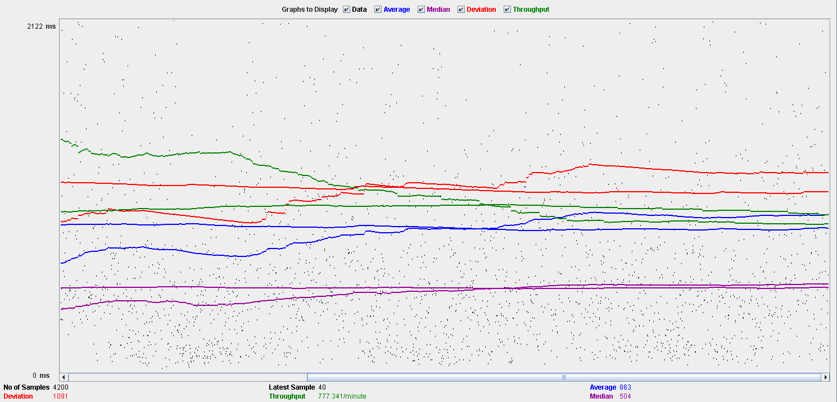

Performance Results:

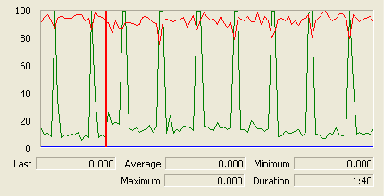

The CPU is always being used while the disk show some peaks.

## Conclusion

The test was performed using:

CPU: i5 2500k (2 cores in the virtual machine)

RAM: 2 GB (virtual machine)

For this use case we can say that the limitation around 30 users.

# Category

## Create

Sequence:

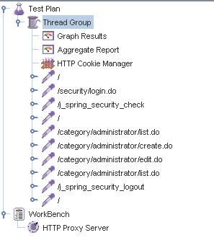

Aggregate Report:

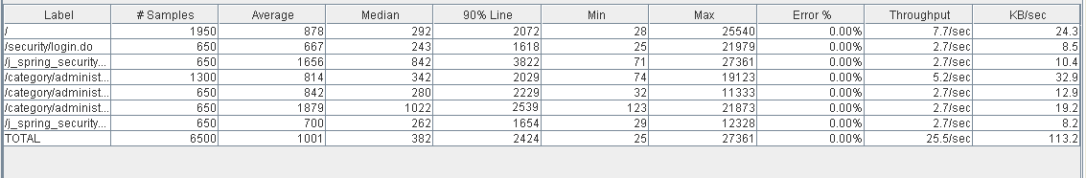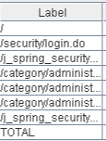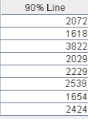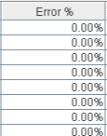

Thread properties:

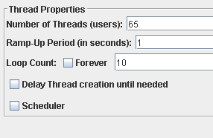

Graph Results:

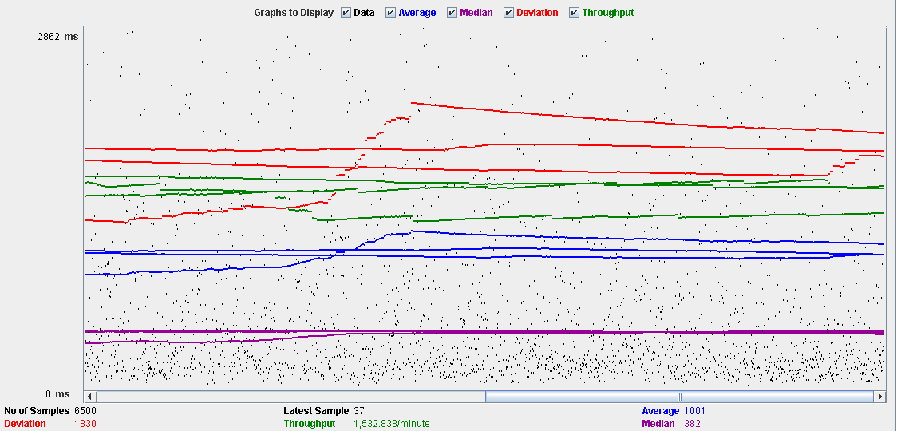

Performance Results:

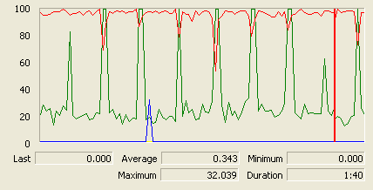

The CPU is always being used and disk show some peaks.

## Edit

Sequence:

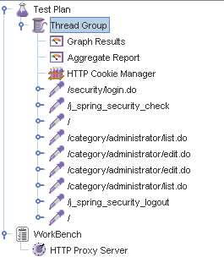

Aggregate Report:

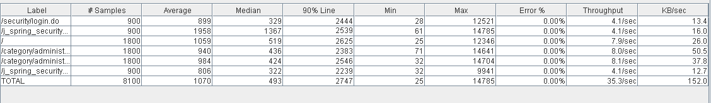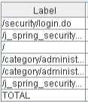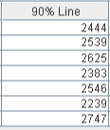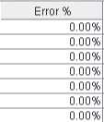

Thread properties:

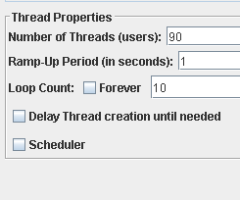

Graph Results:

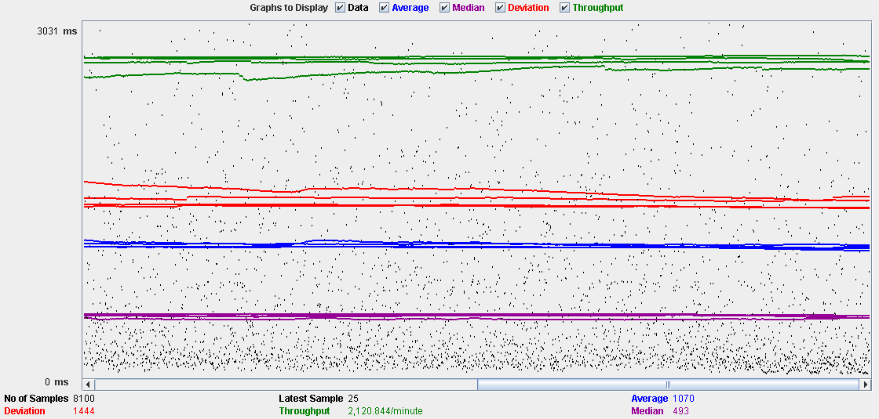

Performance Results:

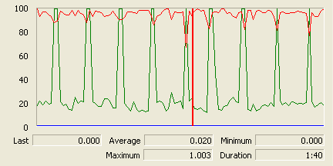

The CPU is always being used and the disk show som peaks.

## Delete

Sequence:

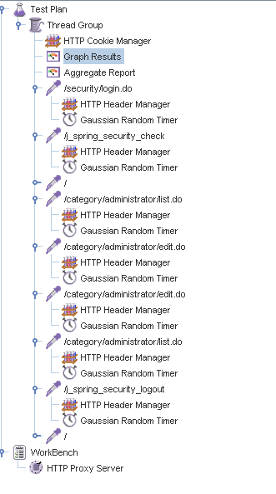

Aggregate Report:

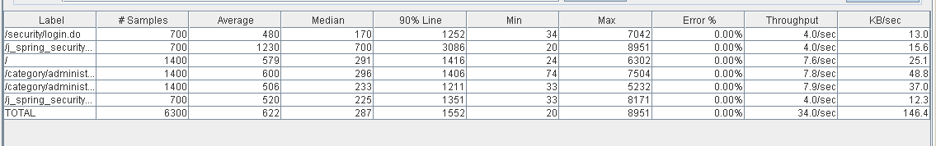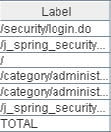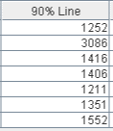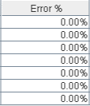

Thread properties:

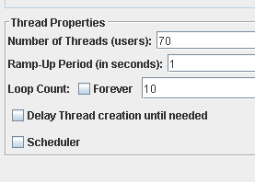

Graph Results:

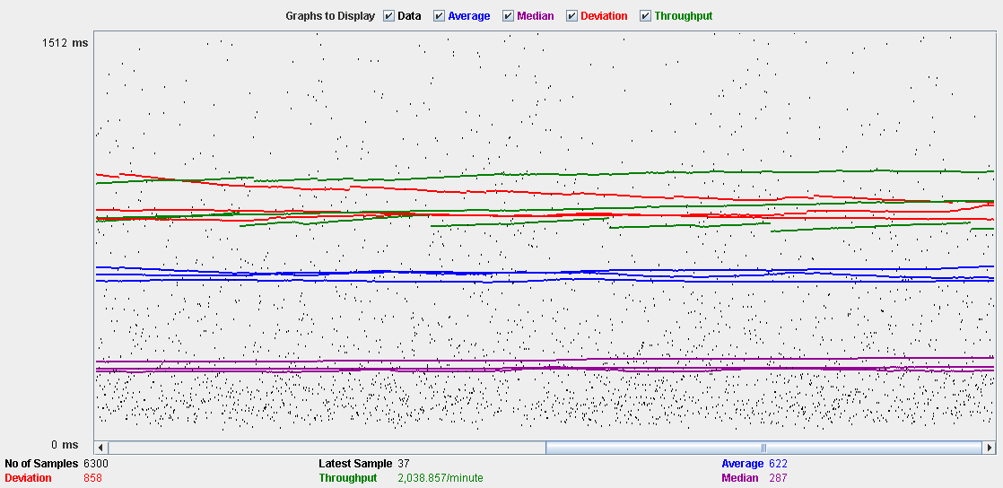

Performance Results:

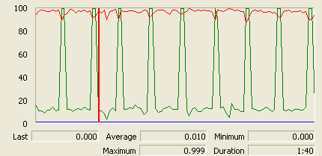

The CPU is always being used and disk show some peaks.

## Conclusion

The test was performed using:

CPU: i5 2500k (2 cores in the virtual machine)

RAM: 2 GB (virtual machine)

For this use case we can say that the limitation occurs during the create process, being the maximum of concurrent users 65.

# Request

## Create

Sequence:

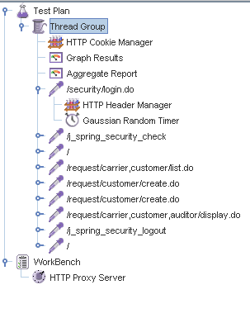

Aggregate Report:

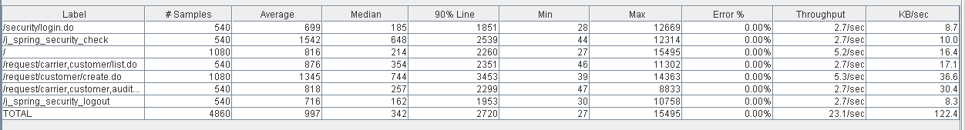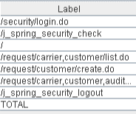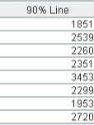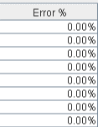

Thread properties:

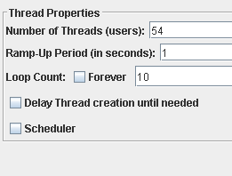

Graph Results:

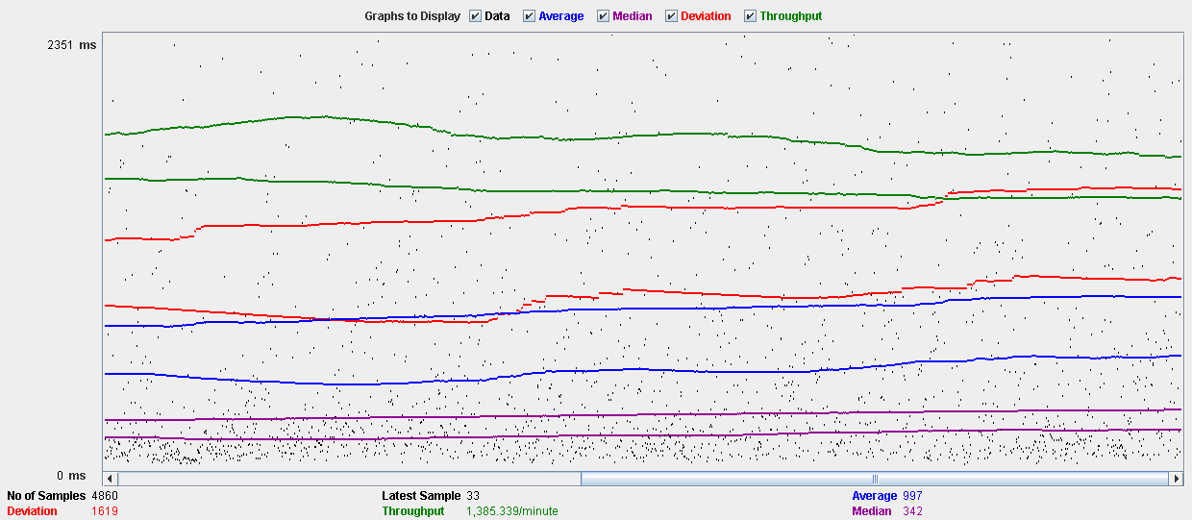

Performance Results:

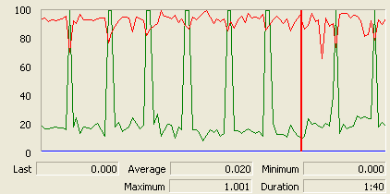

The CPU is always being used and physical disk show some peaks.

## Edit

Sequence:

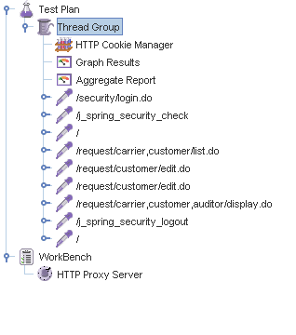

Aggregate Report:

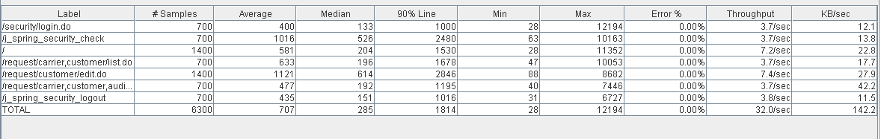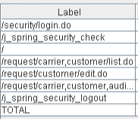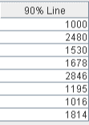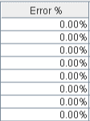

Thread properties:

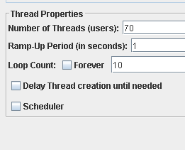

Graph Results:

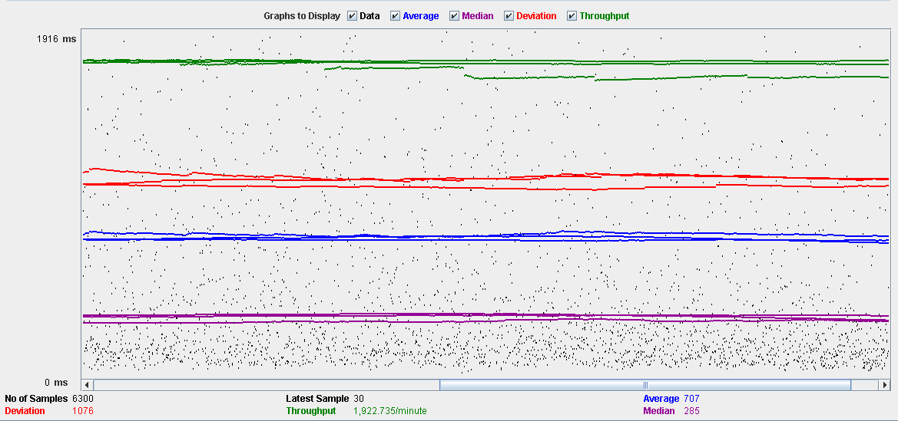

Performance Results:

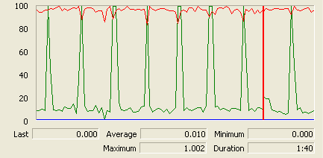

The CPU is always being used and disk show some peaks.

## Delete

Sequence:

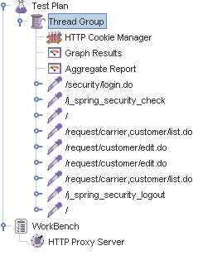

Aggregate Report:

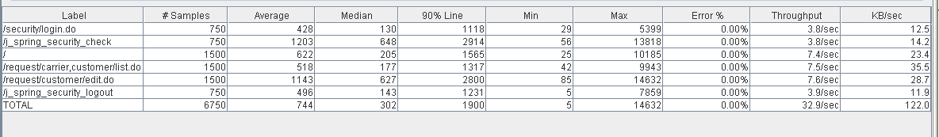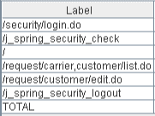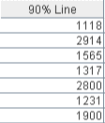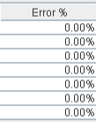

Thread properties:

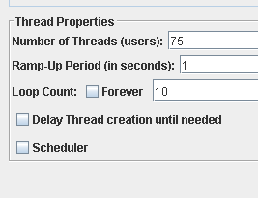

Graph Results:

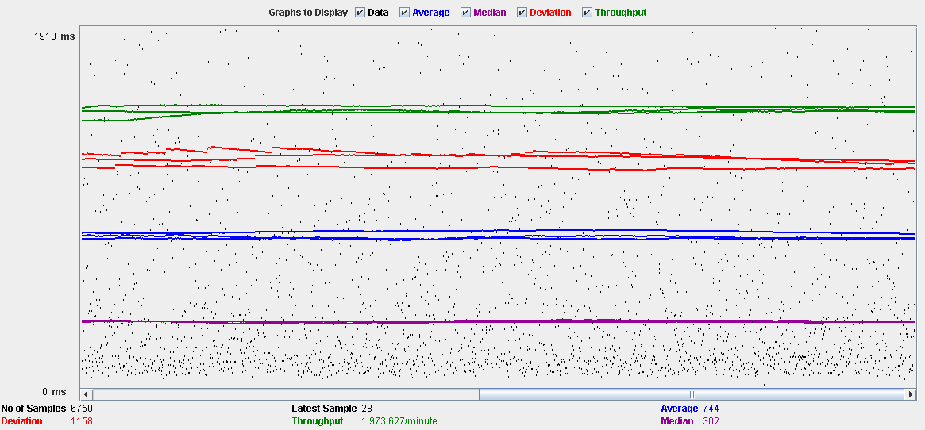

Performance Results:

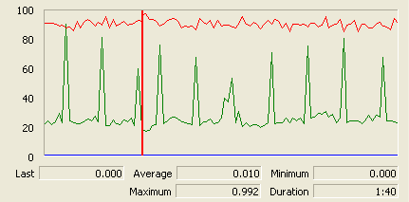

The CPU is always being used while the memory has some peaks.

## Conclusion

The test was performed using:

CPU: i5 2500kk (2 cores in the virtual machine)

RAM: 2 GB (virtual machine)

For this use case we can say that the limitation occurs during the creation process, being the maximum of concurrent users 54.

# TraverseTown

## Create

Sequence:

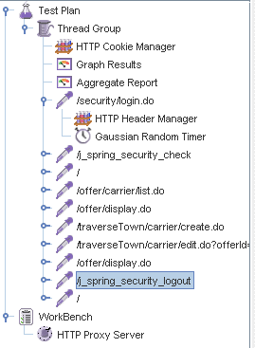

Aggregate Report:

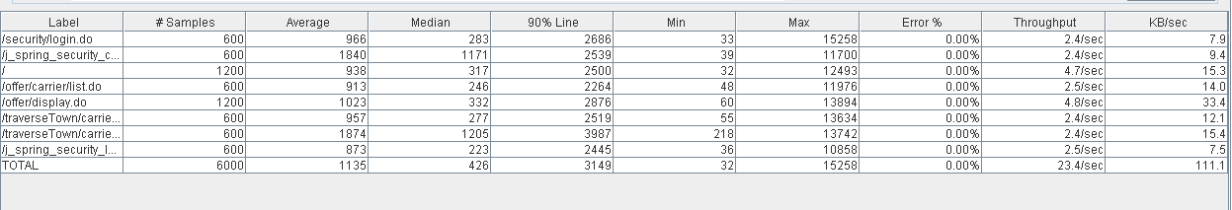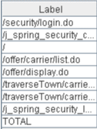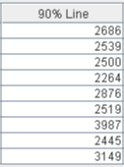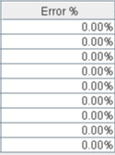

Thread properties:

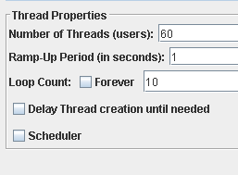

Graph Results:

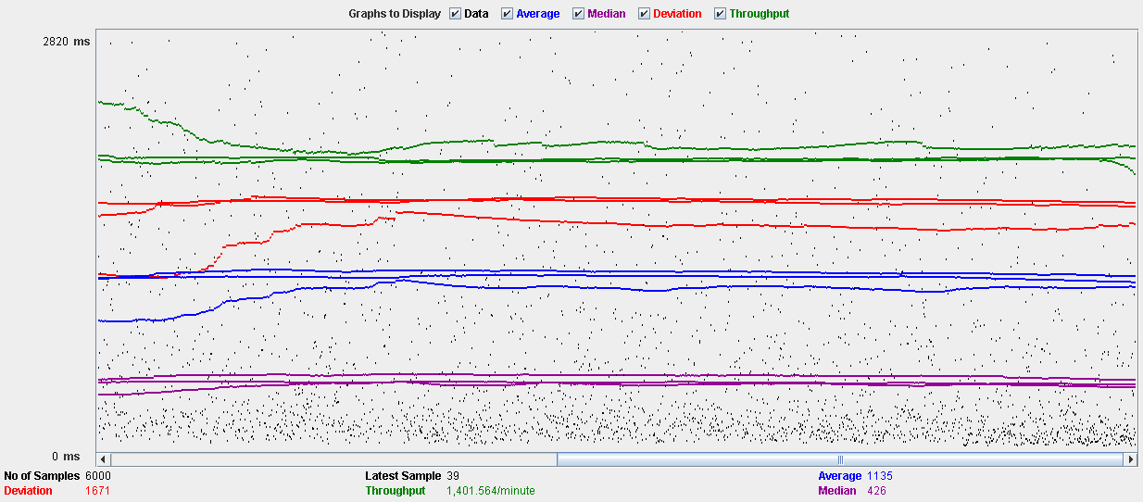

Performance Results:

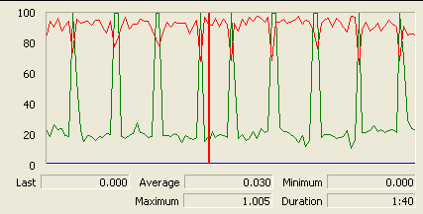

The CPU is always being used and physical disk show some peaks.

## Edit

Sequence:

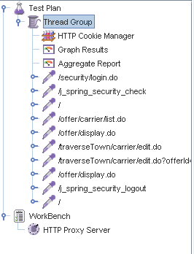

Aggregate Report:

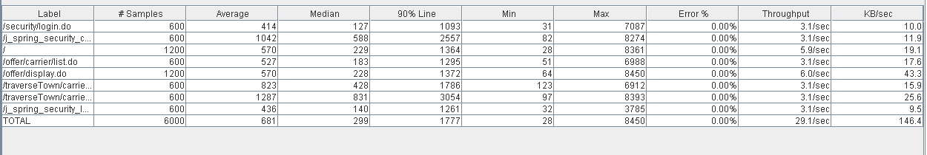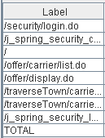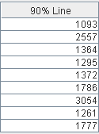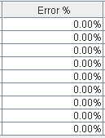

Thread properties:

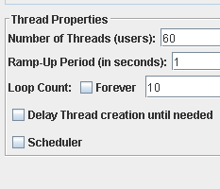

Graph Results:

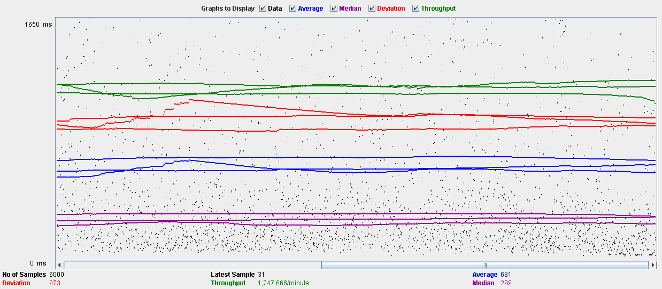

Performance Results:

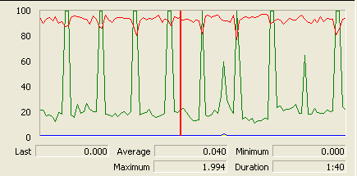

The CPU is always being used and disk show some peaks

## Delete

Sequence:

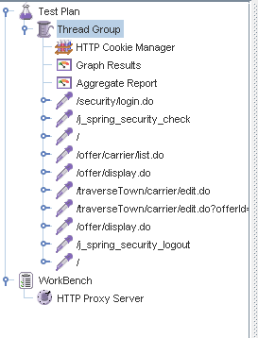

Aggregate Report:

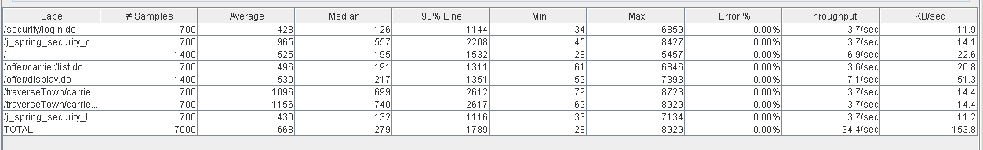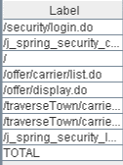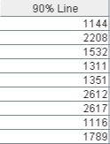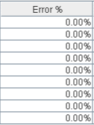

Thread properties:

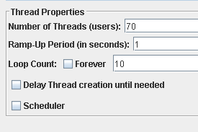

Graph Results:

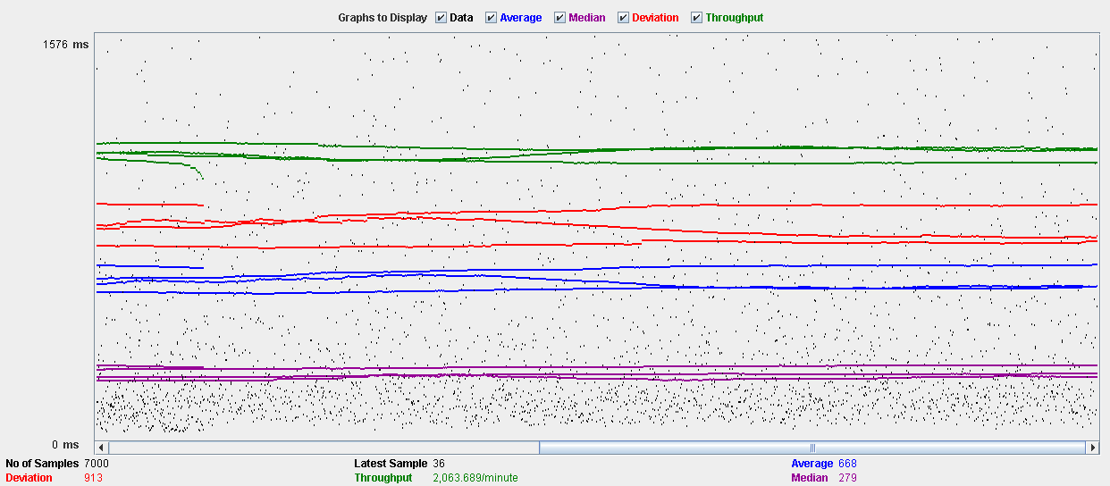

Performance Results:

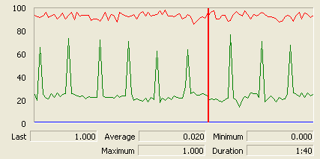

The CPU is always being used while the memory has some peaks.

## Conclusion

The test was performed using:

CPU: i5 2500k (2 cores in the virtual machine)

RAM: 2 GB (virtual machine)

For this use case we can say that the limitation occurs during the creation and edition process, being the maximum of concurrent users 60.

# Issue

## Create

Sequence:

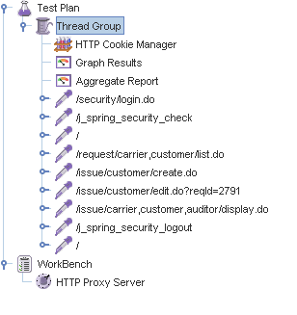

Aggregate Report:

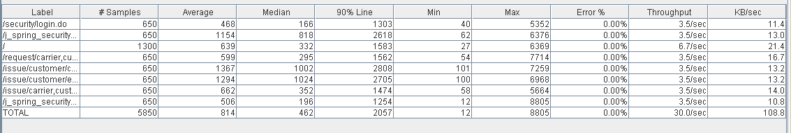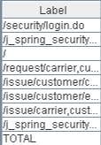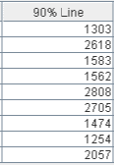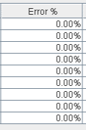

Thread properties:

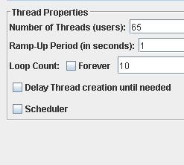

Graph Results:

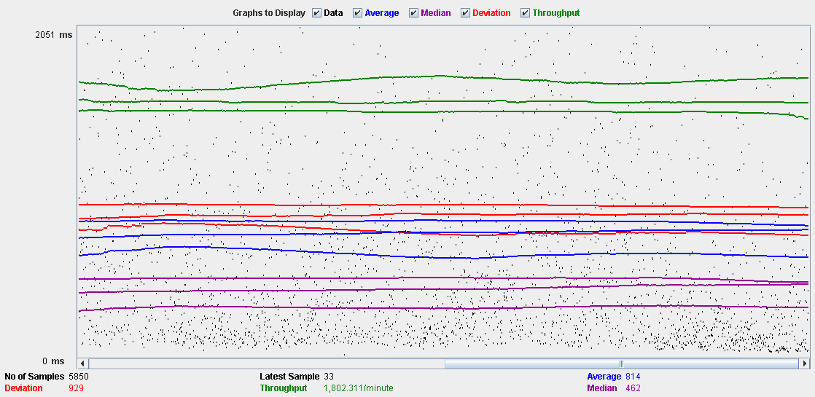

Performance Results:

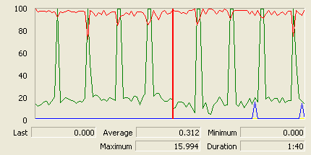

The CPU is always being used and physical disk usage show some peaks.

## Delete

Sequence:

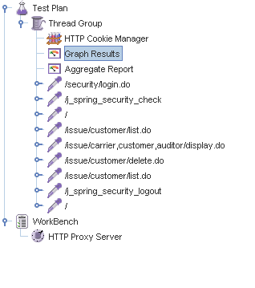

Aggregate Report:

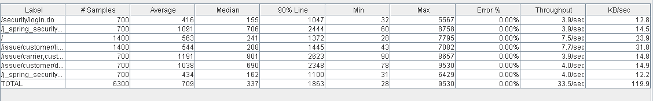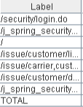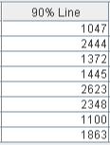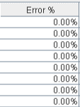

Thread properties:

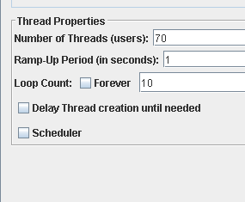

Graph Results:

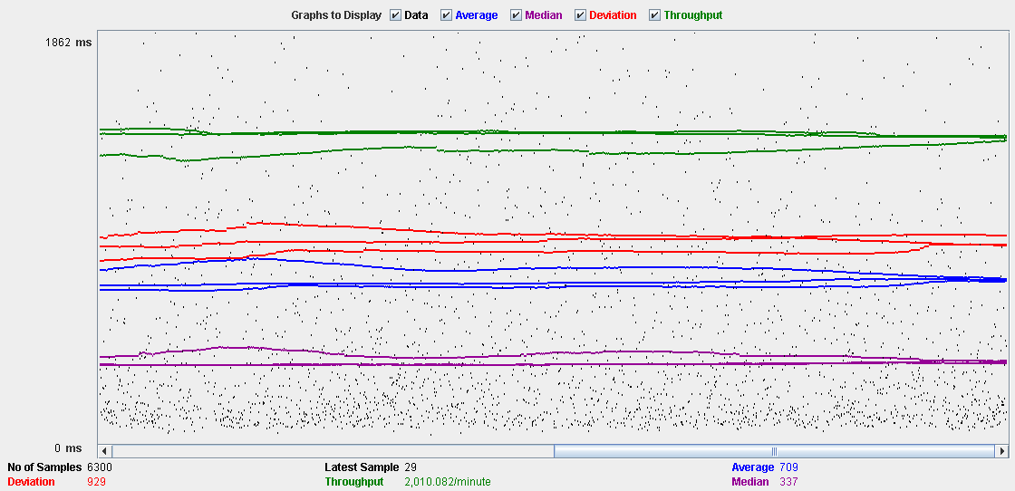

Performance Results:

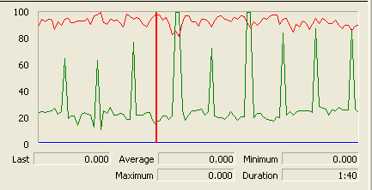

The CPU is always being used and disk show some peaks-

## Conclusion

The test was performed using:

CPU: i5 2500k (2 cores in the virtual machine)

RAM: 2 GB (virtual machine)

For this use case we can say that the limitation occurs during the create process, being the maximum of concurrent users 65.

# Town

## Create

Sequence:

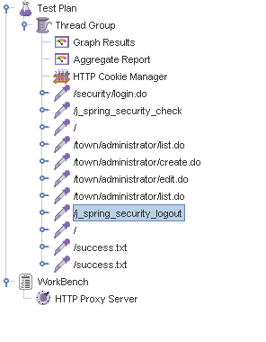

Aggregate Report:

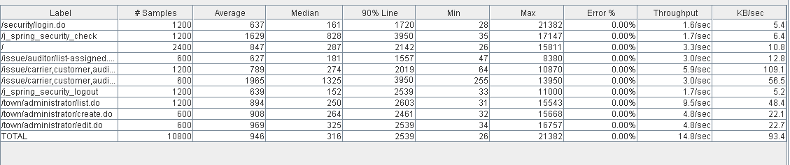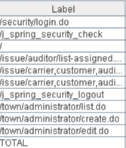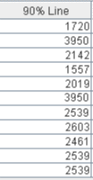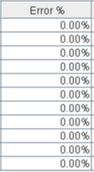

Thread properties:

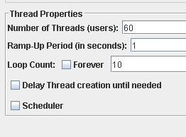

Graph Results:

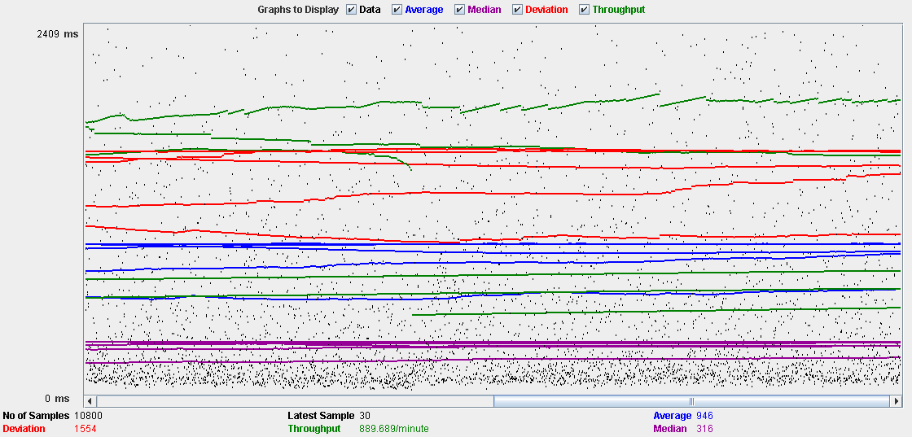

Performance Results:

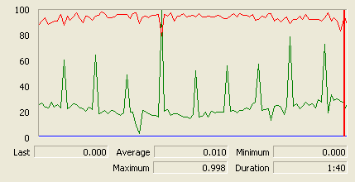

The CPU is always being used and physical disk usage show some peaks.

## Edit

Sequence:

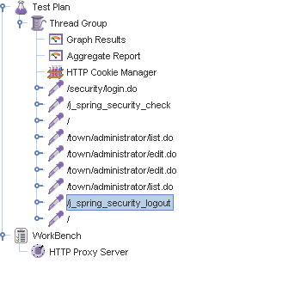

Aggregate Report:

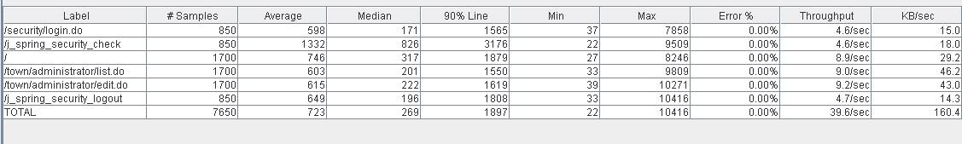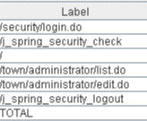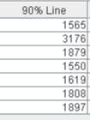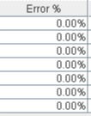

Thread properties:

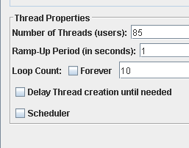

Graph Results:

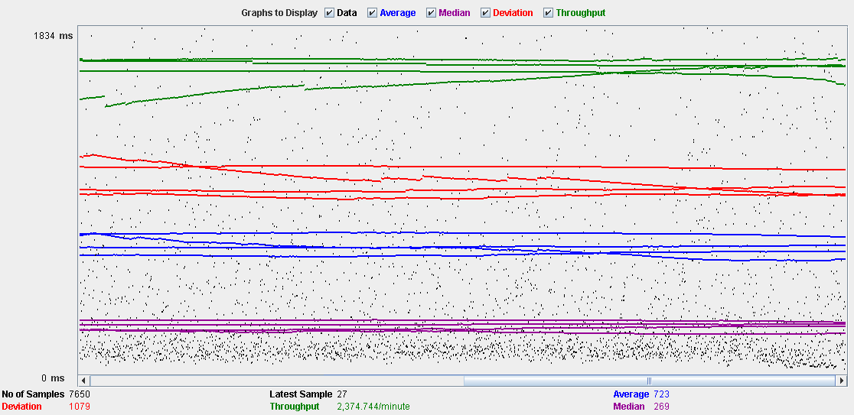

Performance Results:

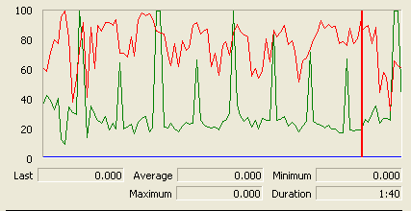

The CPU is always being used and small picks of physical disk

## Delete

Sequence:

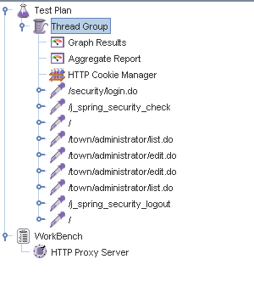

Aggregate Report:

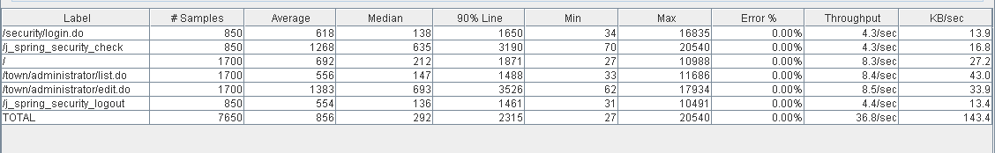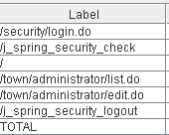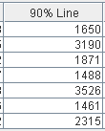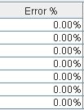

Thread properties:

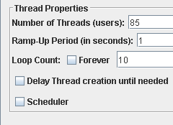

Graph Results:

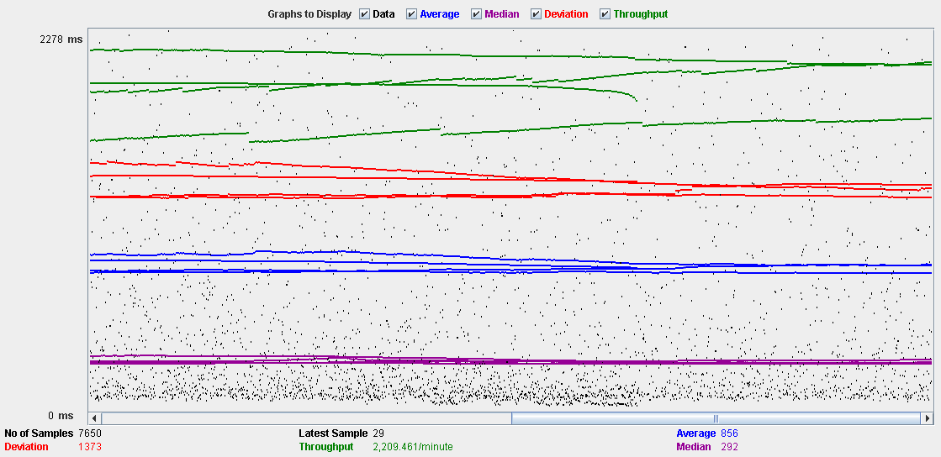

Performance Results:

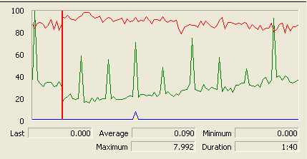

The CPU is always being used while the memory has some peaks.

## Conclusion

The test was performed using:

CPU: i5 2500k (2 cores in the virtual machine)

RAM: 2 GB (virtual machine)

For this use case we can say that the limitation occurs during the create process, being the maximum of concurrent users 60.

# Comment

## Create

Sequence:

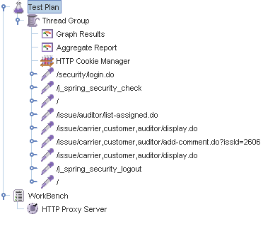

Aggregate Report:

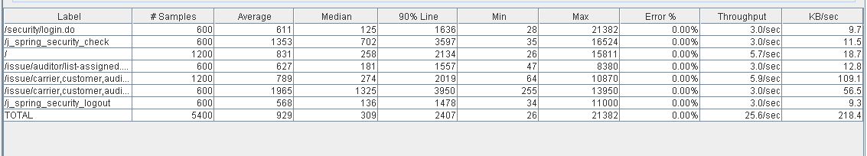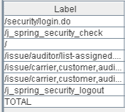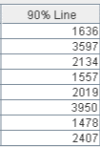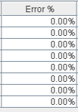

Thread properties:

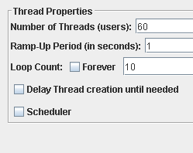

Graph Results:

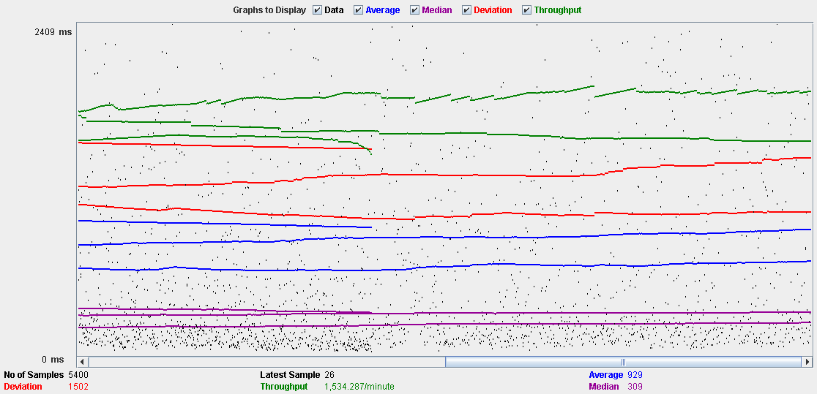

Performance Results:

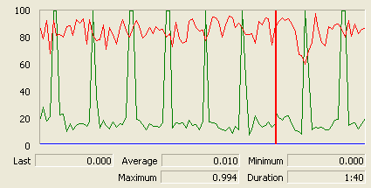

The CPU is always being used and physical disk usage is barely noticeable.

## Conclusion

The test was performed using:

CPU: i5 2500k (2 cores in the virtual machine)

RAM: 2 GB (virtual machine)

For this use case we can say that the limitation occurs with 60 users.

# Configuration

## Display and edit

Sequence:

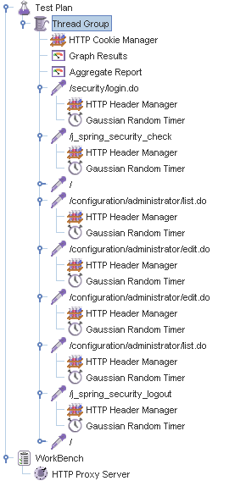

Aggregate Report:

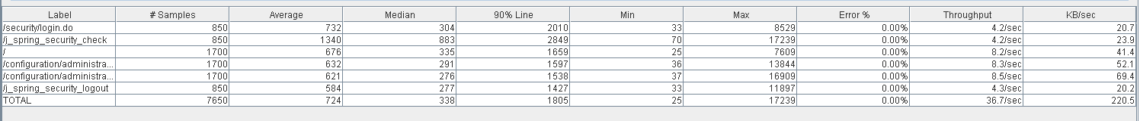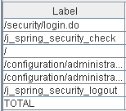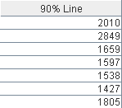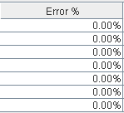

Thread properties:

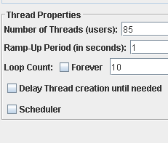

Graph Results:

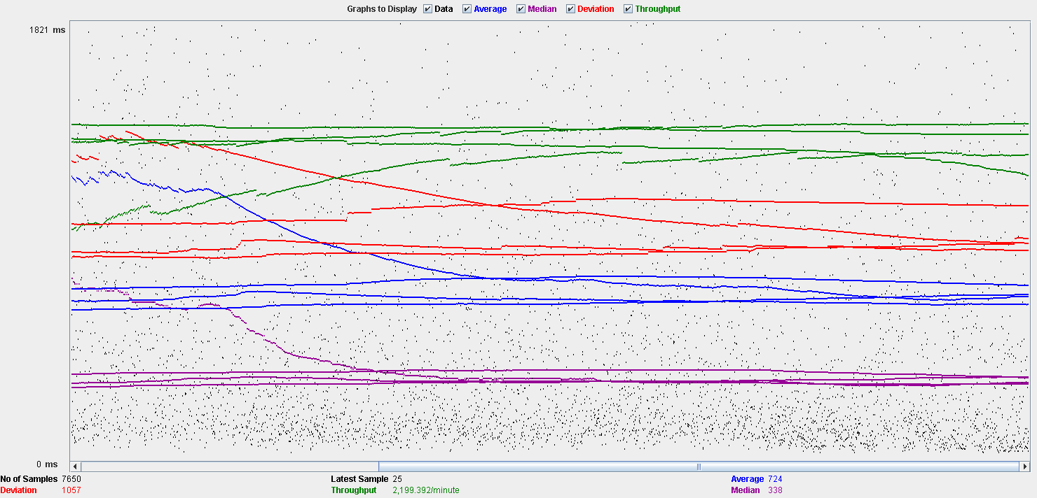

Performance Results:

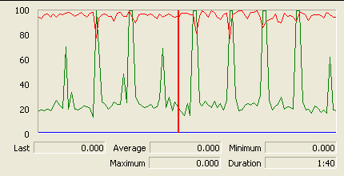

The CPU is always being used and physical disk usage show some peaks.

## Conclusion

The test was performed using:

CPU: i5 2500k (2 cores in the virtual machine)

RAM: 2 GB (virtual machine)

For this use case we can say that the limitation occurs during the edition process, being the maximum of concurrent users 85.

# Finder

## Search

Sequence:

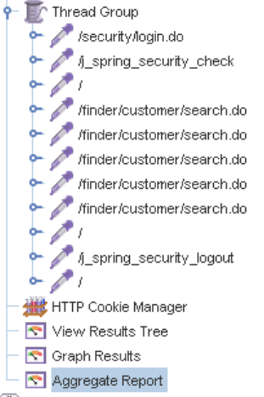

Aggregate Report:

 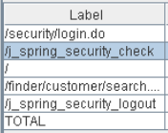 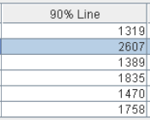 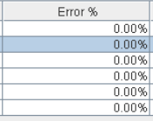

Thread properties:

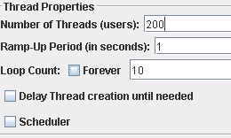

Graph Results:

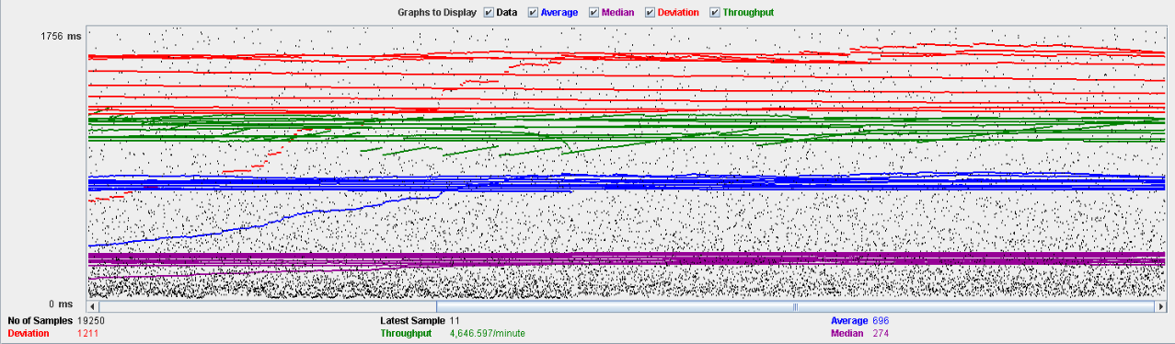

Performance Results:

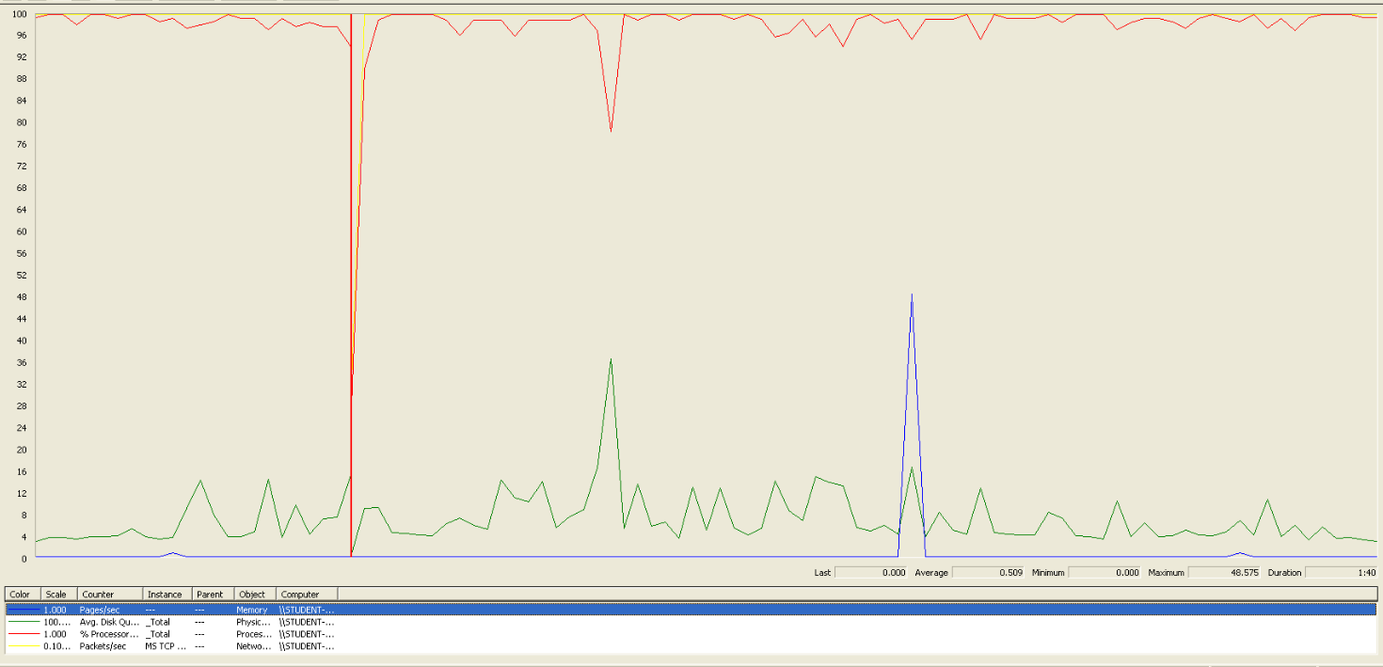

We can clearly see that the bottleneck is the CPU.

## Conclusion

The test was performed using:

CPU: i5 7300HQ (2 cores in the virtual machine)

RAM: 2 GB (virtual machine)

For this use case we can say that the maximum of concurrent users is about 200.

# Offer

## Create/Edit

Sequence:

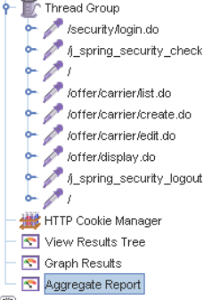

Aggregate Report:

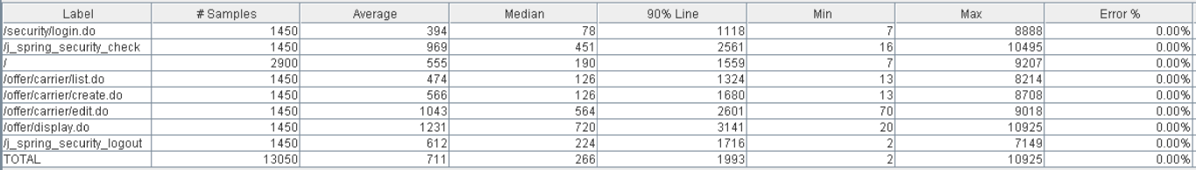 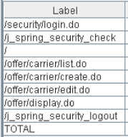 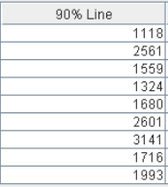 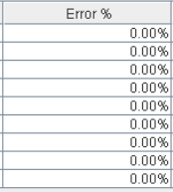

Thread properties:

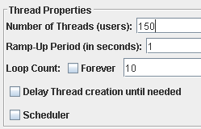

Graph Results:

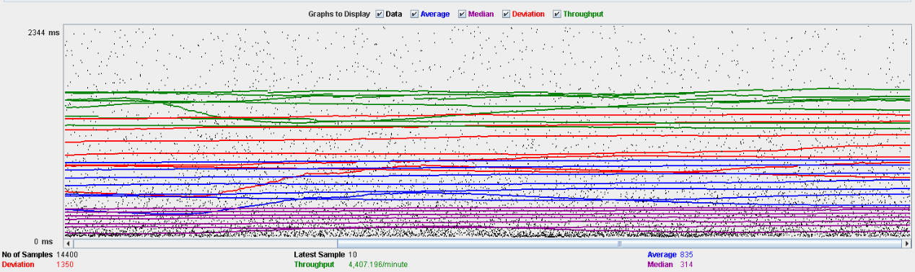

Performance Results:

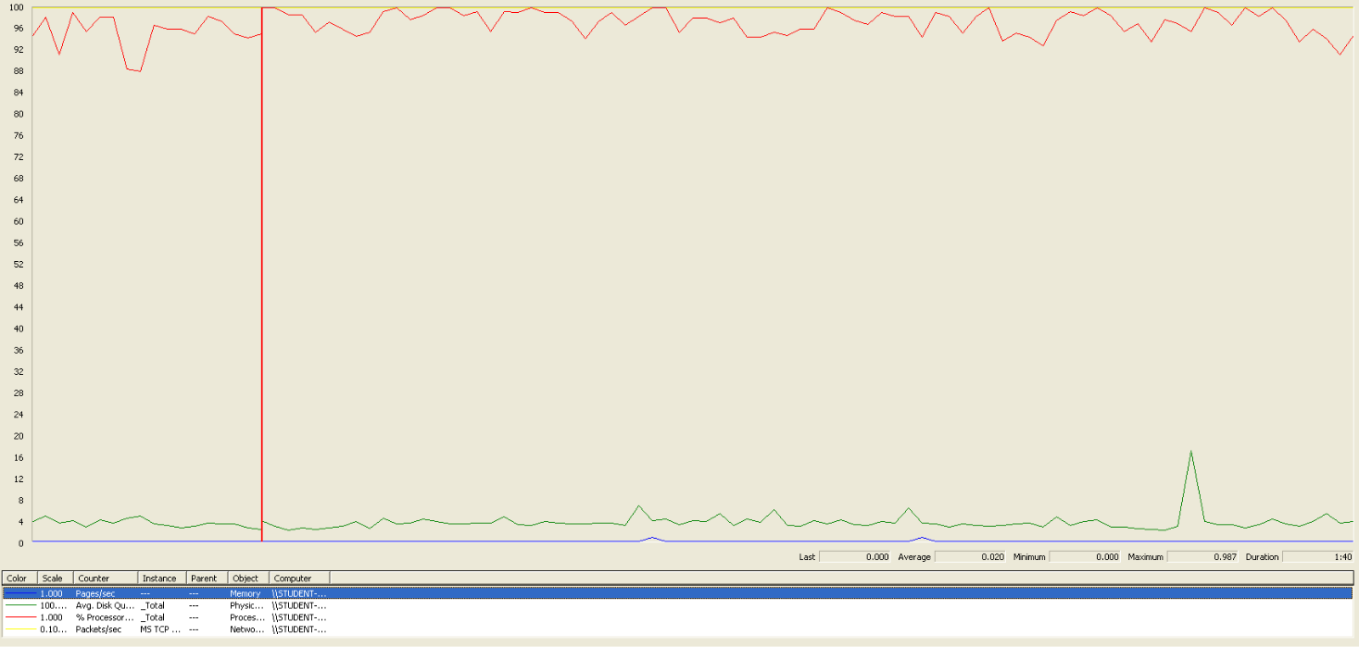

We can clearly see that the bottleneck is the CPU.

## Delete

Sequence:

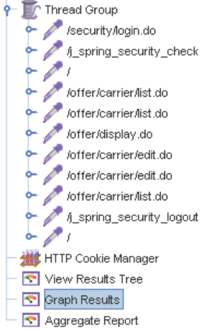

Aggregate Report:

 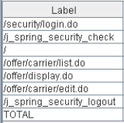 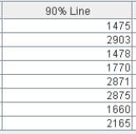 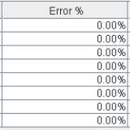

Thread properties:

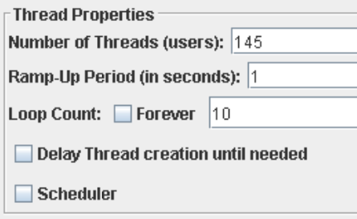

Graph Results:

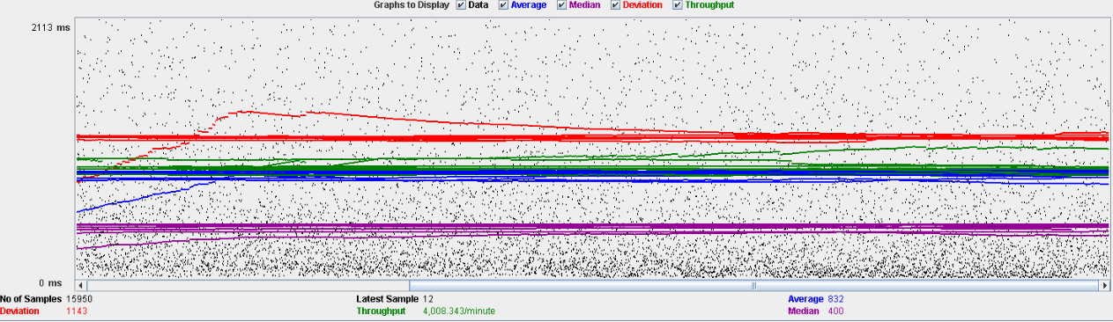

Performance Results:

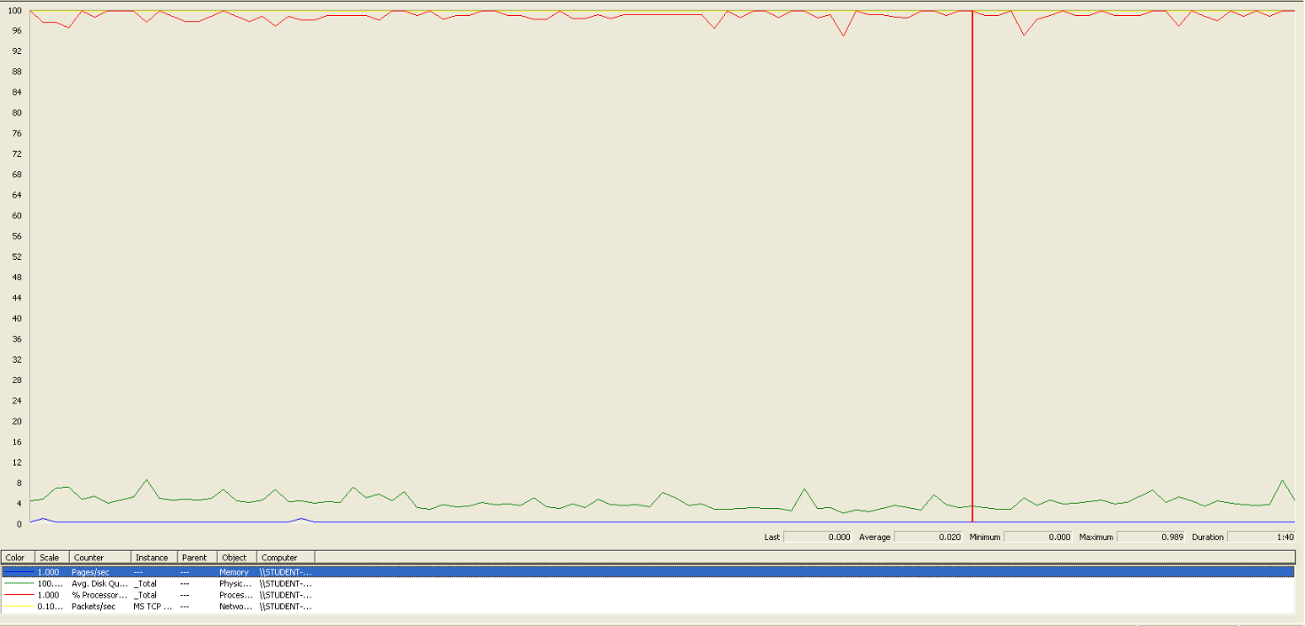

We can clearly see, another time, that the bottleneck is the CPU.

## Conclusion

The test was performed using:

CPU: i5 7300HQ (2 cores in the virtual machine)

RAM: 2 GB (virtual machine)

For this use case we can say that the maximum of concurrent users is about 145, delimited by the delete.

# Curricula

## Create a curriculum

Sequence:

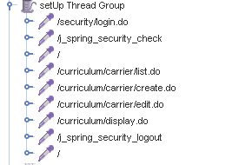

Aggregate Report:

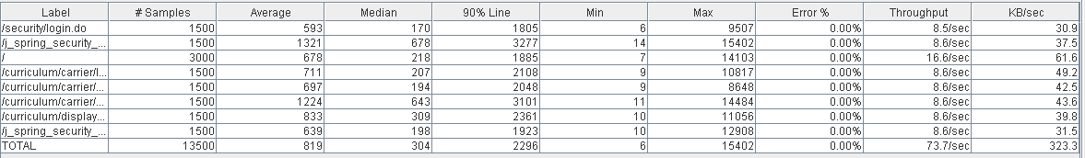

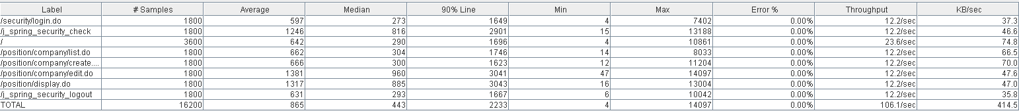

Thread properties:



Graph Results:

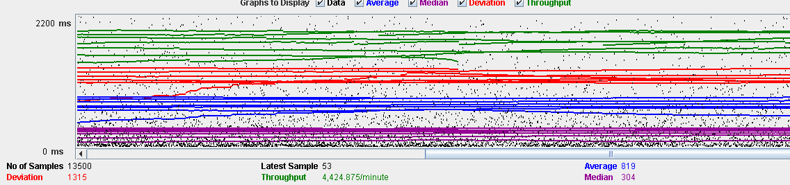

Performance Results:

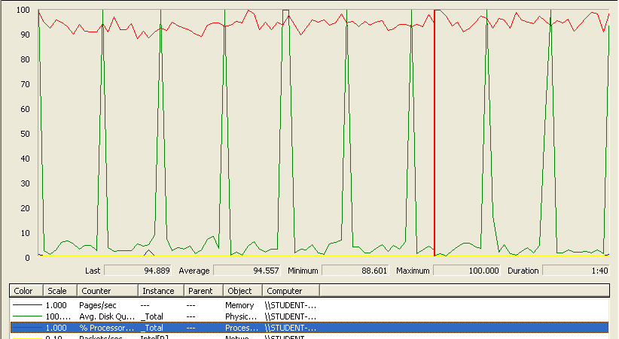

The CPU was always at its limit while the disk usage showed many peaks.

## Edit a curriculum

Sequence:

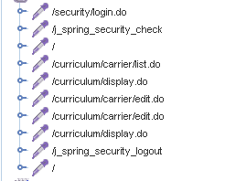

Aggregate Report:

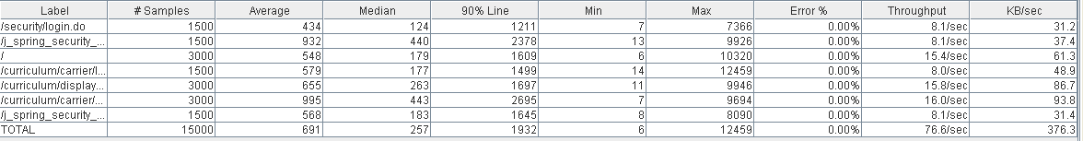



Thread properties:



Graph Results:

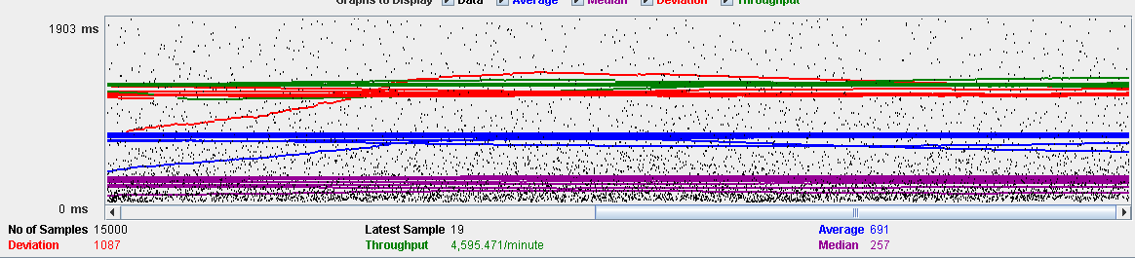

Performance Results:

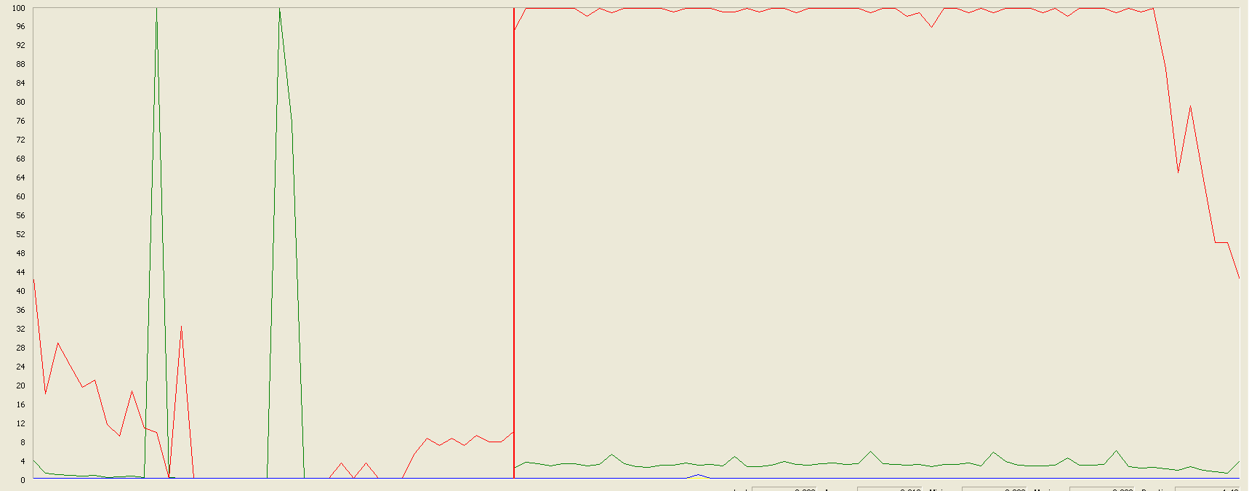

The CPU was always at its limit while the disk usage showed many peaks.

## Delete a curriculum

Sequence:

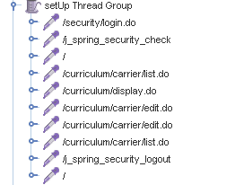

Aggregate Report:

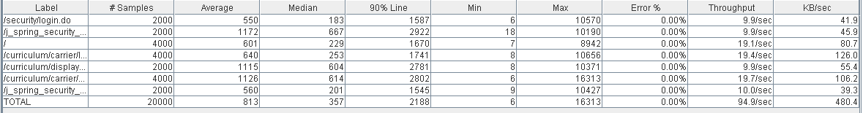



Thread properties:

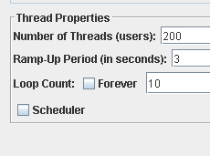

Graph Results:

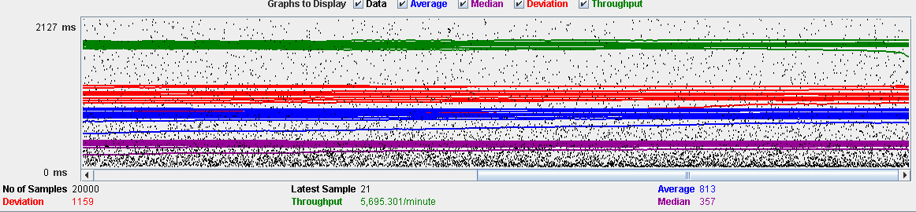

Performance Results:

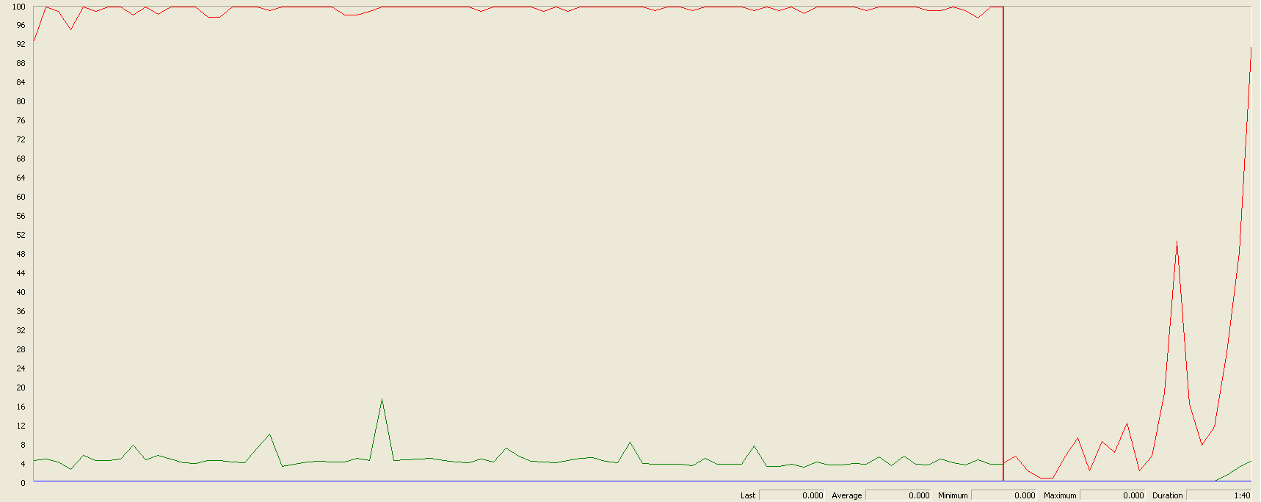

Again we can see that the CPU is always being used while the disk usage shows some little peaks.

# Records (Professional and Miscellaneous record)

## Create Miscellaneous Record

Sequence:

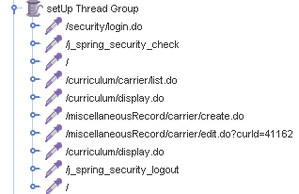

Aggregate Report:

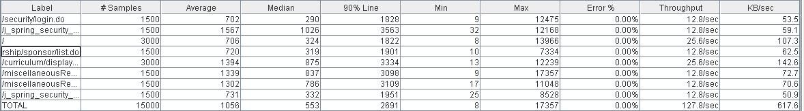



Thread properties:

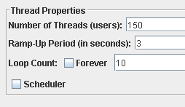

Graph Results:

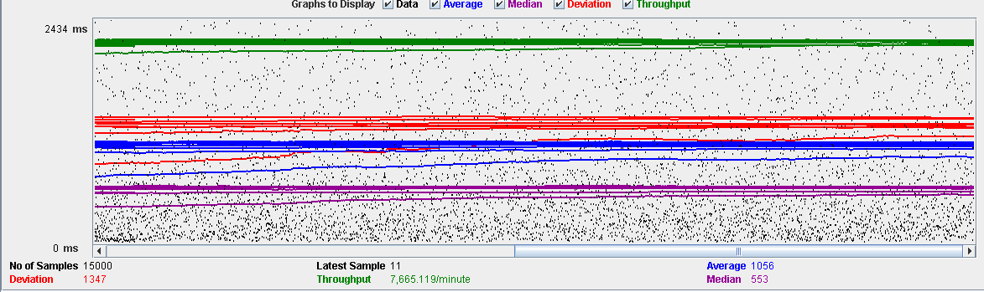

Performance Results:

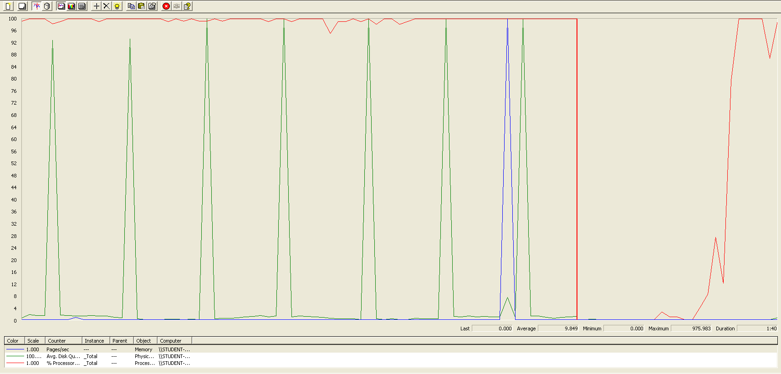

Again we can see that the CPU is always being used while the disk usage shows some periodic peaks.

## Create Professional Record

Sequence:

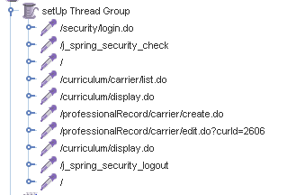

Aggregate Report:

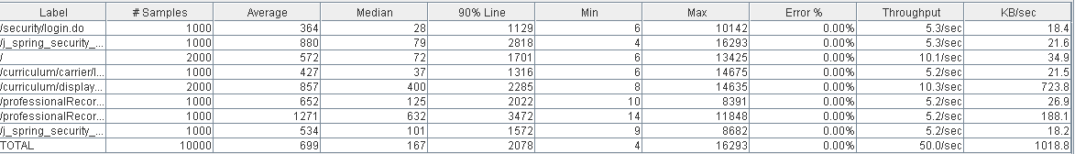



Thread properties:

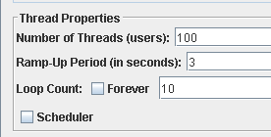

Graph Results:

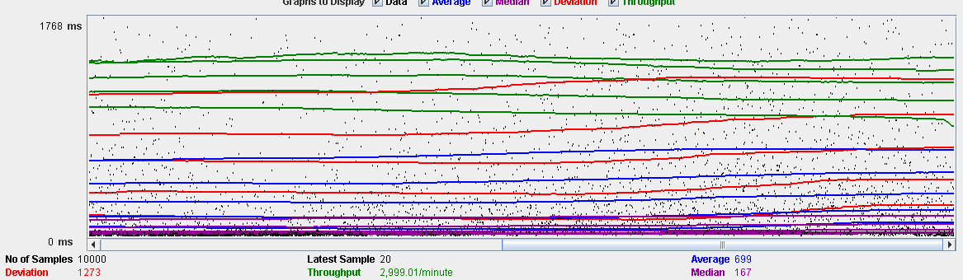

Performance Results:

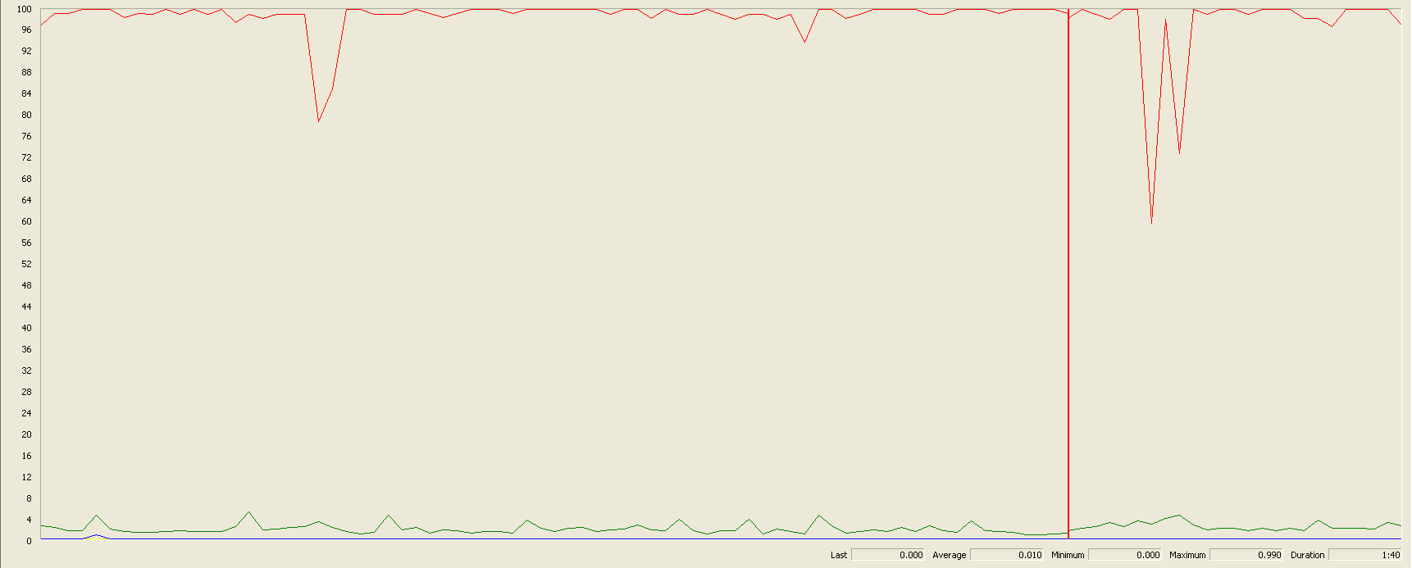

Again we can see that the CPU is always being used while the disk usage shows some low peaks

## Edit a Miscellaneous Record

Sequence:

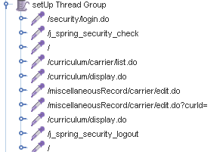

Aggregate Report:

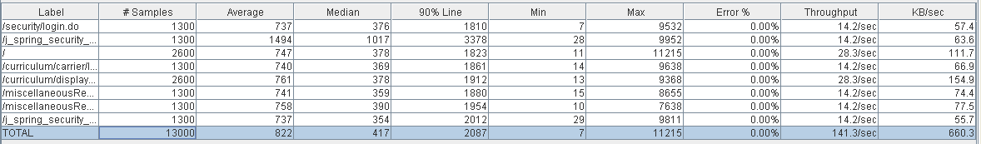



Thread properties:

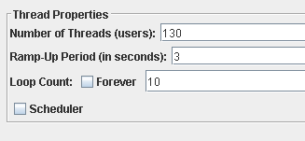

Graph Results:

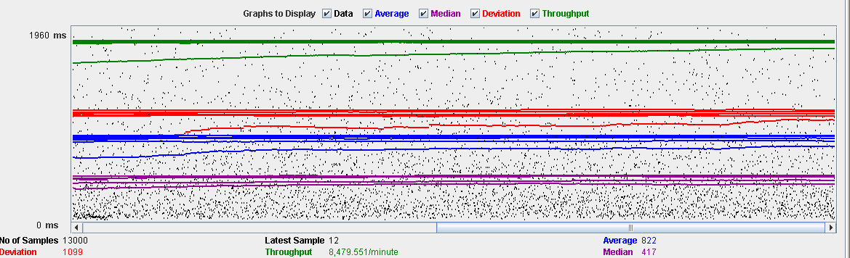

Performance Results:

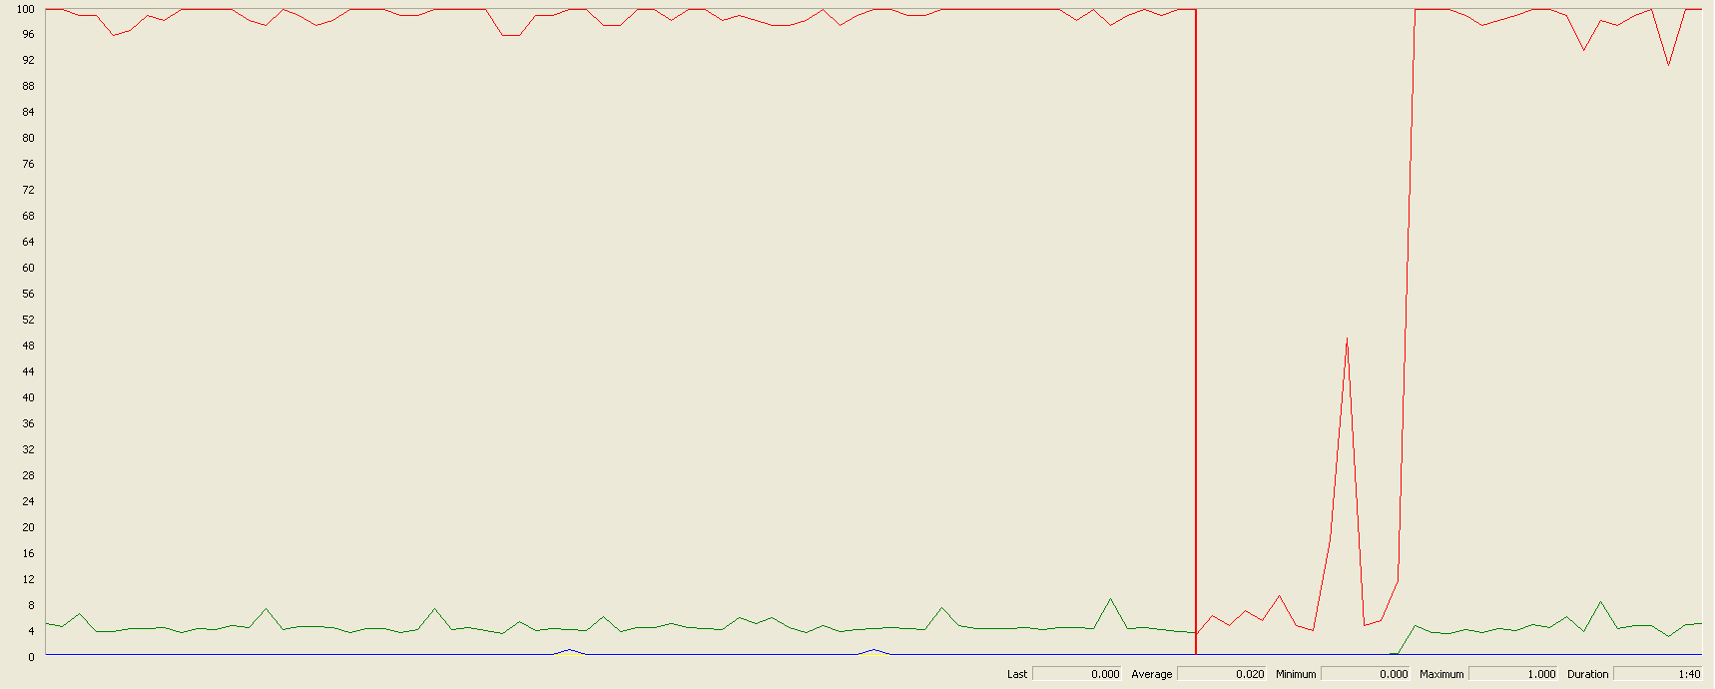

Again we can see that the CPU is always being used while the disk usage shows some peaks.

## Edit a Professional Record

Sequence:

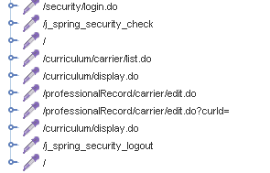

Aggregate Report:

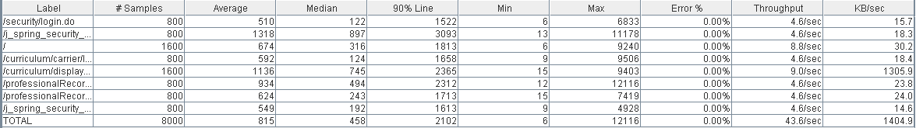



Thread properties:

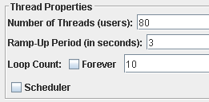

Graph Results:

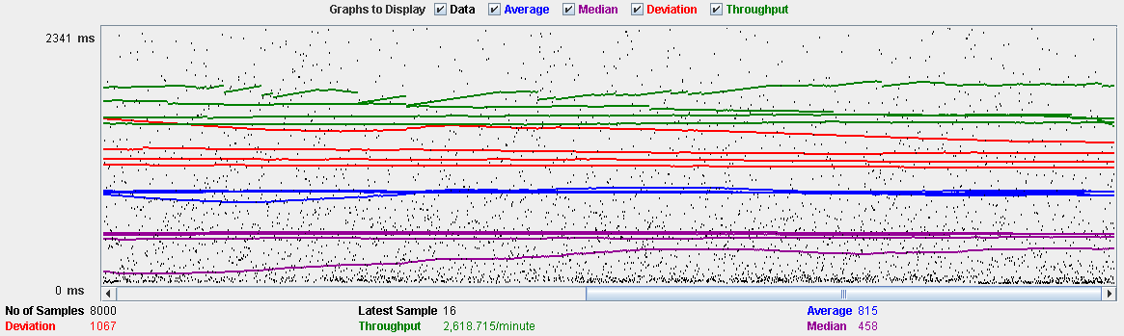

Performance Results:

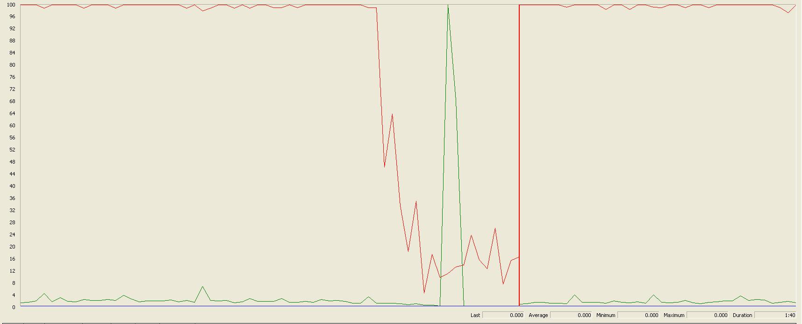

Again we can see that the CPU is always being used while the disk usage shows some peaks.

## Delete a professional record

Sequence:



Aggregate Report:

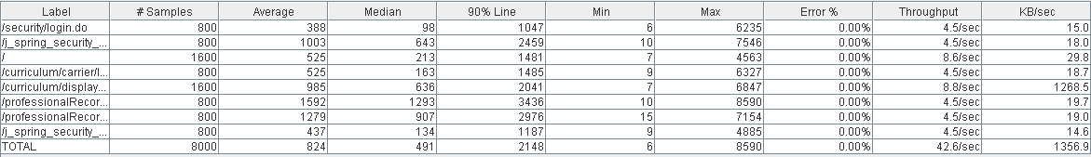

 

Thread properties:

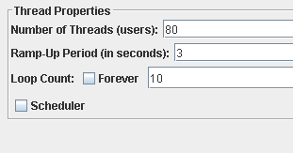

Graph Results:

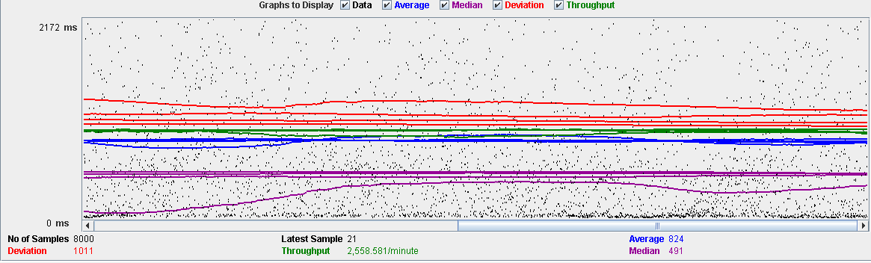

Performance Results:

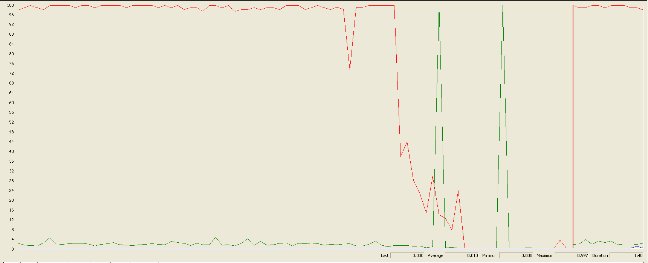

Again we can see that the CPU is always being used while the disk usage shows two peaks.

## Delete a miscellaneous data

Sequence:



Aggregate Report:

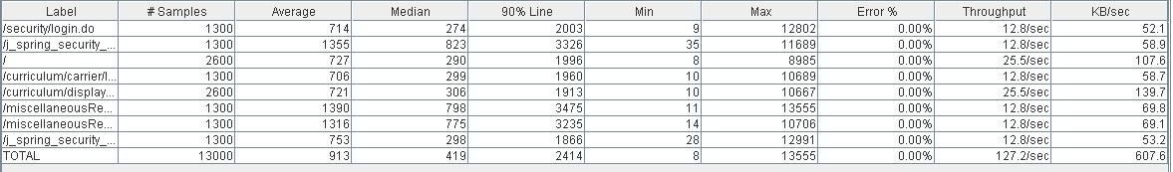

 

Thread properties:



Graph Results:

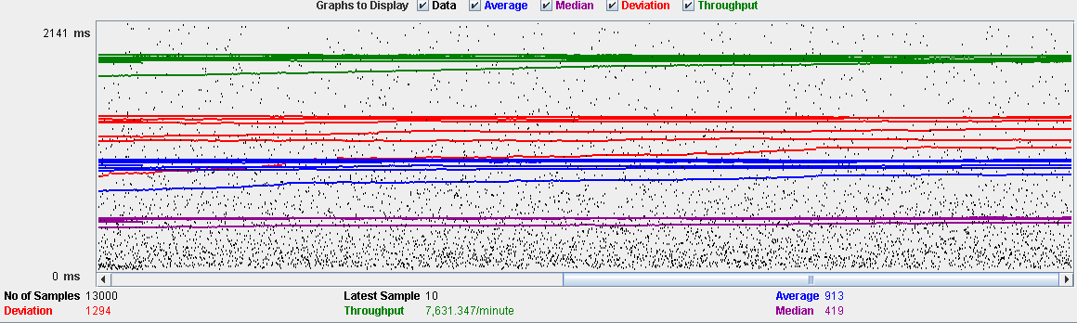

Performance Results:

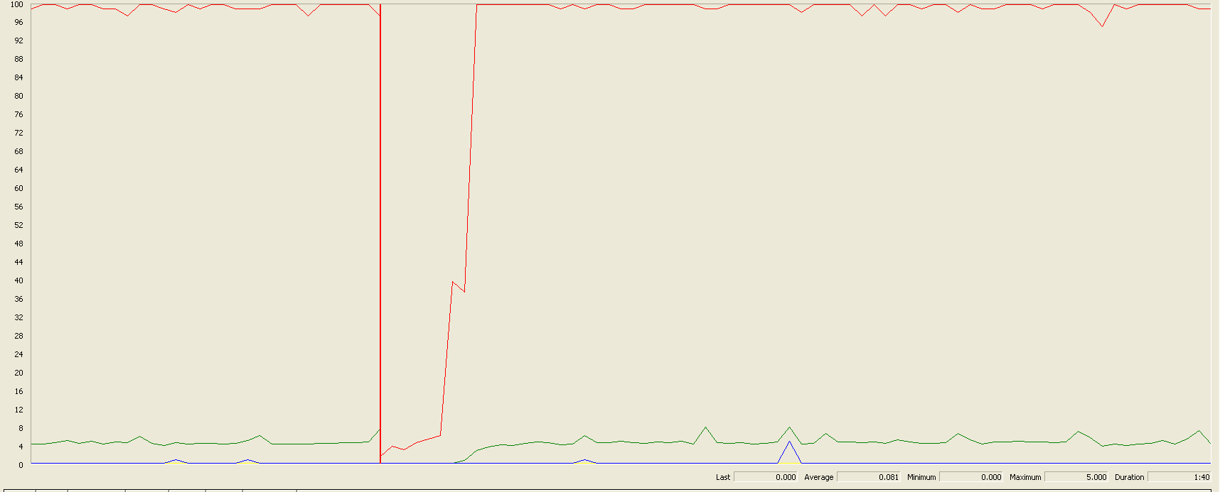

Again we can see that the CPU is always being used while the disk usage shows little peaks.

## Conclusion

The test was performed using:

CPU: i7 6700hq (2 cores in the virtual machine)

RAM: 4 GB (virtual machine)

For this use case we can say that the limitation occurs during the creation process, being the maximum of concurrent users 80.

# Actor

## Create

Sequence:

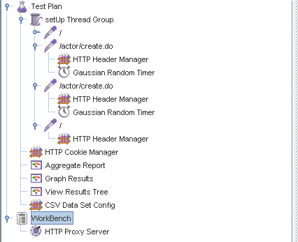

Aggregate Report:



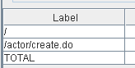  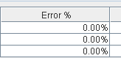

Thread properties:



Graph Results:

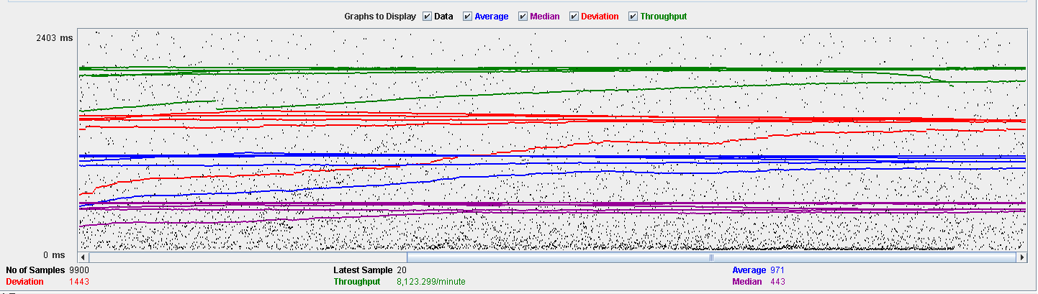

Performance Results:

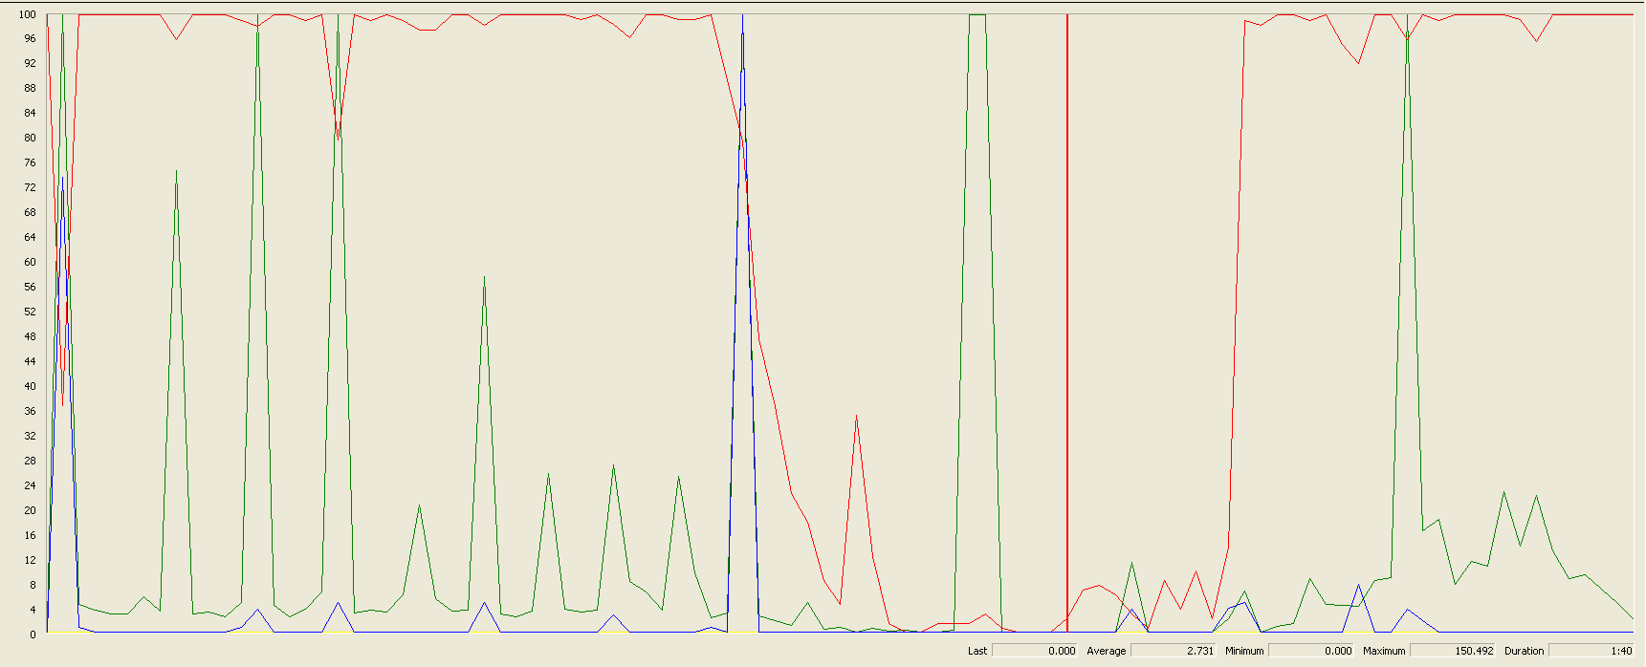

The CPU was always at its limit while the disk usage has a lot of peaks.

## Edit

Sequence:

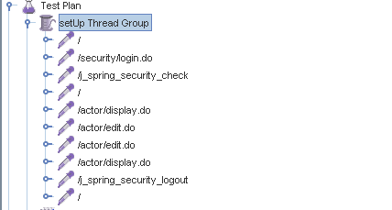

Aggregate Report:

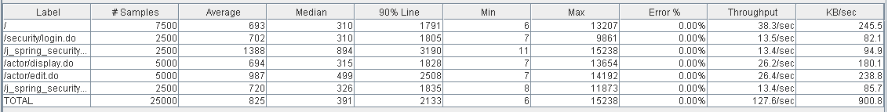



Thread properties:



Graph Results:

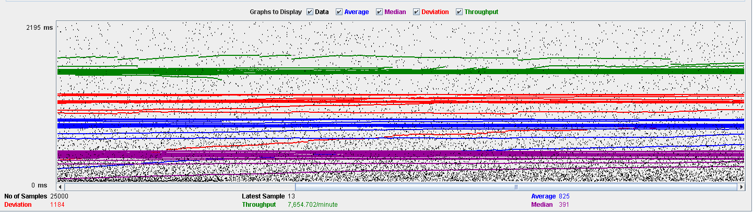

Performance Results:

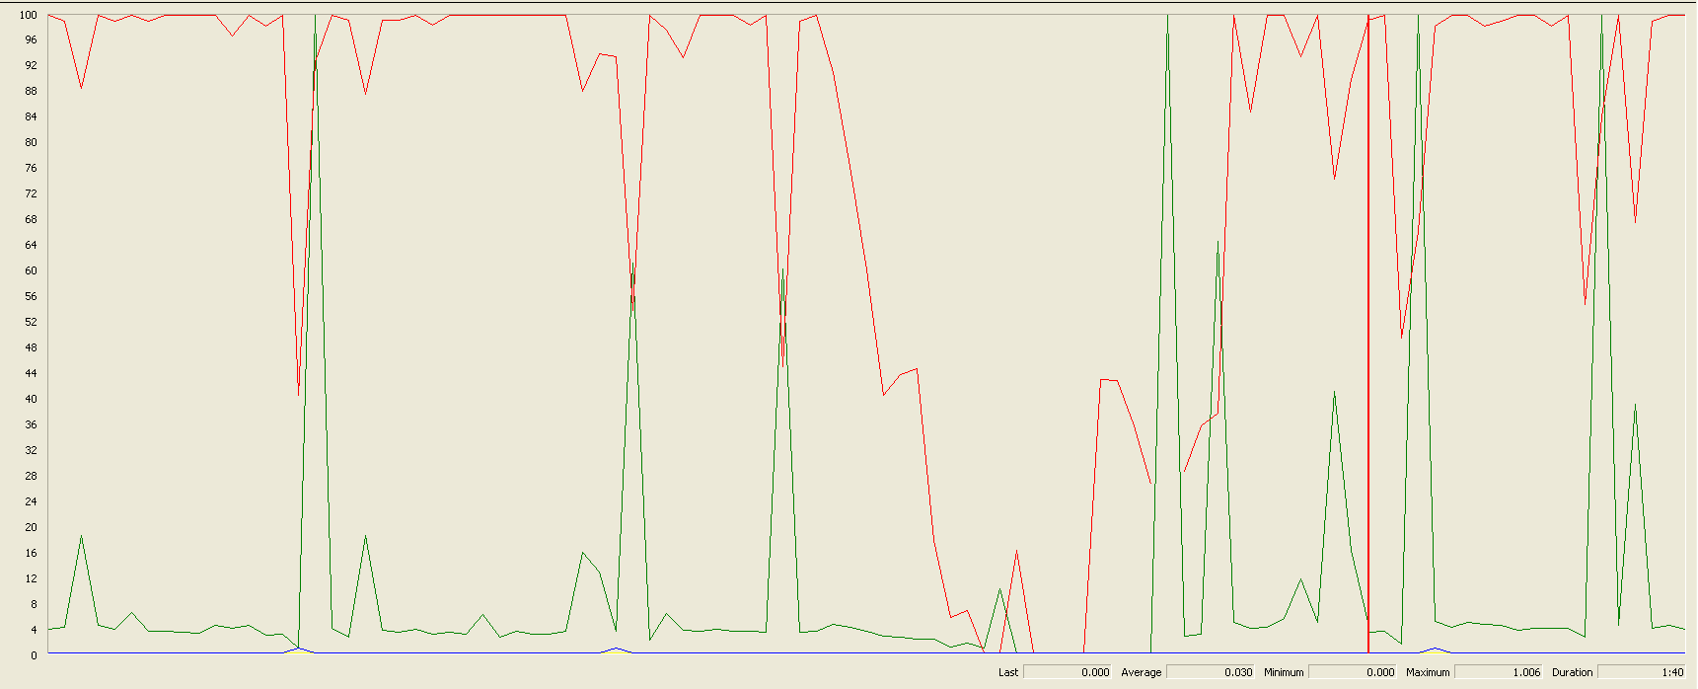

Again we can see that the CPU is always being used while the disk usage has some peaks at times.

## Delete

Sequence:

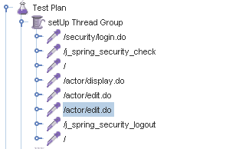

Aggregate Report:



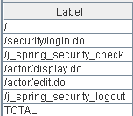

Thread properties:

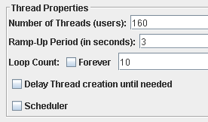

Graph Results:

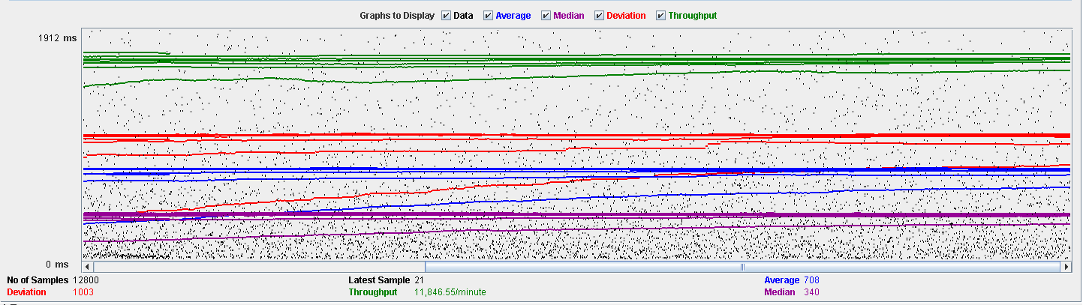

Performance Results:

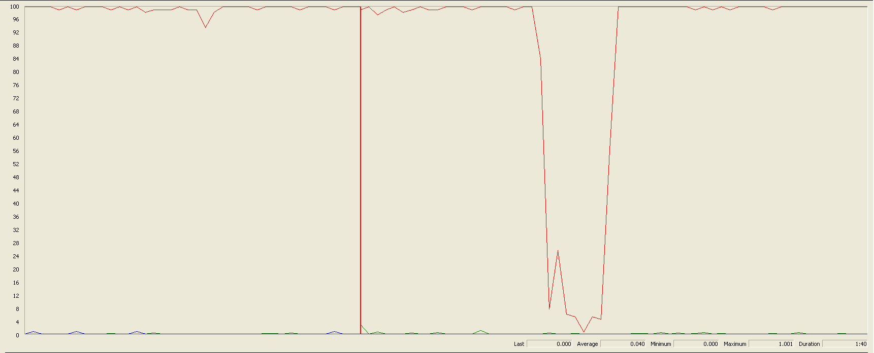

Again we can see that the CPU is always being used while the disk usage has different peaks.

## Conclusion

The test was performed using:

CPU: i7 7700hq (2 cores in the virtual machine)

RAM: 4 GB (virtual machine)

For this use case we can say that the limitation occurs during the creation process, being the maximum of concurrent users is 90.

# Vehicle

## Create

Sequence:

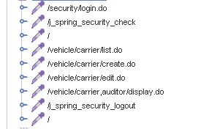

Aggregate Report:

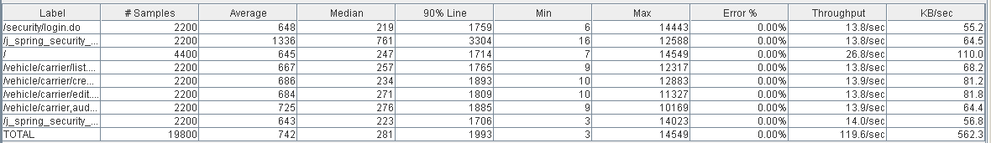



Thread properties:

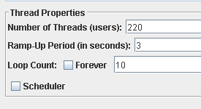

Graph Results:

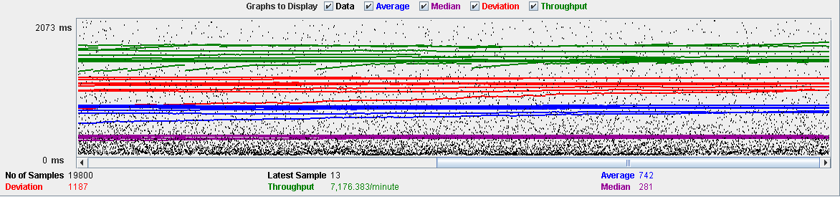

Performance Results:

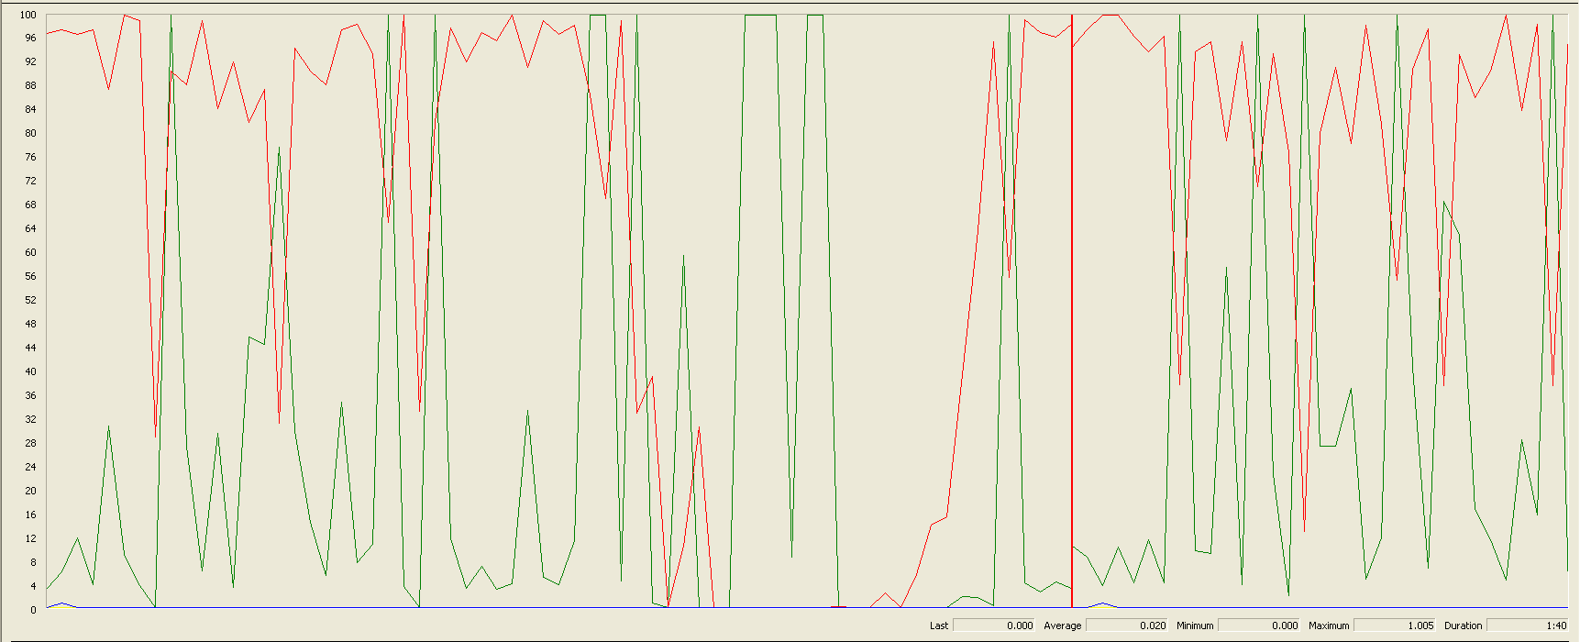

The CPU was always at its limit while the disk usage has many peaks.

## Edit

Sequence:



AggregateReport: 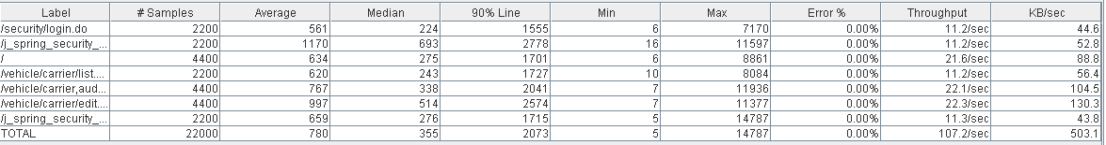



Thread properties:

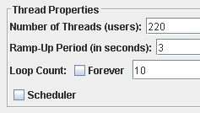

Graph Results:

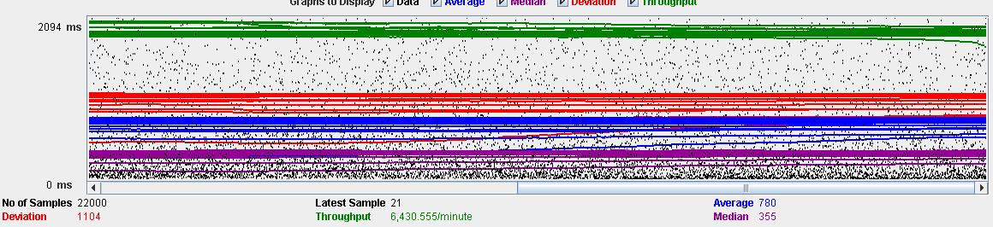

Performance Results:

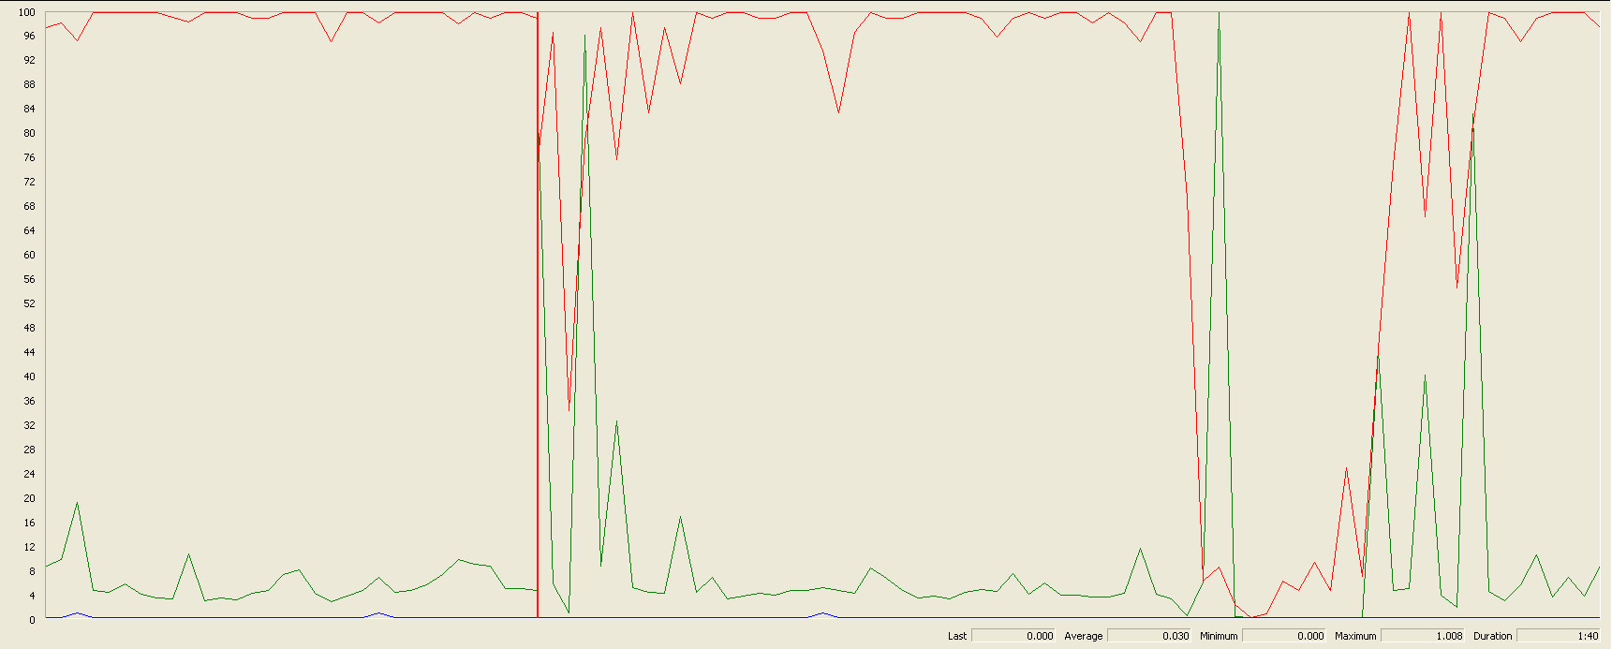

Again we can see that the CPU is always being used while the disk usage has high peaks at times.

## Delete

Sequence:

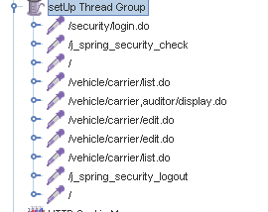

Aggregate Report:

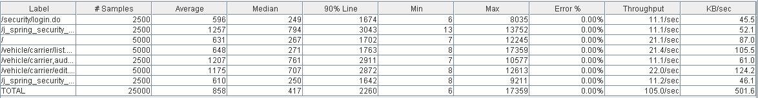



Thread properties:

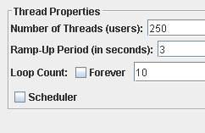

Graph Results:

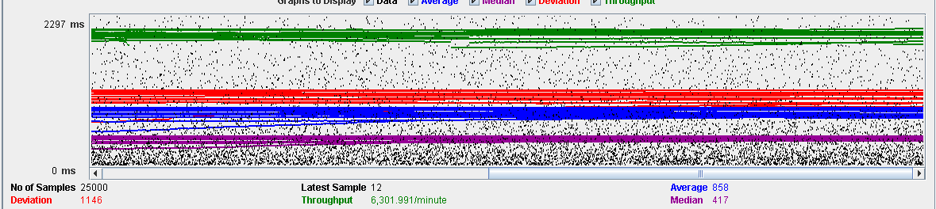

Performance Results:

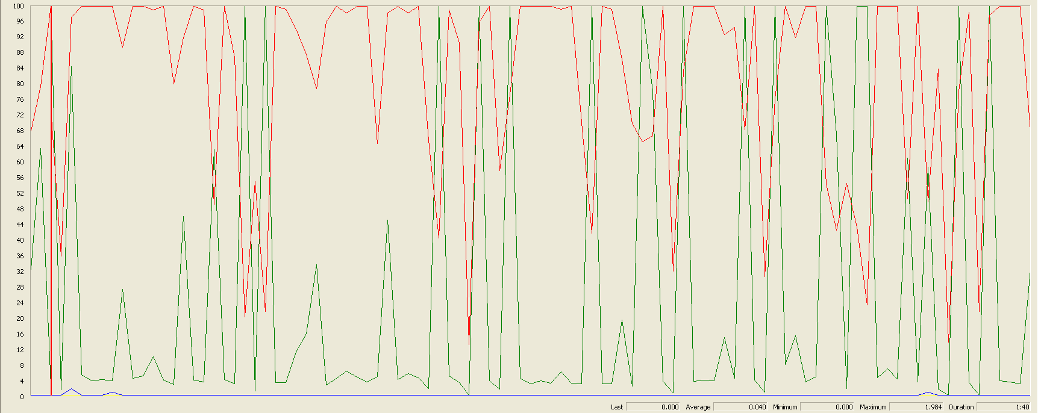

Again we can see that the CPU is always being used while the disk usage has many different peaks.

## Conclusion

The test was performed using:

CPU: i7 7700hq (2 cores in the virtual machine)

RAM: 4 GB (virtual machine)

For this use case we can say that the limitation occurs during the creation process, being the maximum of concurrent users 220.

# Solicitation

## Create

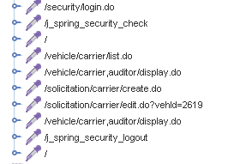

Aggregate Report:

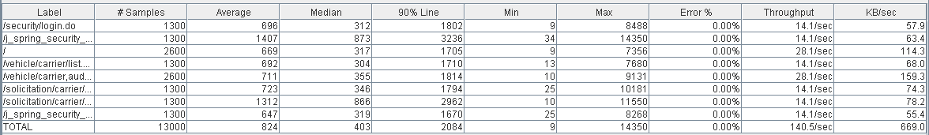

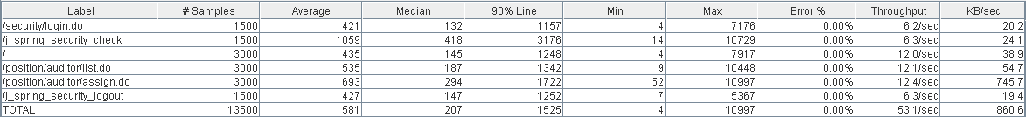

Thread properties:

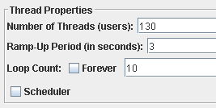

Graph Results:

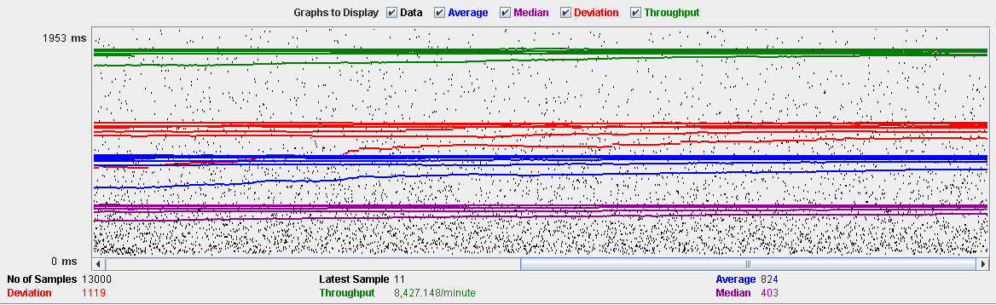

Performance Results:

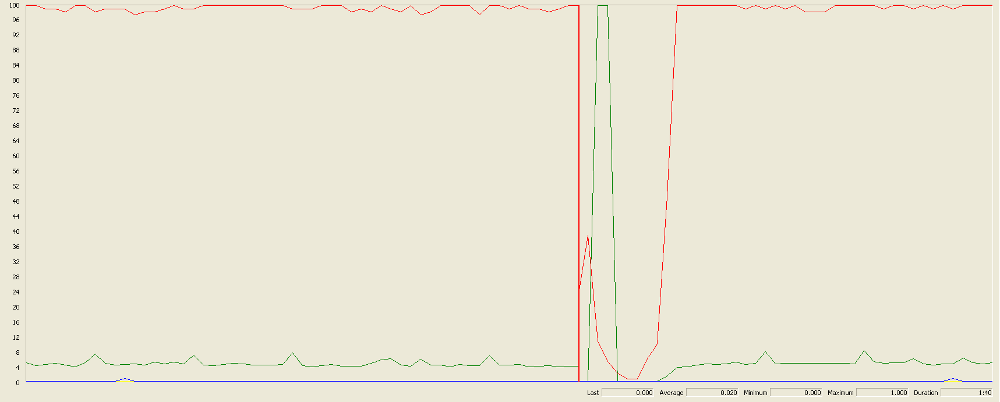

The CPU was always at its limit while the disk usage showed some peaks.

## Edit

Sequence:

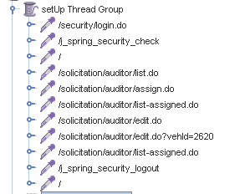

Aggregate Report:

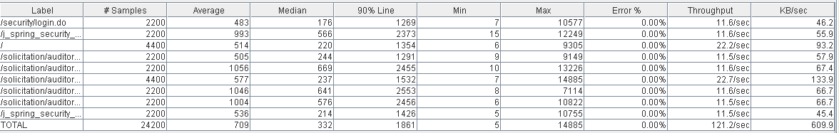

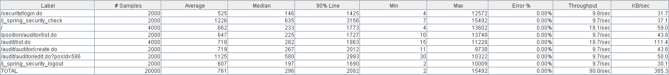

Thread properties:

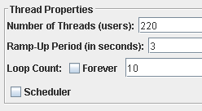

Graph Results:

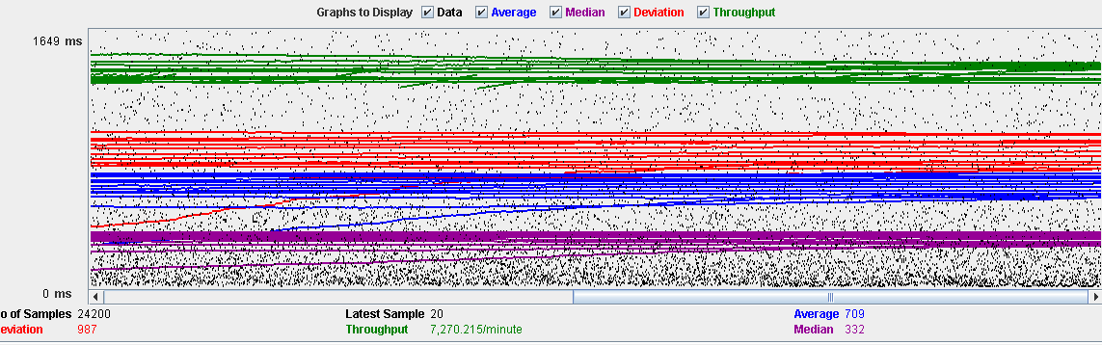

Performance Results:

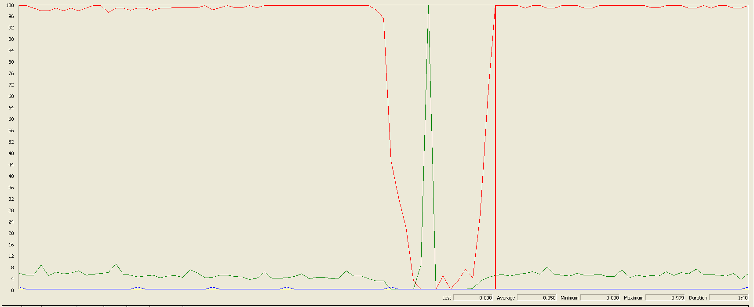

The CPU was always at its limit in various points of the execution while the disk usage showed a big peak.

## Delete

Sequence:

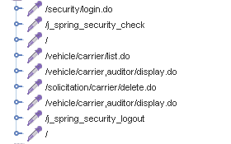

Aggregate Report:

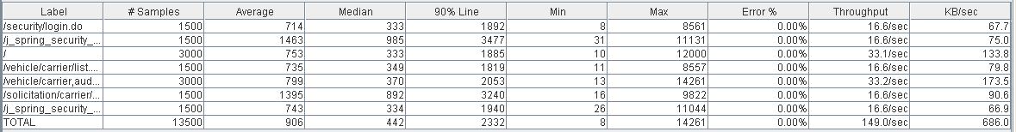

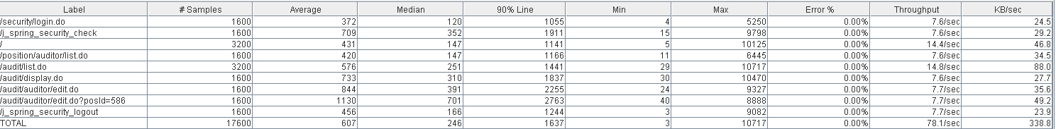

Thread properties:

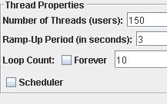

Graph Results:

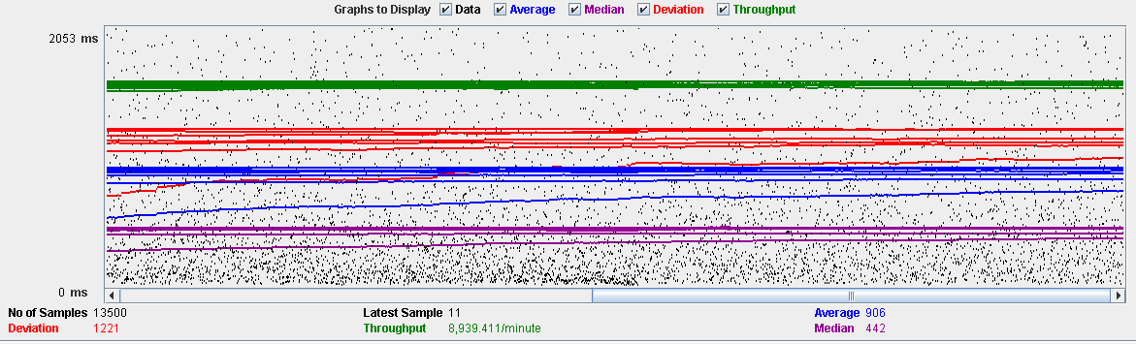

Performance Results:

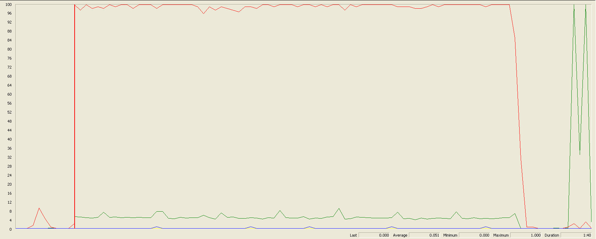

The CPU was always at its limit while the disk usage showed low peaks.

## Conclusion

The test was performed using:

CPU: i7 6700hq (2 cores in the virtual machine)

RAM: 4 GB (virtual machine)

For this use case we can say that the limitation occurs during the assign process, being the maximum of concurrent users 130.

# Sponsorship

## Create

Sequence:

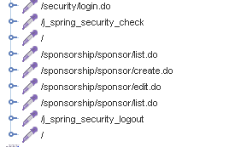

Aggregate Report:

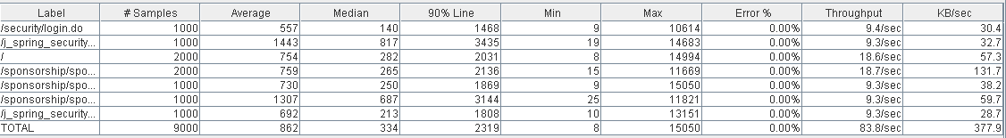

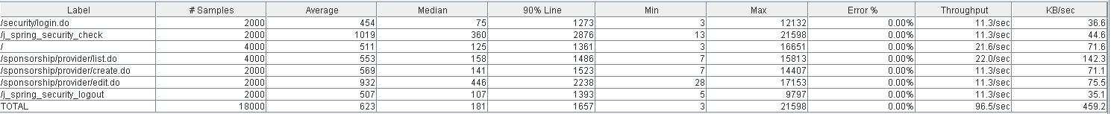

Thread properties:

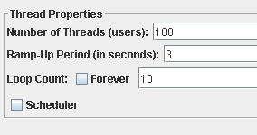

Graph Results:

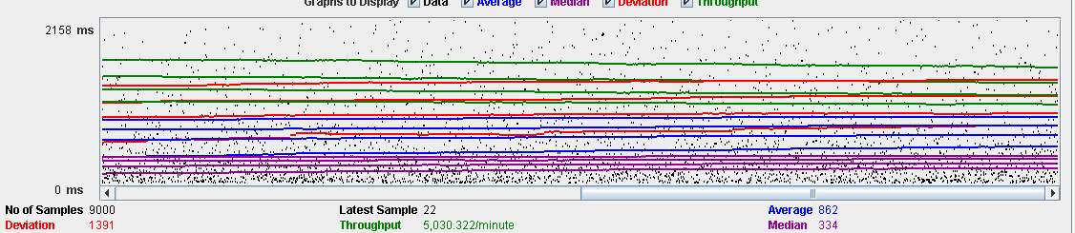

Performance Results:

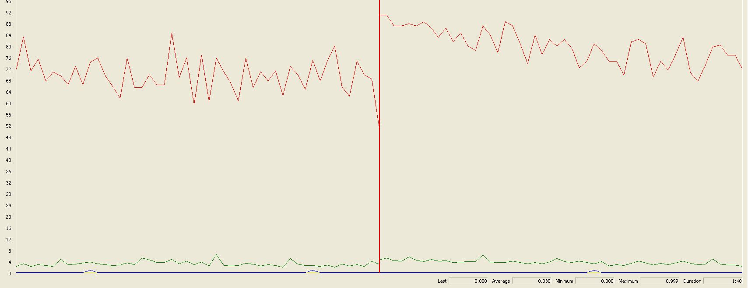

The CPU was always at its limit while the disk usage showed low peaks.

## Edit

Sequence:

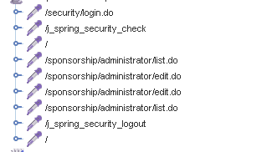

Aggregate Report:

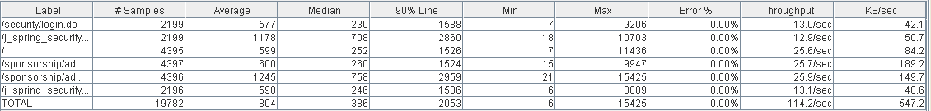



Thread properties:

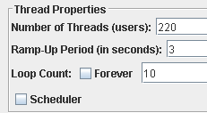

Graph Results:

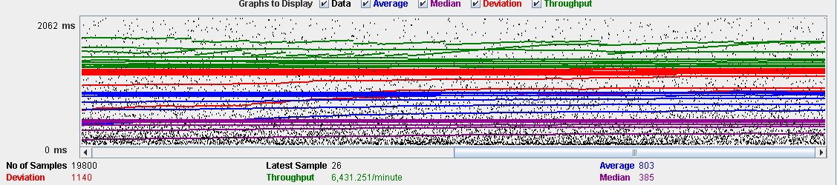

Performance Results:

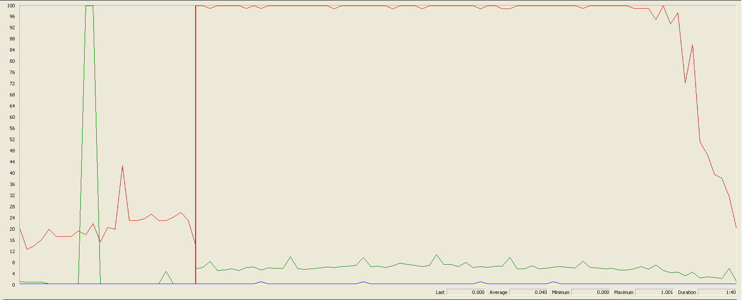

The CPU was always at its limit.

## Delete

Sequence:

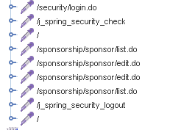

Aggregate Report:

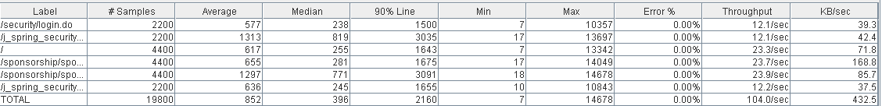



Thread properties:

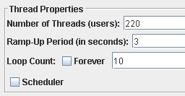

Graph Results:

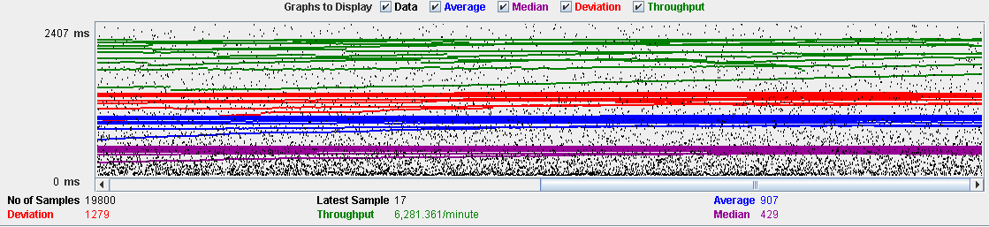

Performance Results:

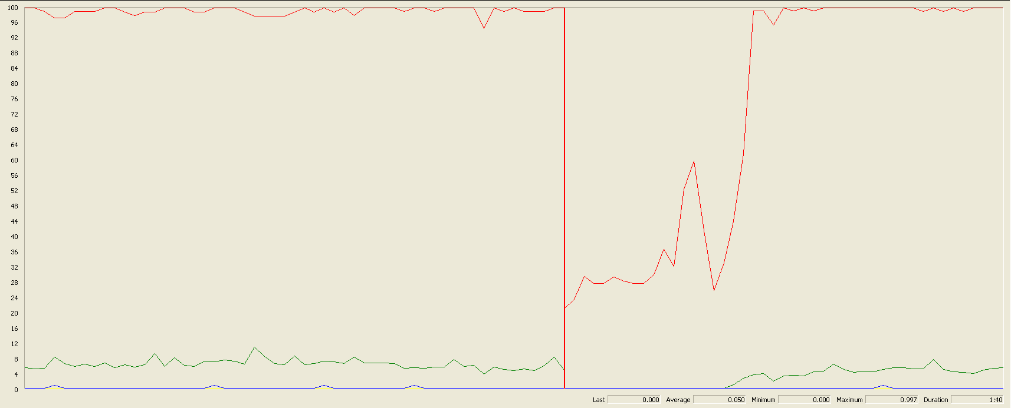

The CPU was always at its limit and had disk usage low peaks.

## Conclusion

The test was performed using:

CPU: i7 6700hq (2 cores in the virtual machine)

RAM: 4 GB (virtual machine)

For this use case we can say that the limitation occurs during the create process, being the maximum of concurrent users 100.

# Fare

## Create

Sequence:

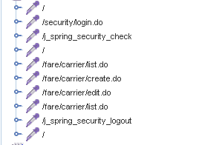

Aggregate Report:

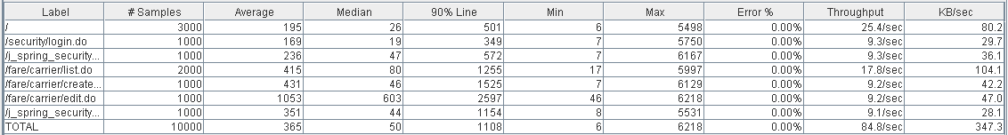

  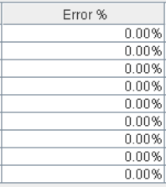

Thread properties:

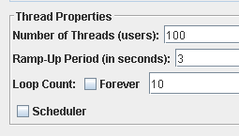

Graph Results:

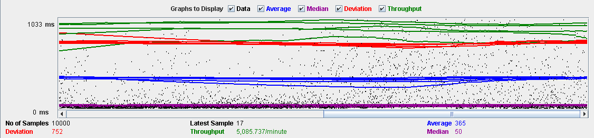

Performance Results:

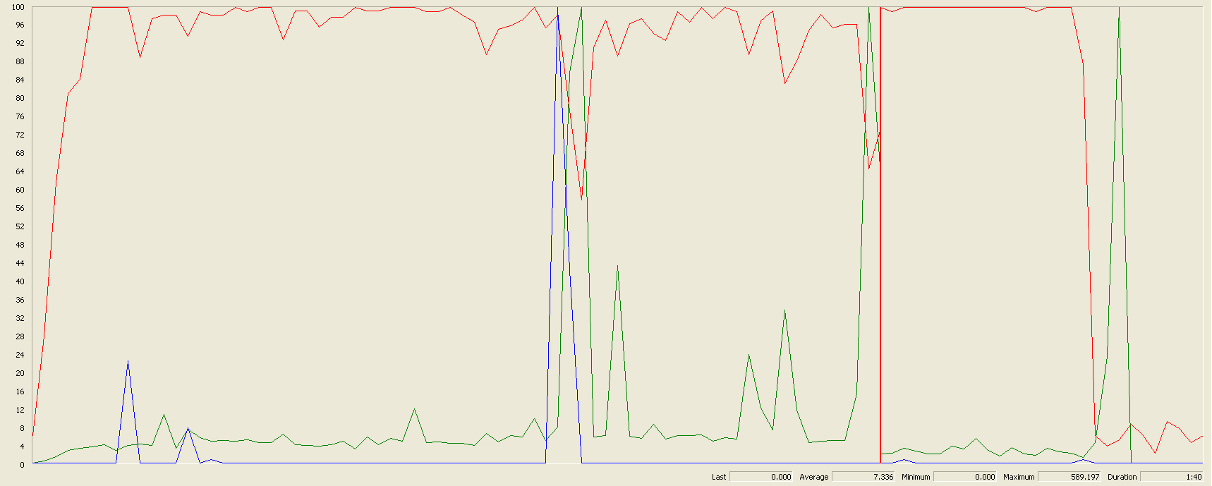

The CPU was always at its limit while the disk usage has a lot of peaks.

## Edit

Sequence:

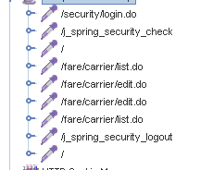

Aggregate Report:

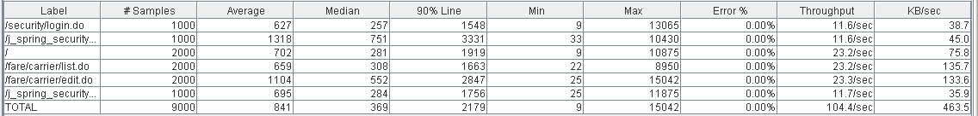

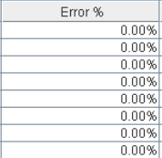

Thread properties:

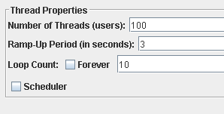

Graph Results:

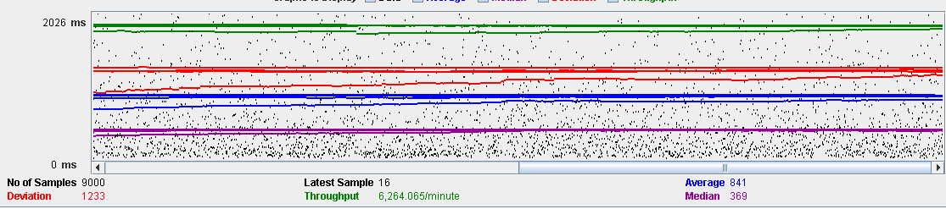

Performance Results:

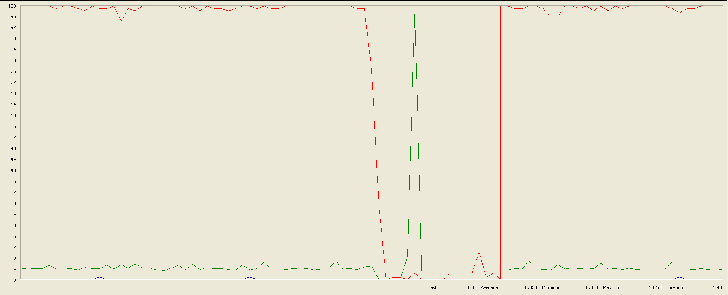

Again we can see that the CPU is always being used and disk usage had some peaks.

## Delete

Sequence:

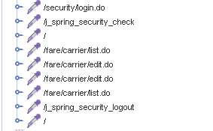

Aggregate Report:

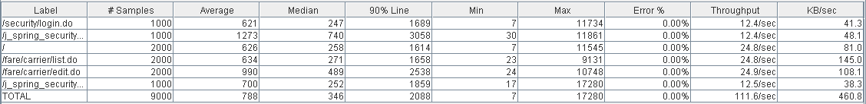

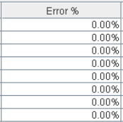

Thread properties:

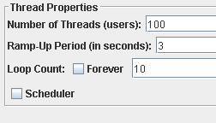

Graph Results:

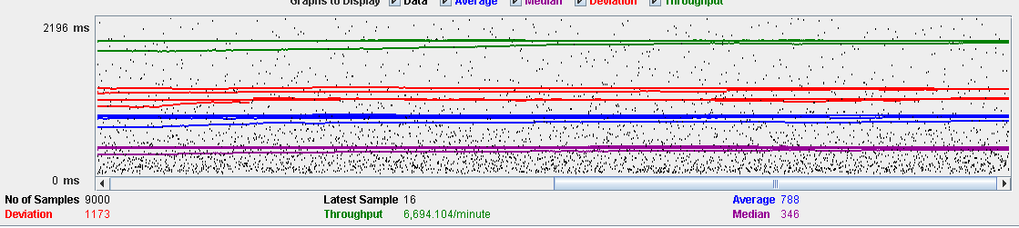

Performance Results:

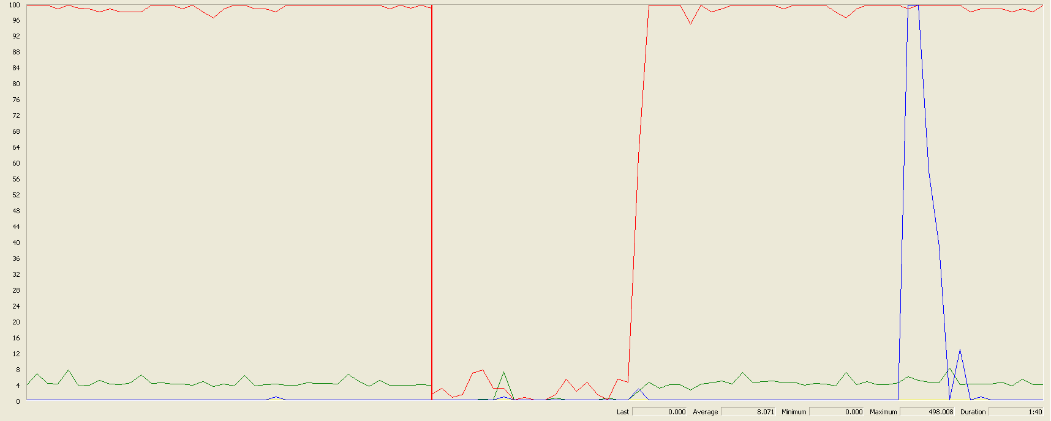

Again we can see that the CPU is always being used while the disk usage and network have different peaks.

## Conclusion

The test was performed using:

CPU: i5 7300hq (2 cores in the virtual machine)

RAM: 2 GB (virtual machine)

For this use case we can say that the limitation occurs during with all the process, being the maximum of concurrent users 100.

# TODO DE AQUI PABAJO SE BORRA

# Position

## Create

Sequence:

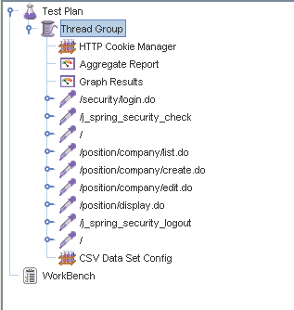

Aggregate Report:

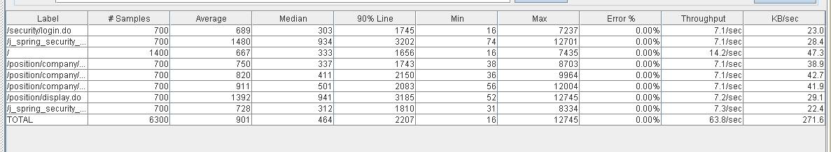

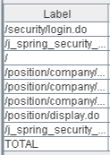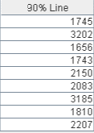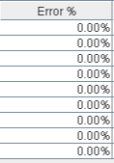

Thread properties:

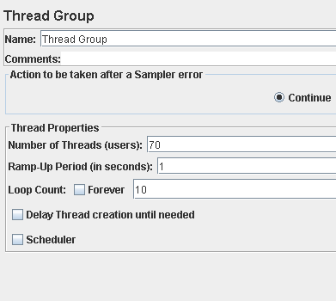

Graph Results:

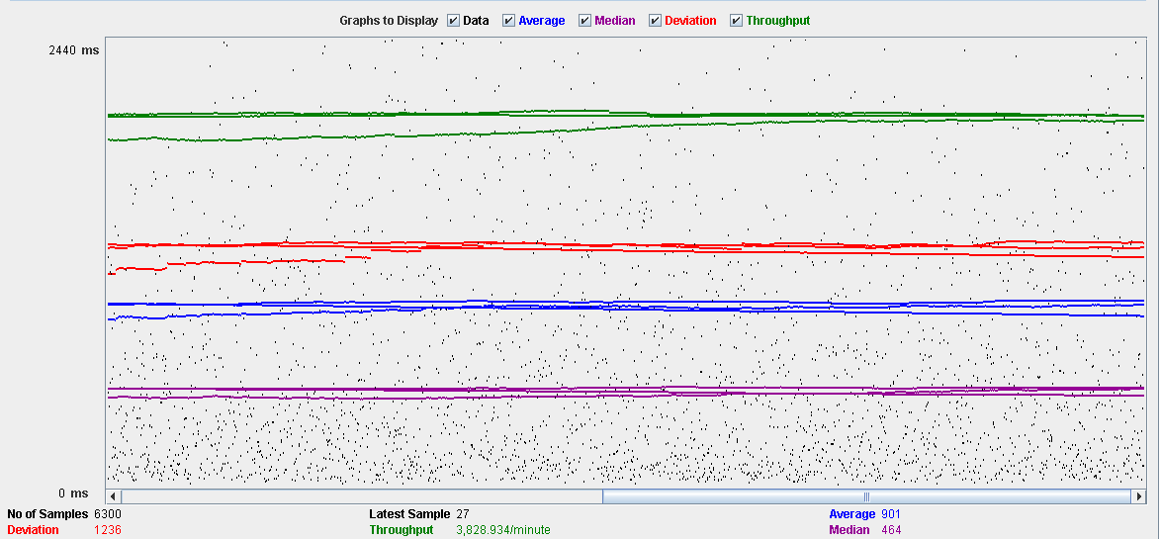

Performance Results:

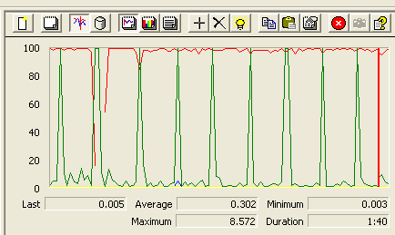

The CPU was always at its limit while the disk usage showed many peaks.

## Edit

Sequence:

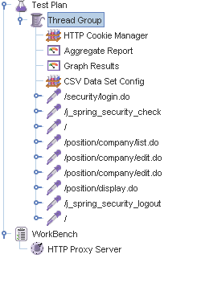

Aggregate Report:

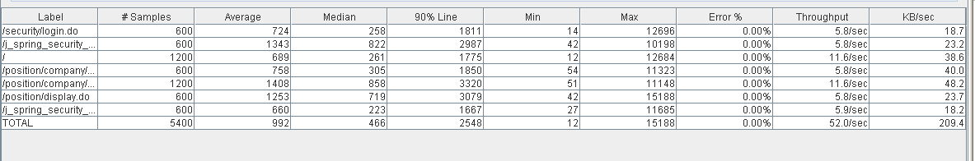

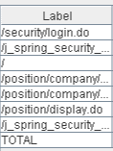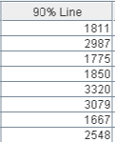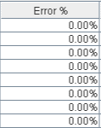

Thread properties:

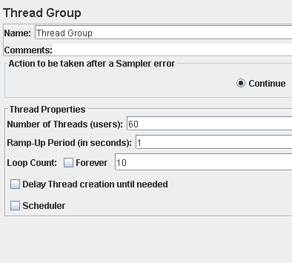

Graph Results:

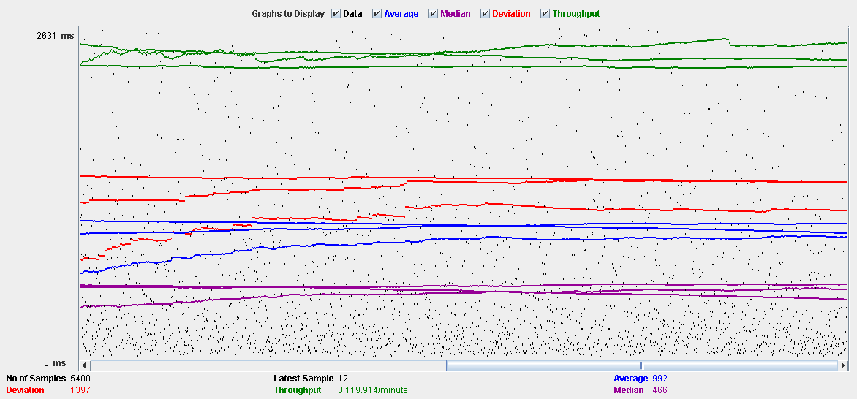

Performance Results:

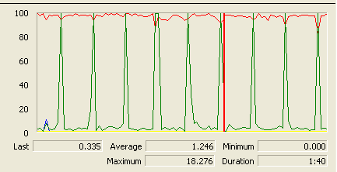

Again we can see that the CPU is always being used while the disk usage shows some periodic peaks.

## Delete

Sequence:

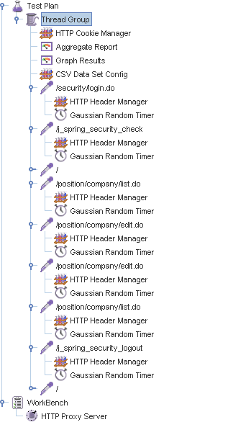

Aggregate Report:

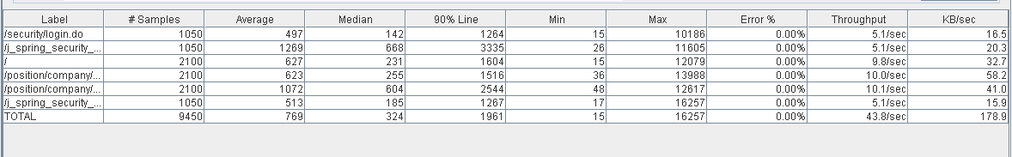

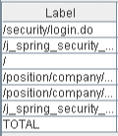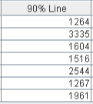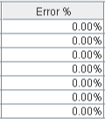

Thread properties:

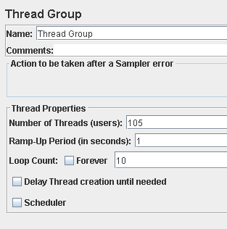.

Graph Results:

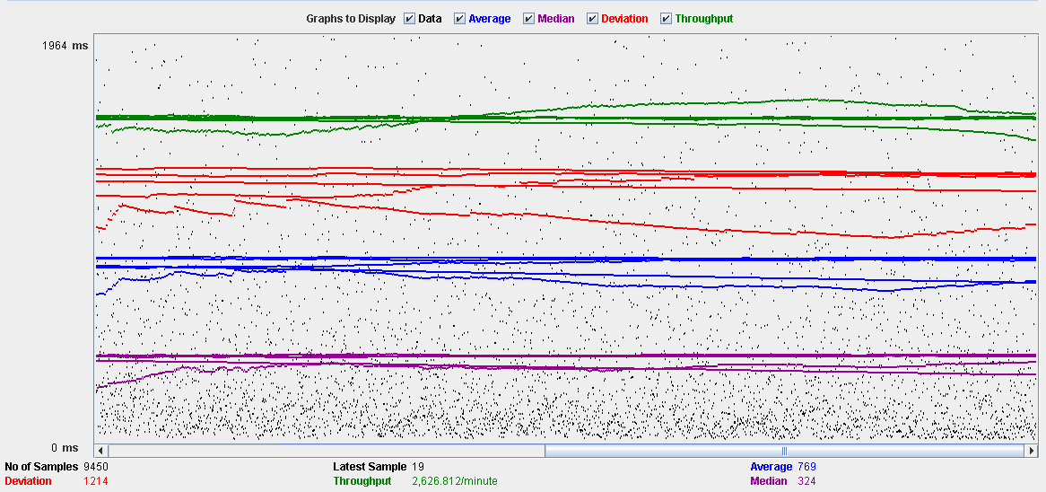

Performance Results:

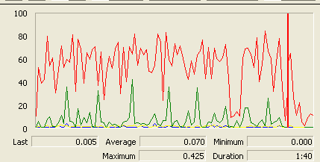

Again we can see that the CPU is always being used while the disk usage shows some peaks.

## Conclusion

The test was performed using:

CPU: 5 2500k (2 cores in the virtual machine)

RAM: 2 GB (virtual machine)

For this use case we can say that the limitation occurs during the edit process, being the maximum of concurrent users 60 because the time of respond starts to be very high at that point.

# Mess

## Search by tags, list by that tag and display a mess

Sequence:

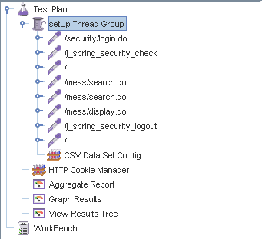

Aggregate Report:

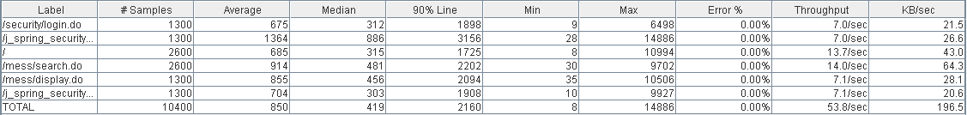

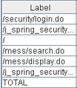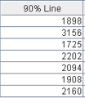

Thread properties:

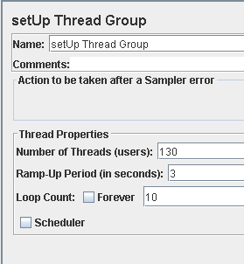

Graph Results:

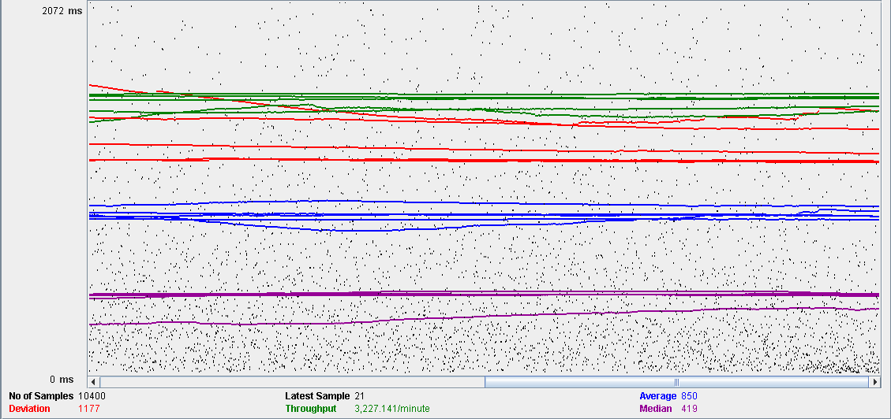

Performance Results:

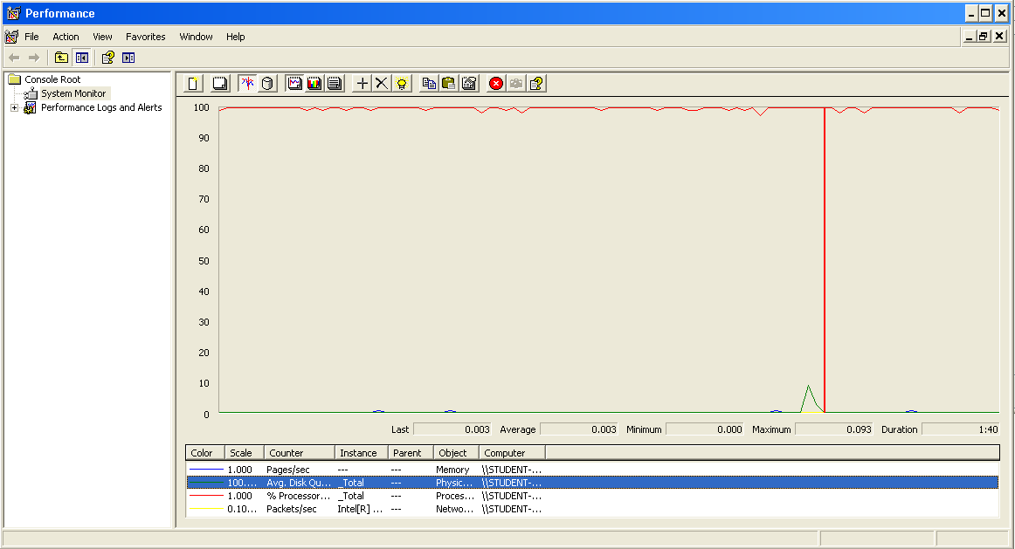

The CPU was always at its limit while the disk usage showed many peaks.

## Send a message

Sequence:

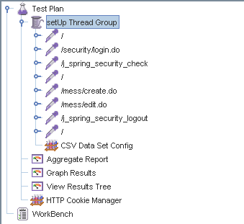

Aggregate Report:



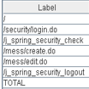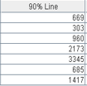

Thread properties:

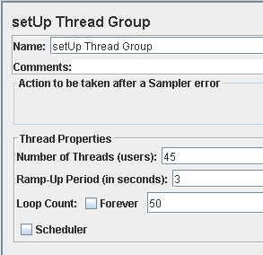

Graph Results:

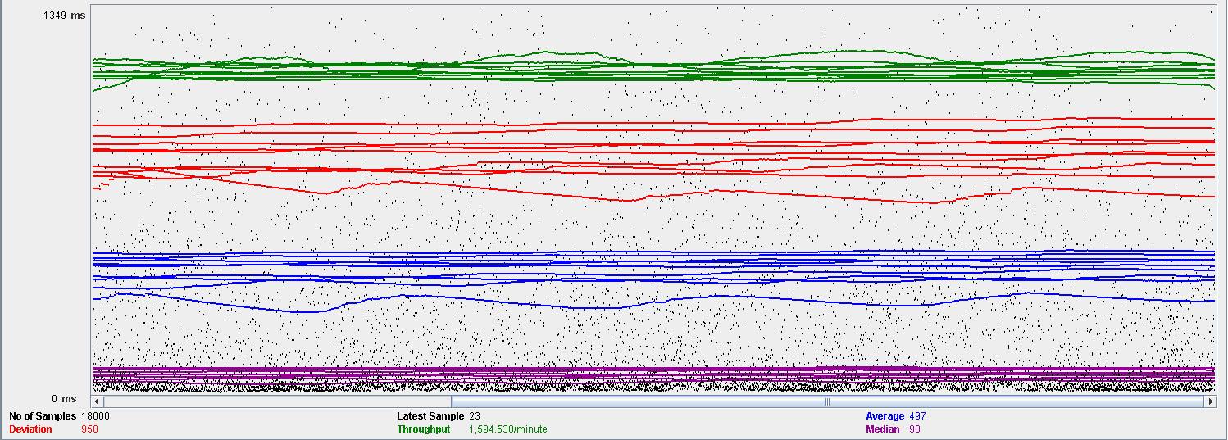

Performance Results:

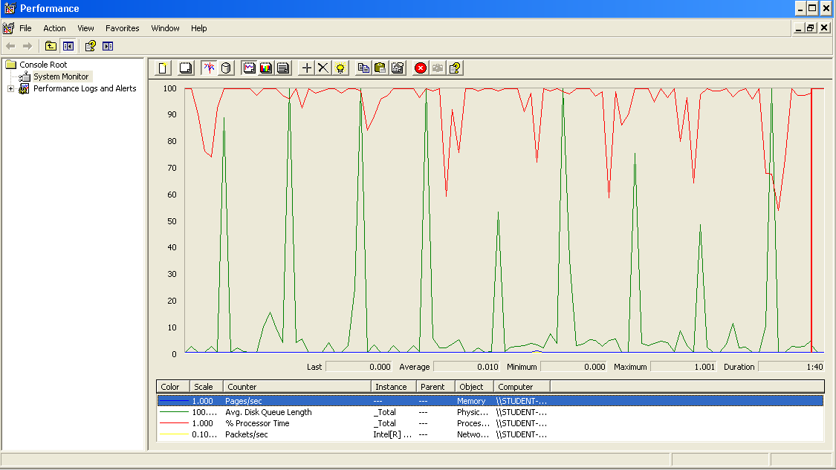

Again we can see that the CPU is always being used while the disk usage shows some periodic peaks.

## Delete a message

Sequence:

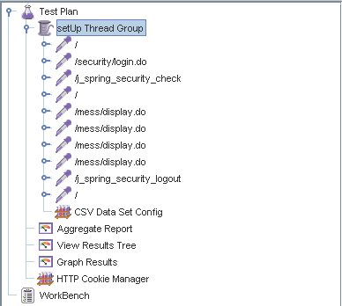

Aggregate Report:

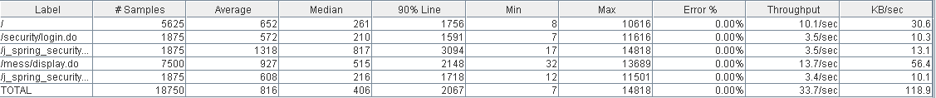

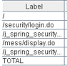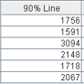

Thread properties:

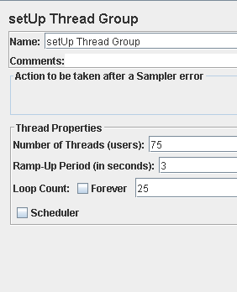

Graph Results:

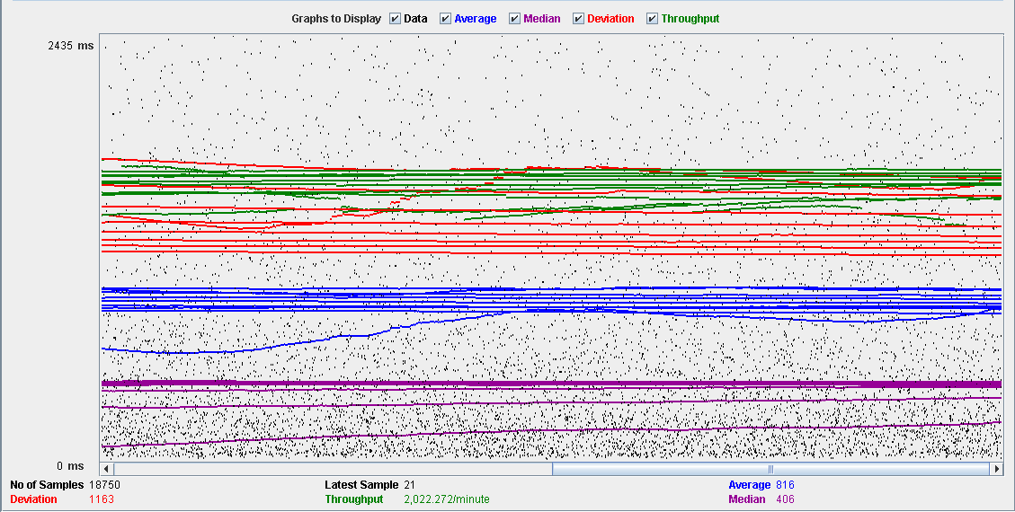

Performance Results:

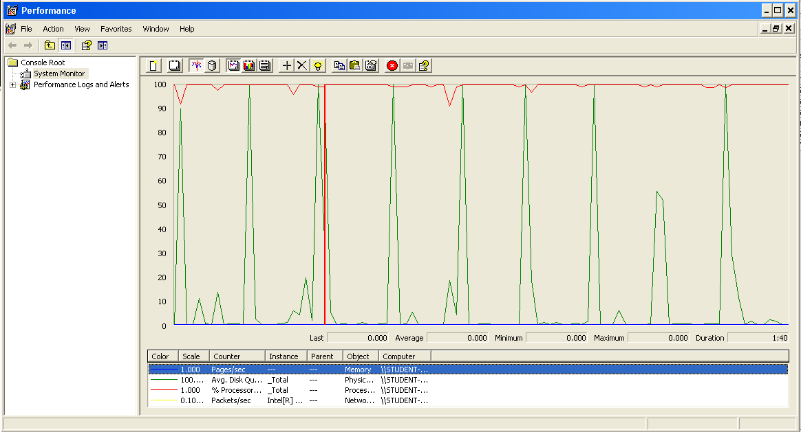

Again we can see that the CPU is always being used while the disk usage shows some periodic peaks.

## Send a broadcast mess

Sequence:

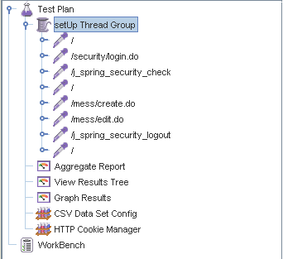

Aggregate Report:

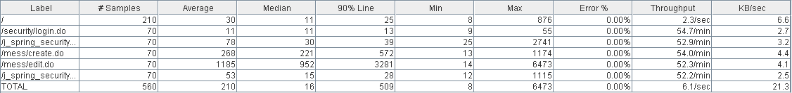

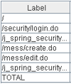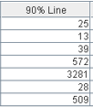

Thread properties:

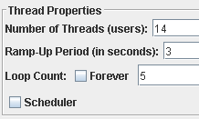

Graph Results:

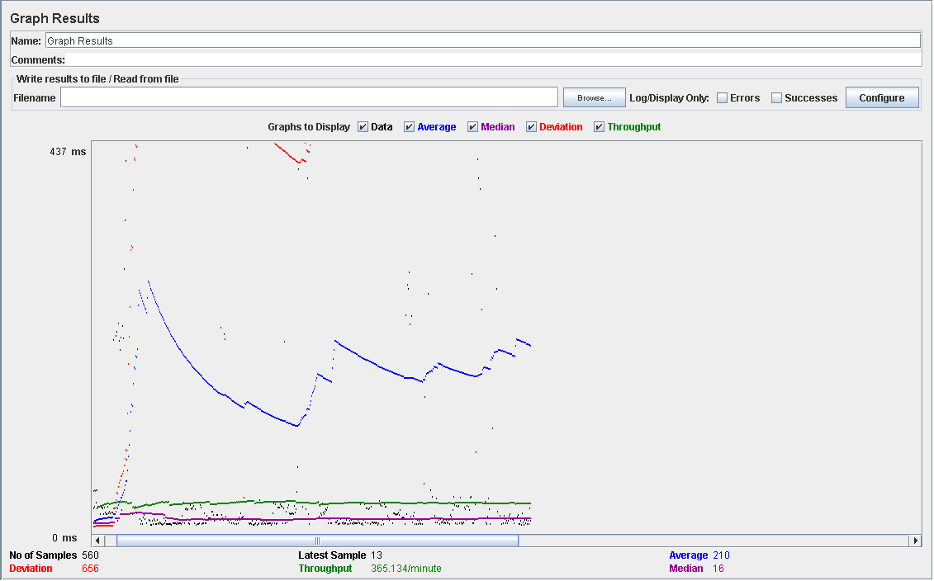

Performance Results:

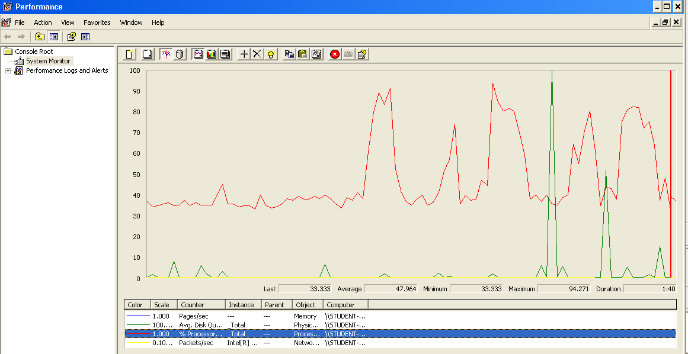

Again we can see that the CPU is always being used while the disk usage shows some peaks.

## Conclusion

The test was performed using:

CPU: i7 7700HQ (2 cores in the virtual machine)

RAM: 2 GB (virtual machine)

For this use case we can say that the limitation occurs during the creation process, being the maximum of concurrent users 14.

# Dashboard

## Display the dashboard and set the spammers

Sequence:

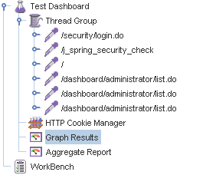

Aggregate Report:

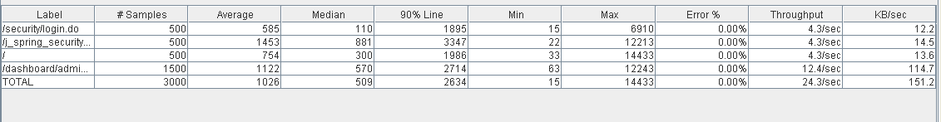

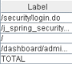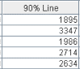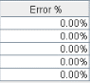

Thread properties:

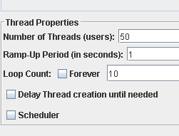

Graph Results:

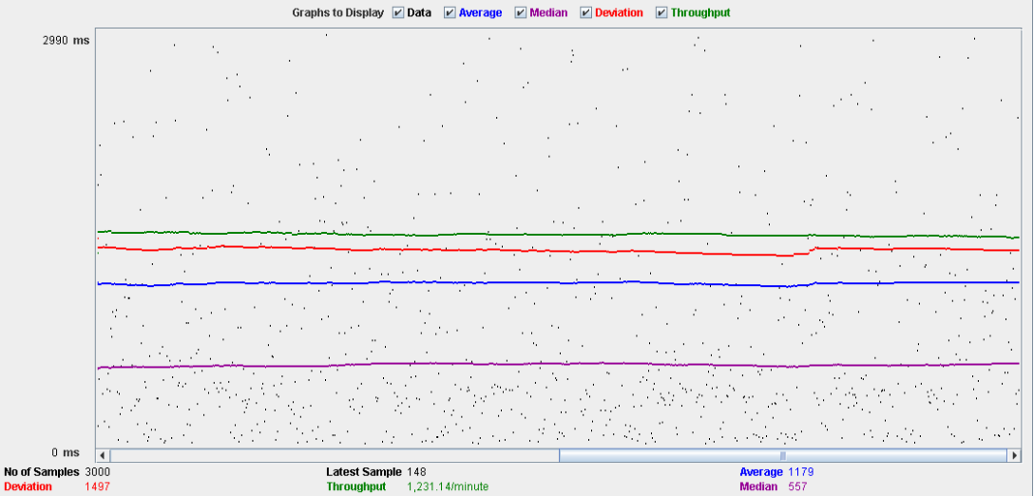

Performance Results:



The CPU was always at its limit while the disk usage showed many peaks.

## Conclusion

The test was performed using:

CPU: i5 2500K (2 cores in the virtual machine)

RAM: 2 GB (virtual machine)

For this use case we can say that the limitation occurs around 50 users when the time of respond begins to be very high.

# Configuration

## Display the configuration and edit it

Sequence:

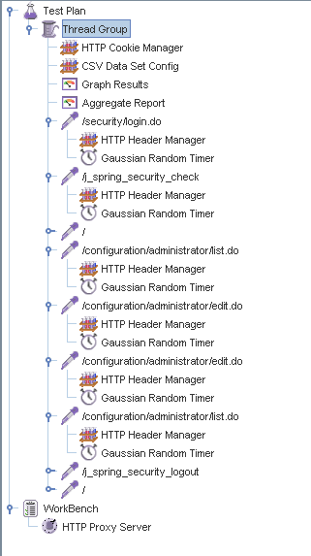

Aggregate Report:

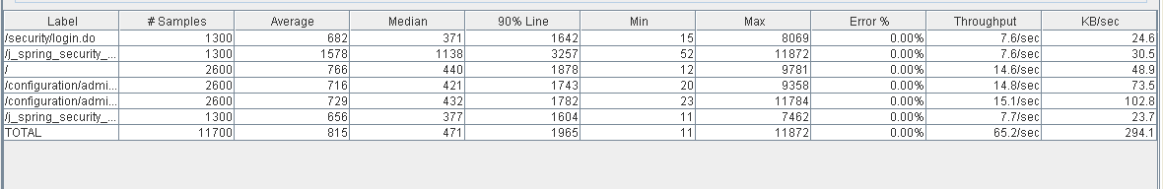

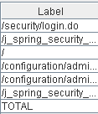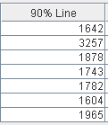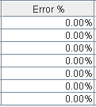

Thread properties:

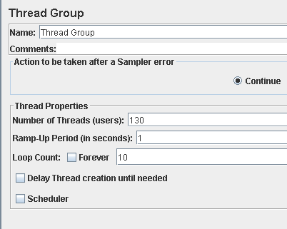

Graph Results:

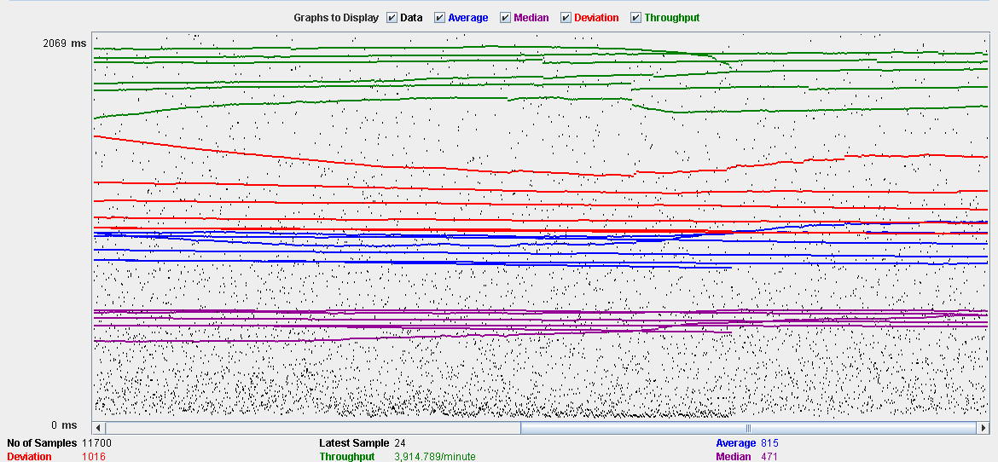

Performance Results:

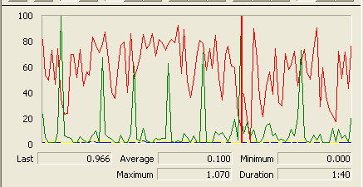

The CPU was always at its limit while the disk usage showed many peaks.

## Conclusion

The test was performed using:

CPU: i5 2500K (2 cores in the virtual machine)

RAM: 2 GB (virtual machine)

For this use case we can say that the limitation occurs around 130 users when the time of respond begins to be very high.

# Problem

## Create

Sequence:

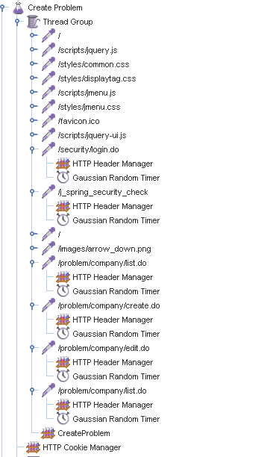

Aggregate Report:

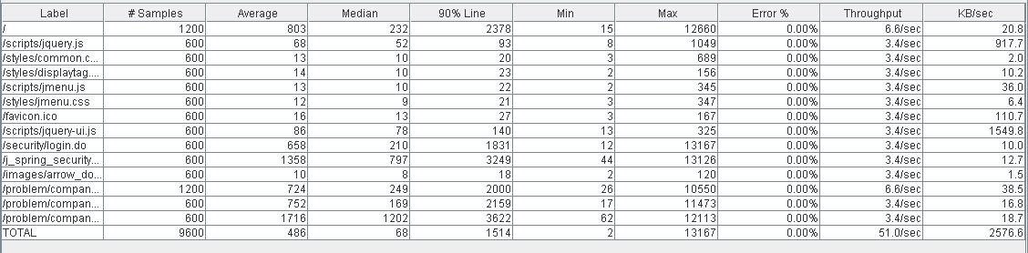

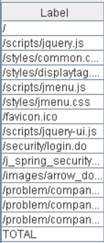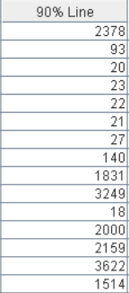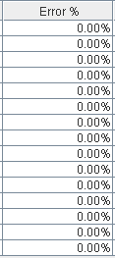

Thread properties:

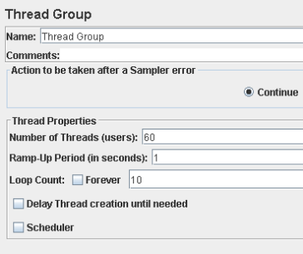

Graph Results:

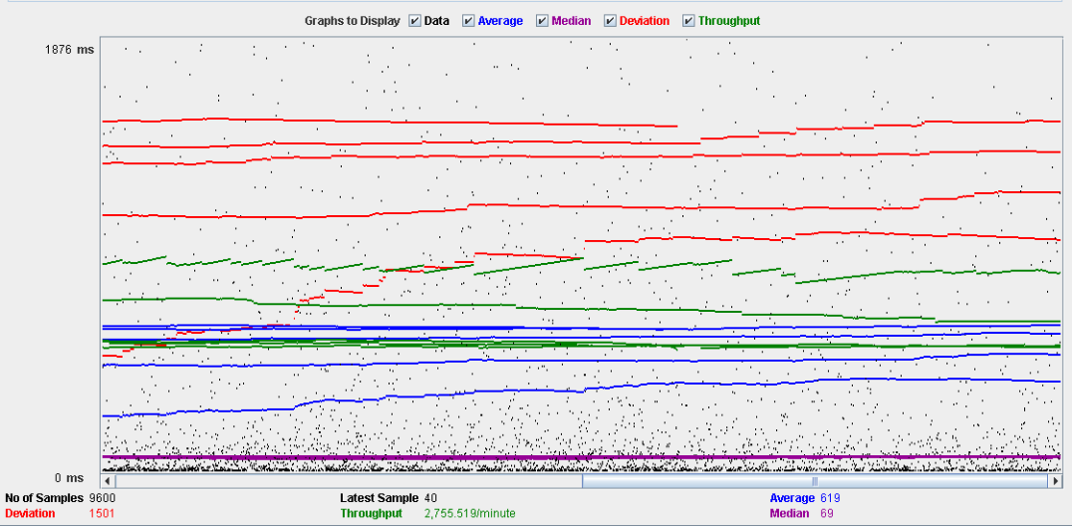

Performance Results:

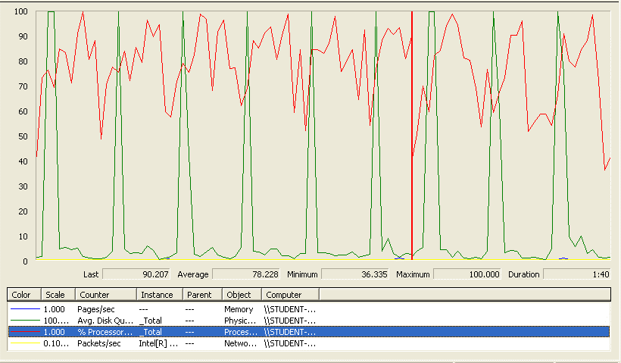

The CPU was always at its limit while the disk usage showed many peaks.

## Edit

Sequence:

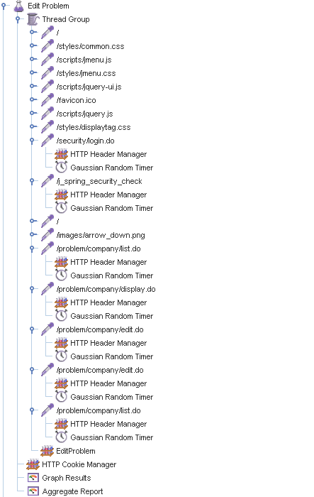

Aggregate Report:

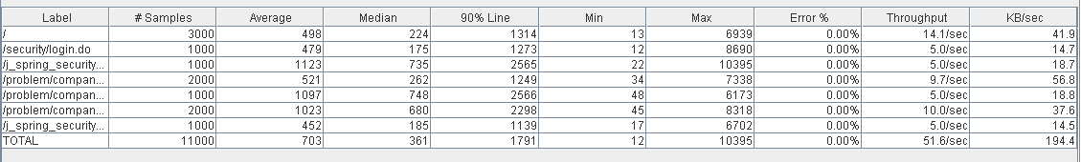

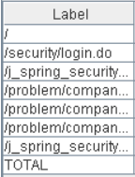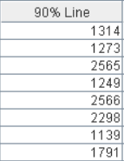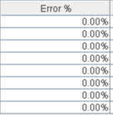

Thread properties:

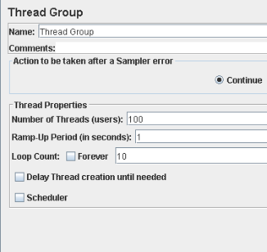

Graph Results:

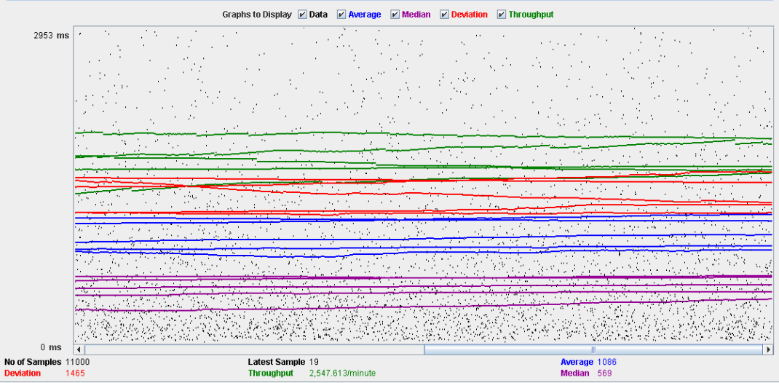

Performance Results:

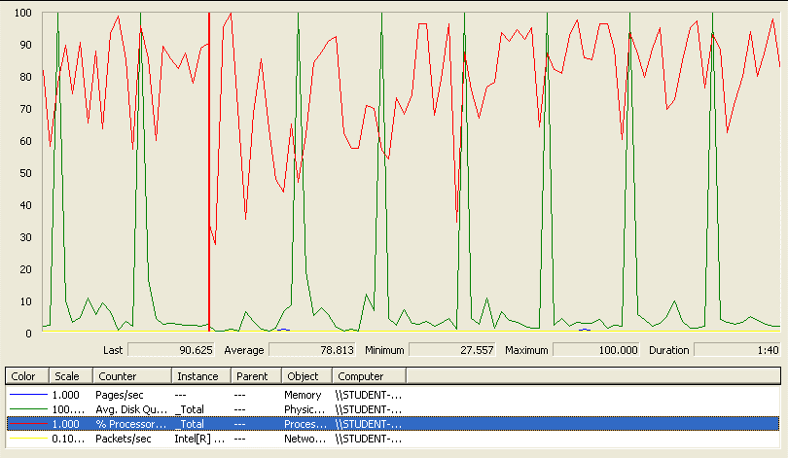

Again we can see that the CPU is always being used while the disk usage shows some periodic peaks.

## Delete

Sequence:

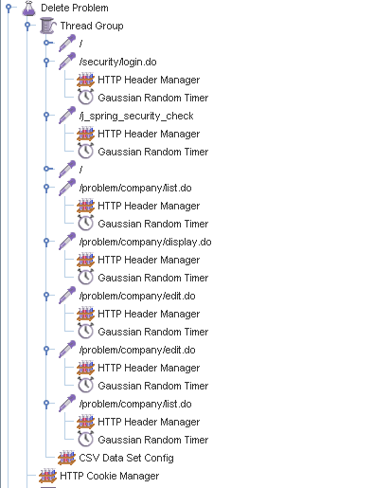

Aggregate Report:

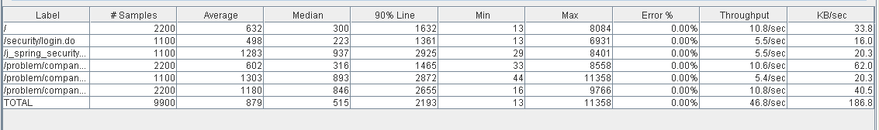

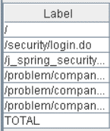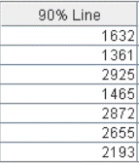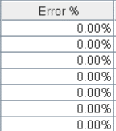

Thread properties:

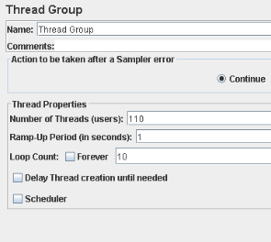

Graph Results:

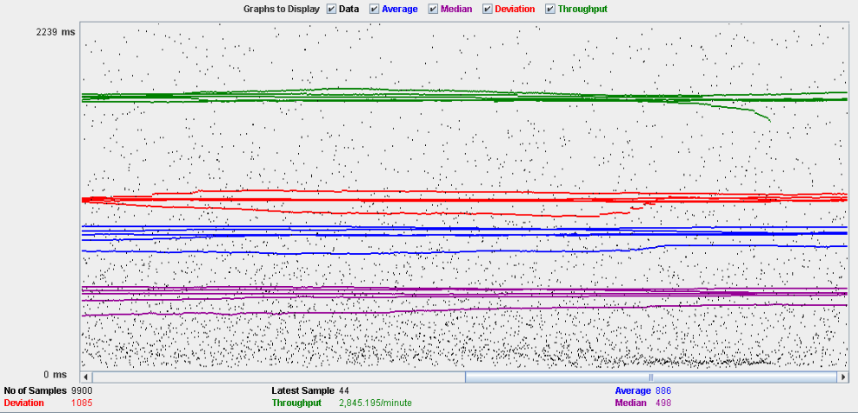

Performance Results:

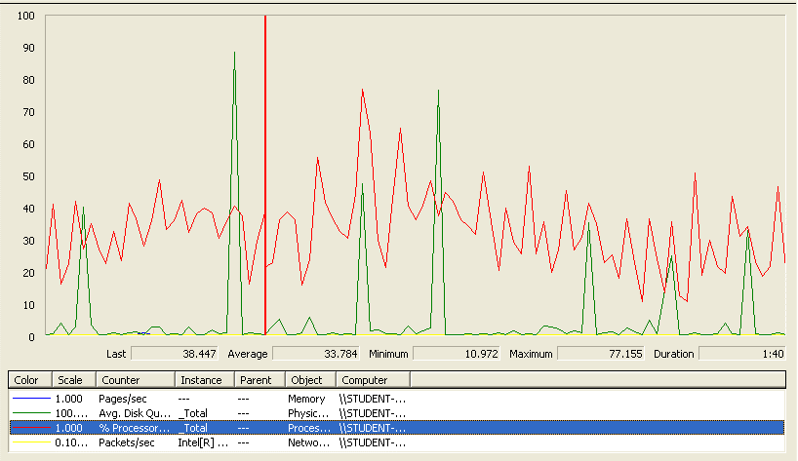

Again we can see that the CPU is always being used while the disk usage shows some periodic peaks.

## Conclusion

The test was performed using:

CPU: i5 2500k (2 cores in the virtual machine)

RAM: 2 GB (virtual machine)

For this use case we can say that the limitation occurs during the create process, being the maximum of concurrent users 60 because the time of respond begins to be very high.

# Finder

## Search and clear

Sequence:

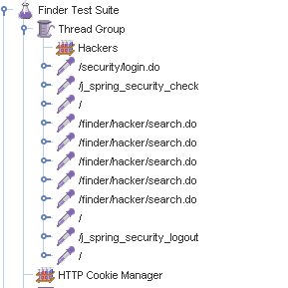

Aggregate Report:



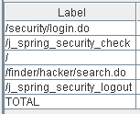 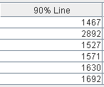 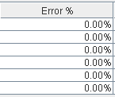

Thread properties:

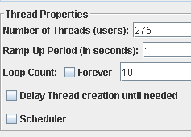

Graph Results:

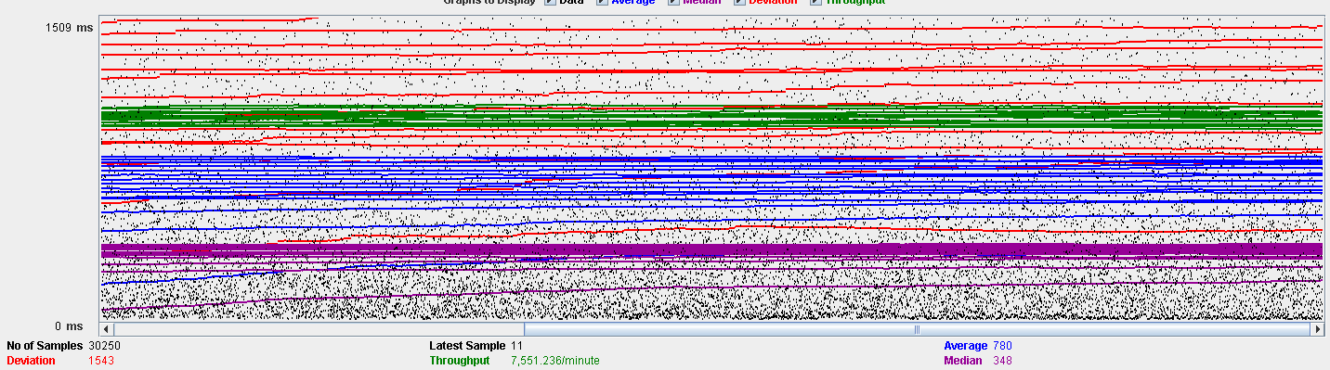

Performance Results:

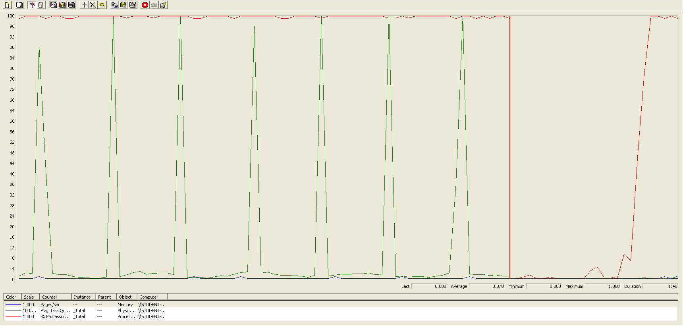

The CPU was always at its limit while the disk usage showed many peaks.

## Conclusion

The test was performed using:

CPU: i7 7300hq (2 cores in the virtual machine)

RAM: 2 GB (virtual machine)

For this use case we can say that the limitation is with a maximum of 275 concurrent users.

# Curricula

## Create a curriculum

Sequence:



Aggregate Report:





Thread properties:



Graph Results:



Performance Results:



The CPU was always at its limit while the disk usage showed many peaks.

## Edit a curriculum

Sequence:



Aggregate Report:





Thread properties:



Graph Results:



Performance Results:



The CPU was always at its limit while the disk usage showed many peaks.

## Delete a curriculum

Sequence:



Aggregate Report:





Thread properties:



Graph Results:



Performance Results:



Again we can see that the CPU is always being used while the disk usage shows some little peaks.

# Records (Professional and Miscellaneous record)

## Create Miscellaneous Record

Sequence:



Aggregate Report:





Thread properties:



Graph Results:



Performance Results:



Again we can see that the CPU is always being used while the disk usage shows some periodic peaks.

## Create Professional Record

Sequence:



Aggregate Report:





Thread properties:



Graph Results:



Performance Results:



Again we can see that the CPU is always being used while the disk usage shows some low peaks

## Edit a Miscellaneous Record

Sequence:



Aggregate Report:





Thread properties:



Graph Results:



Performance Results:



Again we can see that the CPU is always being used while the disk usage shows some peaks.

## Edit a Professional Record

Sequence:



Aggregate Report:





Thread properties:



Graph Results:



Performance Results:



Again we can see that the CPU is always being used while the disk usage shows some peaks.

## Delete a professional record

Sequence:



Aggregate Report:



 

Thread properties:



Graph Results:



Performance Results:



Again we can see that the CPU is always being used while the disk usage shows two peaks.

## Delete a miscellaneous data

Sequence:



Aggregate Report:



 

Thread properties:



Graph Results:



Performance Results:



Again we can see that the CPU is always being used while the disk usage shows little peaks.

## Conclusion

The test was performed using:

CPU: i7 6700hq (2 cores in the virtual machine)

RAM: 4 GB (virtual machine)

For this use case we can say that the limitation occurs during the creation process, being the maximum of concurrent users 80.

# Social profile

## Create

Sequence:

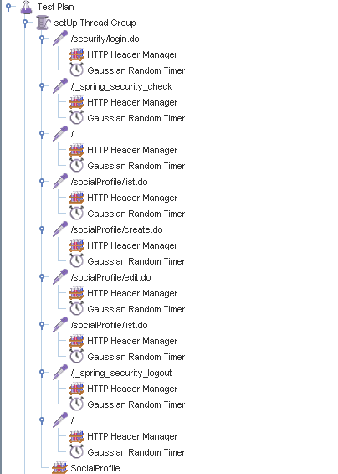

Aggregate Report:

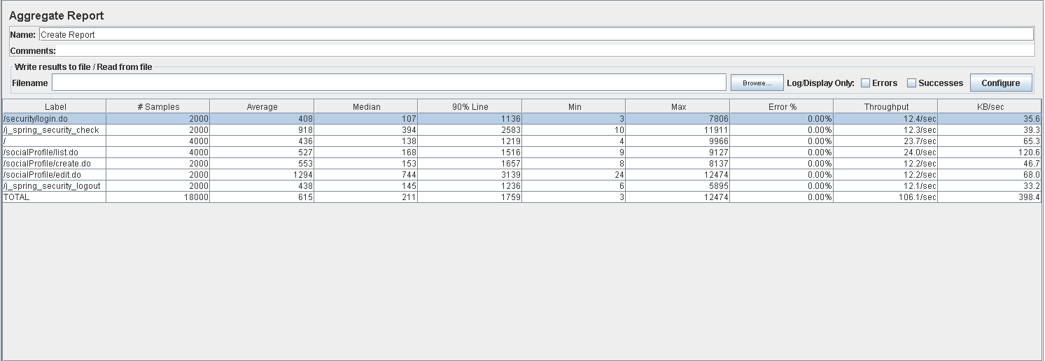



Thread properties:

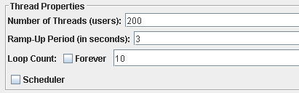

Graph Results:

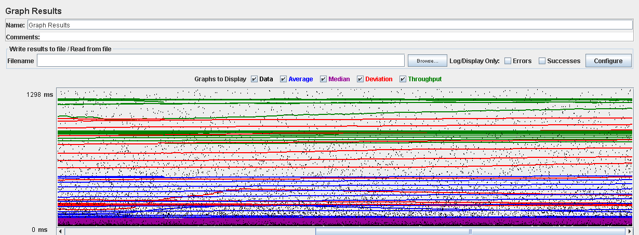

Performance Results:

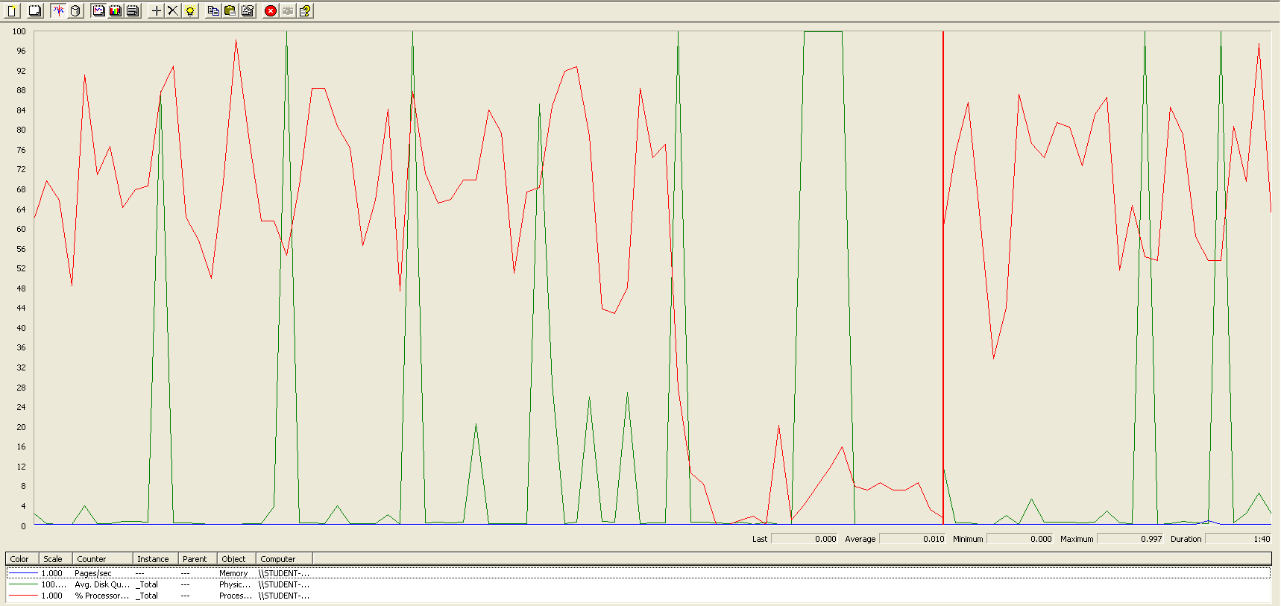

The CPU was always at its limit while the disk usage showed many peaks.

## Edit

Sequence:

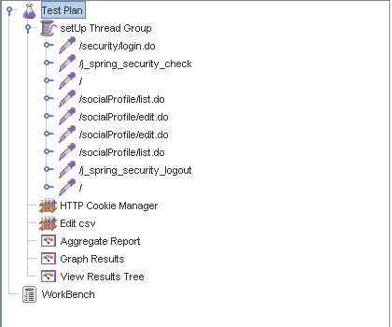

Aggregate Report:

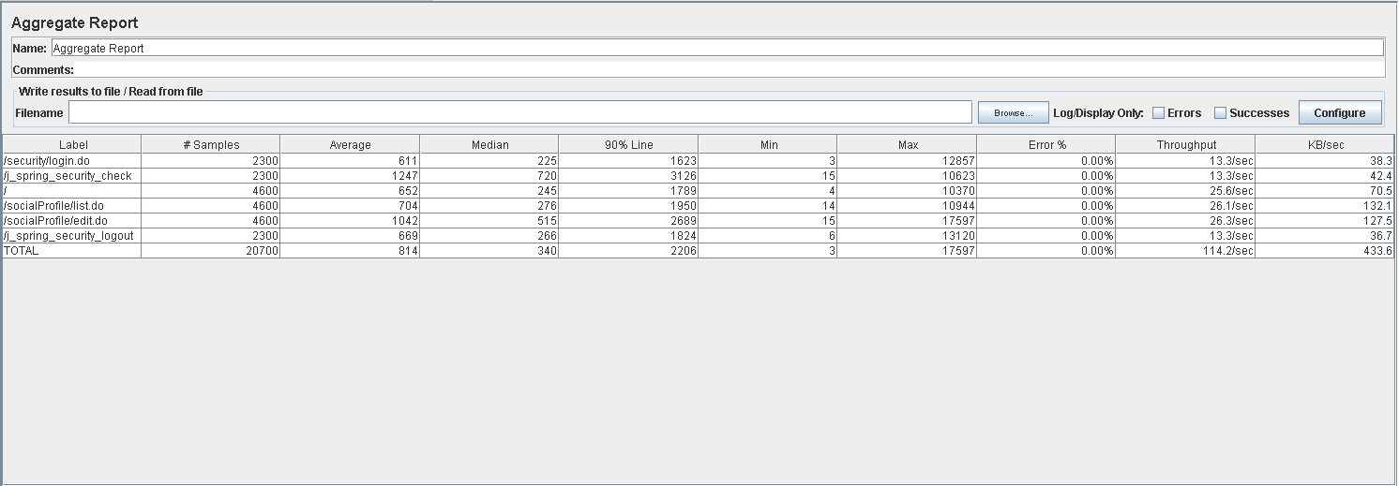

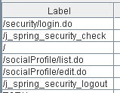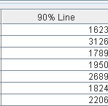

Thread properties:

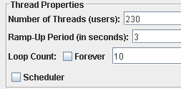

Graph Results:

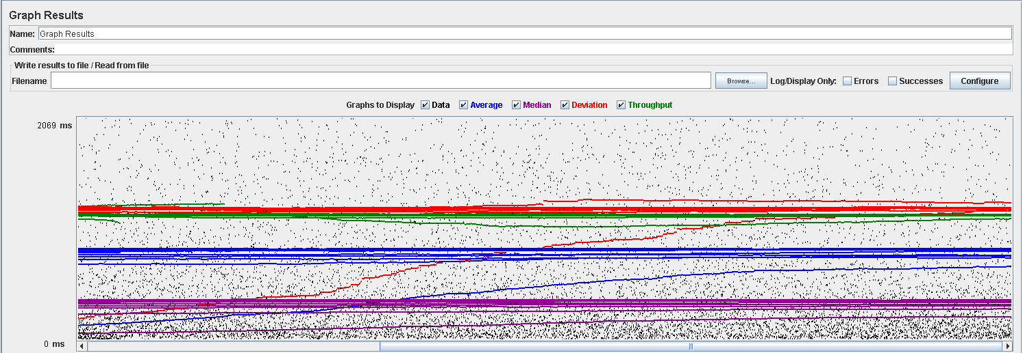

Performance Results:

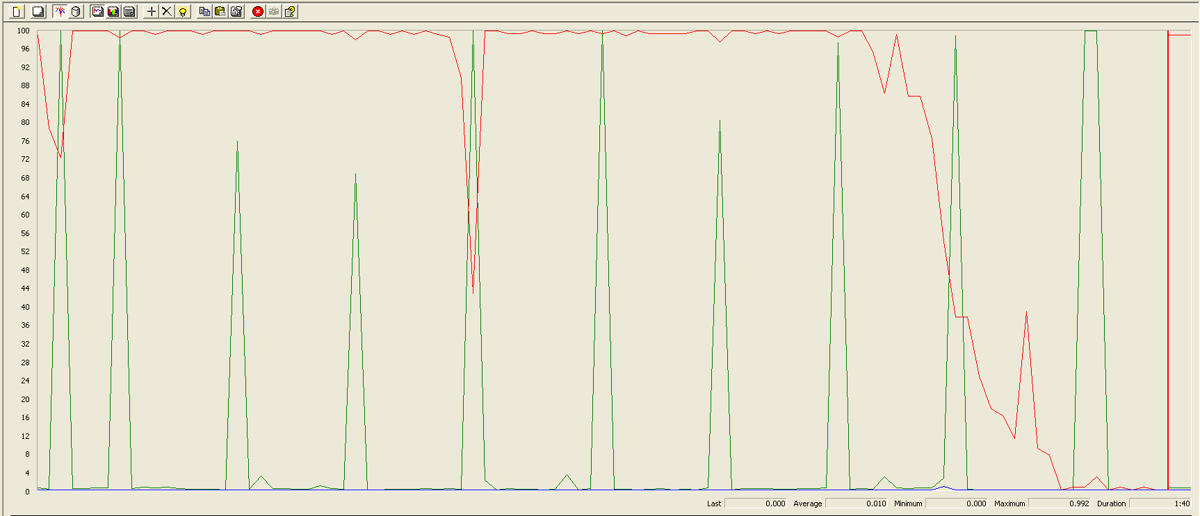

Again we can see that the CPU is always being used while the disk usage shows different peaks at times.

## 

## Delete

Sequence:

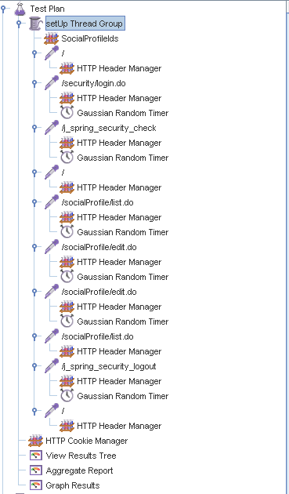

Aggregate Report:

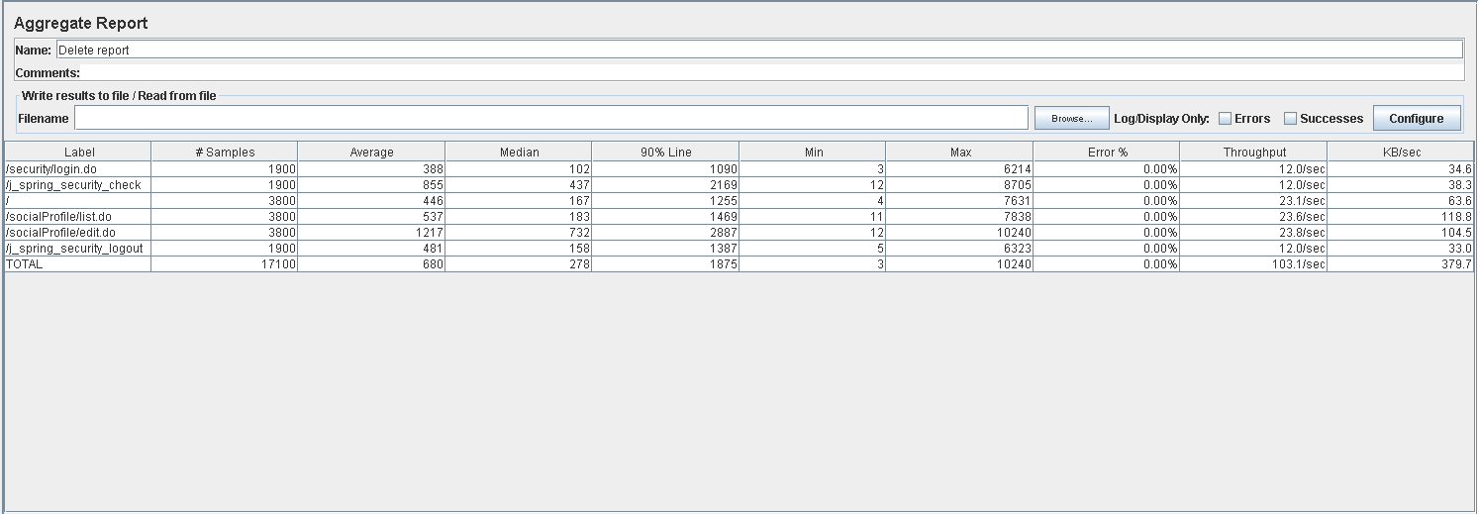

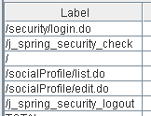

Thread properties:

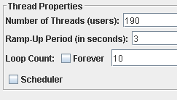

Graph Results:

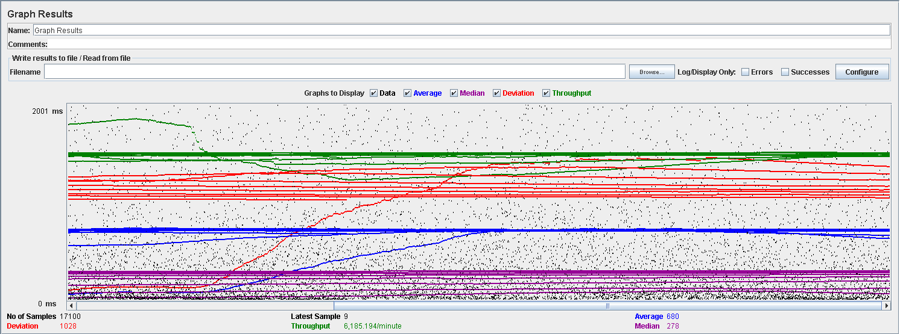

Performance Results:



Again we can see that the CPU is always being used while the disk usage shows some periodic peaks.

## Conclusion

The test was performed using:

CPU: i7 7700hq (2 cores in the virtual machine)

RAM: 4 GB (virtual machine)

For this use case we can say that the limitation occurs during the creation process, being the maximum of concurrent users 190.

# Actor

## Create

Sequence:



Aggregate Report:



  

Thread properties:



Graph Results:



Performance Results:



The CPU was always at its limit while the disk usage has a lot of peaks.

## Edit

Sequence:



Aggregate Report:





Thread properties:



Graph Results:



Performance Results:



Again we can see that the CPU is always being used while the disk usage has some peaks at times.

## Delete

Sequence:



Aggregate Report:





Thread properties:



Graph Results:



Performance Results:



Again we can see that the CPU is always being used while the disk usage has different peaks.

## Conclusion

The test was performed using:

CPU: i7 7700hq (2 cores in the virtual machine)

RAM: 4 GB (virtual machine)

For this use case we can say that the limitation occurs during the creation process, being the maximum of concurrent users is 90.

# Vehicle

## Create

Sequence:



Aggregate Report:





Thread properties:



Graph Results:



Performance Results:



The CPU was always at its limit while the disk usage has many peaks.

## Edit

Sequence:



AggregateReport: 



Thread properties:



Graph Results:



Performance Results:



Again we can see that the CPU is always being used while the disk usage has high peaks at times.

## Delete

Sequence:



Aggregate Report:





Thread properties:



Graph Results:



Performance Results:



Again we can see that the CPU is always being used while the disk usage has many different peaks.

## Conclusion

The test was performed using:

CPU: i7 7700hq (2 cores in the virtual machine)

RAM: 4 GB (virtual machine)

For this use case we can say that the limitation occurs during the creation process, being the maximum of concurrent users 220.

# Solicitation

## Create



Aggregate Report:





Thread properties:



Graph Results:



Performance Results:



The CPU was always at its limit while the disk usage showed some peaks.

## Edit

Sequence:



Aggregate Report:





Thread properties:



Graph Results:



Performance Results:



The CPU was always at its limit in various points of the execution while the disk usage showed a big peak.

## Delete

Sequence:



Aggregate Report:





Thread properties:



Graph Results:



Performance Results:



The CPU was always at its limit while the disk usage showed low peaks.

## Conclusion

The test was performed using:

CPU: i7 6700hq (2 cores in the virtual machine)

RAM: 4 GB (virtual machine)

For this use case we can say that the limitation occurs during the assign process, being the maximum of concurrent users 130.

# Sponsorship

## Create

Sequence:



Aggregate Report:





Thread properties:



Graph Results:



Performance Results:



The CPU was always at its limit while the disk usage showed low peaks.

## Edit

Sequence:



Aggregate Report:





Thread properties:



Graph Results:



Performance Results:



The CPU was always at its limit.

## Delete

Sequence:



Aggregate Report:





Thread properties:



Graph Results:



Performance Results:



The CPU was always at its limit and had disk usage low peaks.

## Conclusion

The test was performed using:

CPU: i7 6700hq (2 cores in the virtual machine)

RAM: 4 GB (virtual machine)

For this use case we can say that the limitation occurs during the create process, being the maximum of concurrent users 100.

# Fare

## Create

Sequence:



Aggregate Report:



  

Thread properties:



Graph Results:



Performance Results:



The CPU was always at its limit while the disk usage has a lot of peaks.

## Edit

Sequence:



Aggregate Report:





Thread properties:



Graph Results:



Performance Results:



Again we can see that the CPU is always being used and disk usage had some peaks.

## Delete

Sequence:



Aggregate Report:





Thread properties:



Graph Results:



Performance Results:



Again we can see that the CPU is always being used while the disk usage and network have different peaks.

## Conclusion

The test was performed using:

CPU: i5 7300hq (2 cores in the virtual machine)

RAM: 2 GB (virtual machine)

For this use case we can say that the limitation occurs during with all the process, being the maximum of concurrent users 100.

# Conclusion of the performance

As we can see in the tests above, the limitations of our system are in the message system, specially in the method of broadcasting a message (14 concurrent users). We think that this may be a bit unrealistic, because in a real environment won’t be many administrators sending multiple notifications. Due that, we consider that the limit of concurrent users for our system is 45 (sending a message).